Synopsis

**1. Title Of The Project**

**“Brain Cafe”**

**Best Platform For Self-Learning**

# Table of Contents

**Structures**

1. Introduction

1. Background
2. Objectives

1. SurveY of Technologies

2.1 Front end

2.2 Back end

3 Requirements and Analysis

1. Requirements Specification
2. Planning and Scheduling
3. Software and Hardware Requirement
4. Preliminary Product Description

3.5.1 Modular Description

3.5.2 Process Logic

1. Conceptual Models

4 System design

4.1 Basic Module

4.2 Architecture Diagram

4.3 Sequence Diagram

* 1. Data Design
  2. Security Issues

1. COnclusions

5.1 Conclusion

5.2 Limitation of the this Project

5.3 Future Enhancement

6 REFERENCES

**project report**

1. introduction
2. objectives
3. system analysis
   1. identification of needs
   2. priliminiary investigation
   3. feasibility study
   4. project scheduling
   5. software requirements specification

1. SYSTEM DESIGN
   1. Modularisation Details
   2. Data Integrity and Conclusion
   3. Procedural Design

1. DATA DESCRIPTION
2. STANDARDISATION OF THE CODING
   1. Code Efficiency
   2. Validation checks
3. TESTING TECHNIQUES AND STRATEGIES
4. SYSTEM SECURITY AND MEASURES
5. COST ESTIMATION OF THE PROJECT
6. REPORTS OF THE PROJECT
7. FUTURE SCOPE
8. BIBLIOGRAPHY

# INTRODUCTION

## Background

Education is very important part of our life. Without education we can’t do anything. Now-a-days, if we want to get successful life and if we think that without education we will get successful life then it’s not possible. Education makes you capable to be successful in every field.

In previous education system was limited means that if any student want to get educated its self then they had to go any educational institute like schools, colleges, universities or libraries. These educational institutes are too much costly and it’s have limited admission seats and courses. In that case only those students were capable of take education that have strong financial position and which course are also matched with educational institute.

Traditional education expects students to learn skills at the same rate. While one student may be ready to read at age five or earlier, another may not show the same readiness until he is eight. While both students have the ability to learn and will eventually be readers, traditional education does not recognize this. Students who are quick learners often become bored or disruptive, while students who are less quick to assimilate information are labeled as learning-disabled. The result is often that both learners are unable to meet their full potential.

It is not uncommon to find schools with more than 1,000 students enrolled. The average enrollment for a middle school in Nevada as of 2009 is 996 students, according to a report prepared by Education Information and Accountability Services. One of the results of high enrollment is that schools become areas with high concentrations of crime. Theft, assault and drugs are commonplace in many schools today. Rape and murder, along with gang violence and intimidation are also not unheard of in some schools. Behavior problems such as defiance, rudeness and bullying take on gargantuan proportions in a classroom where a teacher is attempting to instruct 30 or more students. Effective academic learning simply cannot occur in such an environment.

Traditional education system had following drawbacks:-

* Financial Problem
* Caste reservation system
* No Repeated Class
* One Size Does Not Fit All
* Social Problems Are Condensed Into a Small Space
* Places students in a passive rather than an active role, which hinders learning.
* Requires a considerable amount of unguided student time outside of the classroom to enable understanding and long-term retention of content.

## 1.2 Objectives

Now-a-days everything is online every where is the available the facility of internet, so it’s possible that, if there is a source on which a student can study online. There is most two trade is available in online 1st is E-learning and 2nd is virtual classes.

E-learning can occur in or out of the classroom. It can be self-paced, asynchronous learning or may be instructor-led, synchronous learning.

Virtual learning can take place synchronously or asynchronously. In synchronous systems, participants meet in “real time” and teachers conduct live classes in virtual classrooms. But there is a problem in both, In E- learning if student have any doubt then no it’s not possible to solve it and Virtual learning have some same problems as traditional learning like time dependency, No repeated class, One Size Does Not Fit All etc. so we decided a project which based on E-learning but in which students will clear his doubts. Which features are following:-

* **E-Learning is student centered.** The learner is the core of any e-Learning system. Materials and activities are designed with the needs and interests of the learner in mind. Students assume control of their learning experience and use it to suit their own specific needs.
* **E-Learning is self-directed and self-paced.** Learners control the amount of time they spend on any particular topic. This allows learners to spend additional time on difficult items before moving on or to skip material they already understand. This “individualized” approach usually allows learners to complete their education and training faster than in traditional courses.
* **E-Learning is interactive and hands-on.** The use of a variety of multimedia in e-Learning increases student involvement and reinforces the learning experience. This leads to increased retention and a stronger grasp of the subject at hand.
* **E-Learning is flexible.** Learning can take place anytime and anywhere, as long as the necessary equipment is accessible. The logistics and expense of face-to-face education and training can be extremely limiting when students are separated by distance. E-Learning also allows physically or otherwise challenged students to more fully participate.
* **E-Learning provides consistent and effective training.** All of the target learners can participate simultaneously and receive the same information, reducing the variability introduced through multiple sessions in different locations.
* **E-Learning provides classes in lower cost.** E-learning is more cost-effective because there is a reduction in training time known as learning compression. This is because the single largest cost of training in organizations is the cost of staff attending the training course, rather than the direct delivery costs in terms of trainers, course materials, travels and accommodation.

# Survey of Technologies

**Project Category**

The project category is **RDBMS** (Relational Database Management System). A relational database management system is a database managements system (DBMS) that is based on the relational model as invented by E. F. Codd, of IBM’s San Jose Research Laboratory. Many popular databases currently in use are based on relational database model. RDBMS data is structured in database tables, fields and records. Each RDBMS table consists of database table rows. Each database table row consists of one or more database table fields. RDBMS store the data into collection of tables, which might be related by common fields (database table columns). RDBMS also provide relational operators to manipulate the data stored into the database tables. Most RDBMS use SQL (Structure Query Language) as database query language.

**Features of RDBMSs**

There are several “advanced features” of RDBMSs that developers learn once they’ve familiarized themselves with basic CRUD functionality. Each of these features is so important, and often so complex, that they require their own articles to cover them properly. So for now I will introduce you to the concepts and then link to these other articles for the details. These features include:

**Object storage.** To store an object in a relational database we need to flatten it – create a data representation of the object – because relational databases only store data. To retrieve the object you would read the data from the database and then create the object, often referred to as restoring the object, based on that data.

**Implementing behavior within the database**. Behavior is implemented in a relational database via stored procedures and/or stored functions that can be invoked internally within the database and often by external applications. Stored functions and procedures are operations that run within an RDBMS, the difference being what the operation can return and whether it can be invoked in a query.

**Concurrency control**. Concurrency control must be implemented throughout your object source code and within our database.

**Transaction control**. A transaction is a collection of actions on our database – such as the saving of, retrieval of, or deletion of data – which form a work unit. A flat transactions is an “all-or-nothing” approach where all the actions must either succeed or be rolled back (cancelled). Transaction control is a critical concept for all developers to understand.

**Enforcing referential integrity**. Referential integrity (RI) is the assurance that a reference from one entity to another entity is valid. All developers should understand basic strategies for implementing referential integrity.

**Front-End Survey**

we use C# language with .NET Framework which is more user-friendly which advantages are following:

* **C#**

C# is Microsoft’s programming language for its new .NET development environment. Microsoft’s goal with C# is to provide a simple, modern, object-oriented .NET programming language that is Internet-centric. Although .NET code can be written in many languages, C# is the only language designed specifically for the .NET platform and for that reason may become the language of choice for this environment. C# may be deceptively simple. Although it has only about 80 keywords and a dozen intrinsic data types, it is highly expressive. It includes support for all types of modern component-based, object-oriented development. C#, like C++ and Java, owes its origins to the C programming language. For that reason, C++ and Java developers will notice a striking similarity to those languages and enjoy an easy-to-learn and familiar programming environment. Specifically, C# is an elegant language object-oriented language.

* **ASP.NET**

## Server Application Development

Server-side applications in the managed world are implemented through runtime hosts. Unmanaged applications host the common language runtime, which allows your custom managed code to control the behavior of the server. This model provides you with all the features of the common language runtime and class library while gaining the performance and scalability of the host server.

The following illustration shows a basic network schema with managed code running in different server environments. Servers such as IIS and SQL Server can perform standard operations while your application logic executes through the managed code.

**ACTIVE SERVER PAGES.NET**

ASP.NET is a programming framework built on the common language runtime that can be used on a server to build powerful Web applications. ASP.NET offers several important advantages over previous Web development models:

**Enhanced Performance.**

**World-Class Tool Support.**

* **Power and Flexibility.**
* **Simplicity.**
* **Manageability.**
* **Scalability and Availability.**
* **Customizability and Extensibility.**

**Security**

**Back-End Survey**

The most popular RDBMS are MS-SQL Server, DB2, Oracle RDBMS stands for Relational Database Management System. We use MS-SQL SERVER in our project because is automatically install with Visual Studio so we don’t have to install any other RDBMS, another advantages of the MS-SQL SERVER is following:

**FEATURES OF SQL SERVER**

SQL SERVER is one of the leading database management systems (DBMS) because it is the only Database that meets the uncompromising requirements of today’s most demanding information systems. From complex decision support systems (DSS) to the most rigorous online transaction processing (OLTP) application, even application that require simultaneous DSS and OLTP access to the same critical data, SQL Server leads the industry in both performance and capability

SQL SERVER is a truly portable, distributed, and open DBMS that delivers unmatched performance, continuous operation and support for every database.

SQL SERVER RDBMS is high performance fault tolerant DBMS which is specially designed for online transactions processing and for handling large database application.

SQL SERVER with transactions processing option offers two features which contribute to very high level of transaction processing throughput, which are

The row level locks manager

* **ENTERPRISE WIDE DATA SHARING**
* **PORTABILITY**
* **OPEN SYSTEMS**
* **DISTRIBUTED DATA SHARING**
* **UNMATCHED PERFORMANCE**
* **SOPHISTICATED CONCURRENCY CONTROL**

## Requirements and Analysis

### Requirement Specification

**Performance Requirements**

The following performance characteristics were taken care of in developing the systems

* + - **User Friendliness**

The system is easy to learn and understand. A native user can also use the system effectively, without any difficulty.

* + - **User Satisfaction**

The system is such that it stands up to the user’s expectations and requirements.

* + - **Response Time**

The response time of all the operations is very low. This has been made possible by careful programming.

* + - **Error Handling**

Response to User Errors and undesired situations have been taken care of to ensure that the system operates without halting in case of such situation and proper error messages are given to user.

* + - **Safety**

The system is able to avoid catastrophic behavior.

* + - **Robustness**

The system recovers from undesired events without human intervention.

* + - **Security**

The system provides protection of information through the mechanism of password incorporated in it. Therefore, only authorized people can access the databases.

* + - **Accuracy**

The system is accurate. Thus, its utility is very high.

* + - **Throughput**

The system gives the maximum throughput.

* + - **Cost Element**

In this system, servicing a given demand in a program does not require a lot of money. The system is reliable, versatile and efficient.

**Disadvantages of Present Working System**

* **Not User Friendly**

The existing system is not user friendly because the retrieval of data is very slow and also data is not maintained efficiently.

* **Difficulty in Search**

We require more calculations to search so it is generated at the end of the session.

* **Manual Control**

All operation to search or maintain is done manually so there is greater chance of errors.

* **Lots of Paperwork**

Existing system requires lot of paper work. Loss of even a single register/record led to difficult situation because all the papers are needed to generate the reports

* **Time Consuming**

Every work is done manually so we cannot generate report in effectively and less time consuming.

### Planning and Scheduling

From the inception of a given idea for software system, until it is implemented and delivered to the customer and even after that the system undergoes the several changes. The software is said to have a lifecycle known as Software Lifecycle composed of several phases. Each of these phases results in the development of either a part of the system or something associated with the system, such as a test plan or user manual. In the traditional and most common lifecycle model called WATERFALL MODEL, each phase has well defined starting and ending points with clearly identifiable inputs to the very next phase attached to it. It is actually the first engineering approach of software development.

The waterfall model provides a systematic and sequential approach to software development and is better than the build and fixes approach. But, in this model, complete requirements should be available at the time of commencement of the project, but in actual practice, the requirements keep on originating during different phases. The waterfall model can accommodate new requirements only in the maintenance phase. Moreover, it does not incorporate any kind of risk assessment. In the waterfall model, a working model of software is not available. Thus, there is no way of judging the problems of the software in- between different phases. A slight modification of the waterfall model is a model with feedback. Once software is developed and is operational, then the feedback to various phases may be provided

System engineering

Analysis

Design

Coding

Testing

Maintenance

**Figure 3.3.1: Waterfall Model**

**3.3 Software and Hardware Requirements**

* **Hardware Requirements for Server**

Processor : Intel Core i5 (or above)

Speed : 3.4 GHz

Ram : 8GB DDR3

HDD Space : 1TeraBites

Monitor : 15” color

* **Software Requirements**

Development Environment: MicrosoftVisualStudio2010

Database Used : Microsoft Sql Server 2008

Operating System : Windows NT

Web Browser : Internet Explorer

E-Mail Service : Microsoft Outlook

Running Environment : .NET Framework 4

* **Hardware Requirements for Client**

Processor : Intel Pentium III (or above)

Speed : 700MHZ

Ram : 512MB

HDD Space : 50MB

Mouse : 3 button scroll mouse

Keyboard : 104 keys keyboard

Monitor : 15” color

Graphics Card : Direct X 7 / 64 MB (or above)

Internet Connection : Any Internet Network

Network Card : Any Network interface or modem

Printer : Any Printer (Dot matrix or Lager)

* **Software Requirements**

Operating System : Windows 98/2000/XP/7/8

Web Browser : Internet Explorer

E-Mail Service : Microsoft Outlook

* 1. **Preliminary Product Description**

**3.4.1 Module description**

* **Login Module**

The Login Manager is responsible for handling login related information of user. It has user friendly GUI interface which provides all the required information with minimum efforts.

The Login Manager has the responsibility to allow only authenticated users to login to the website. It keeps check over the entry of the user.

The module consists of procedures to handle the storage, updating and deleting of records of a particular userid. It also consists of methods for authenticating the user.It is also responsible for fetching the hint question if the user forgets the password.

* **Basic Profile**

Basic profile deals with profile creation of the user during his/her registration time. Users can be either being Learner or trainer.

It is like a form which is going to be filled with personal details by the users . This information can be filled by the user during his login detail entriesWhile reaching to the homepage learner and trainer can view their basic information detail and can edit their personal details according to their situation.

* **Learner Advance Profile**

This advance profile is responsible for saving the entries given by the learner according to his learning interest area . Learning area is that area or part in which learner want to query to the trainer and request for study materials in that particular area. There are more than 100 learning area where learner shows his interest and adopt for more than one learning area and will also tell his level in that learning area i.e his grading in particular subject. Their remarks will also be welcomed. All the learning area will be related to the IT- Technology fields. According to this learning area the expertise trainer will be allotted to the learner.

* **Request Module**

This module is responsible for sending request by the learner to the trainer whom he want to handshake or attached so that learner will get his desired material. By just clicking to the request button his request will be forwarded to the requested trainer. Then if trainer will accept his request then that learner will attached to the learner. Through this process material will be requested and material will be send by the trainer to the learner.

* **Download Material Module**

This module is responsible for downloading material which is given by the trainer to the learner. According to that requirement which is given by the learner to the trainer will provide material to the learner by providing him download button. From that download button learner will download the material.

* **Material Collection**

This module is responsible collecting all the materials according to trainer’s need. Trainer will maintain his archive that is he will upload all material of different file format in his library and according to learner’s query he will transfer or send that material to learner. This archive will be maintained with full description of the material.

* **Exam Module**

This module is responsible for learning capability test; in this module we check that how much learner gain knowledge with our learning program for check its knowledge we take a small exam of learner and give them grade according to its score.

* + 1. **Process Logic**
* **Login Process :** The process deals with allowing only the authenticated to user sign in using valid username and password .it also implement the process of recovering password in the case the user forget it as well as updating the same .
* **Registration process:** This process enables the trainer or learner to register and make their profiles.
* **Request Process:** Using this process learner can request his/her choice of learner for exchange of study material.
* **Download material process:** Learner can download study material of his/her choice using this process.
* **Suggestion-Cum-Feedback process:** Trainerand learner can submit their feedback and suggestion to be viewed by the administrator.
* **Archive Process:** Trainer uploads the course materials to be downloaded by the learner.
* **Administrator process:** This process deals with the management of user, suggestion, archive, materials by the administrator.
* **Exam process:** This process deals with the learner capability test in this we can take the exam of learner and give them score.
* **Report Process:** This process deals with the learner and facility. This contain the report card of learner after the examination.
* **Notice Process:** This process is containing the current notices of the Brain Café. About new course or new facility updates it’s a type of dashboard where current news will be flash.

**3.5 Conceptual Models**

**Zero Level DFD**

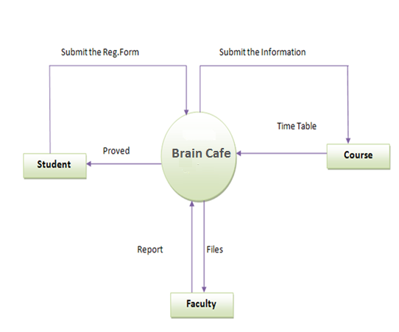

First Level DFD

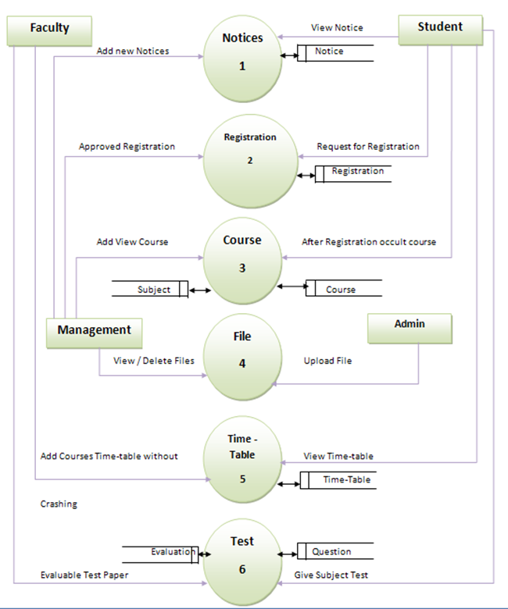

**Entity Diagram**

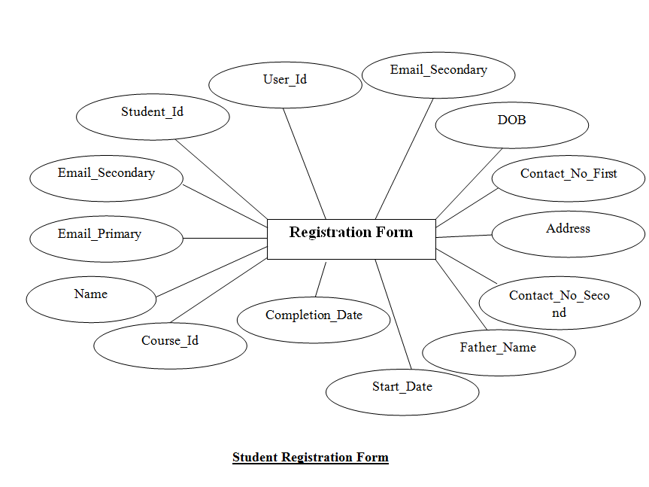

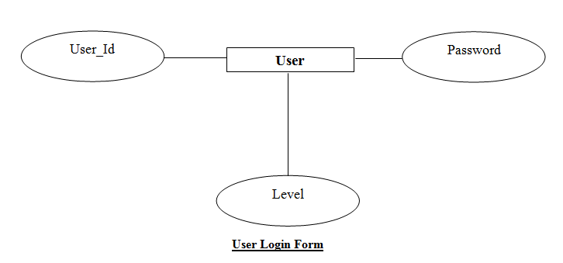

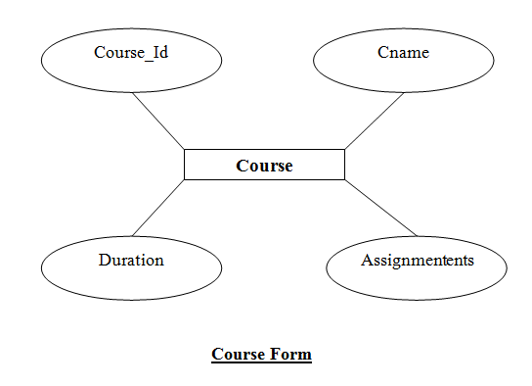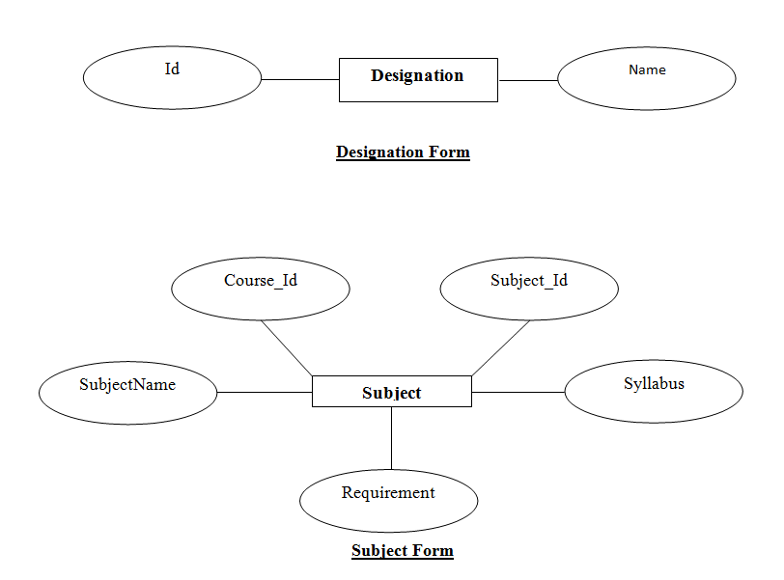

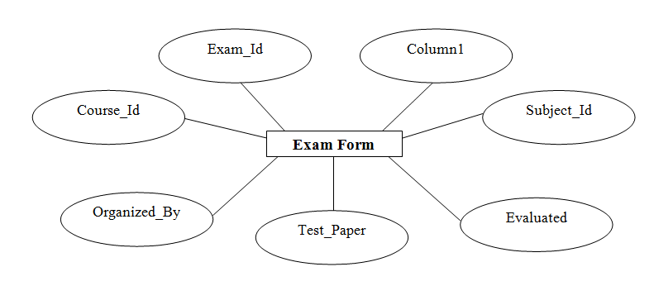

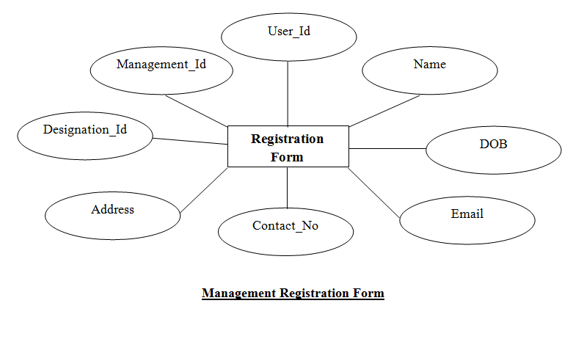

**Exam Form**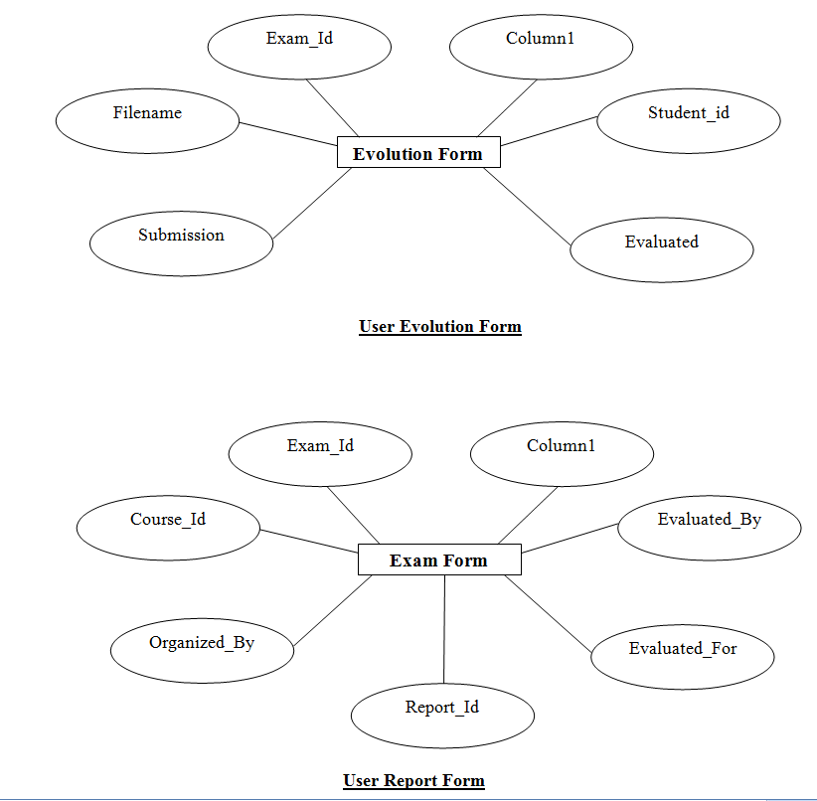

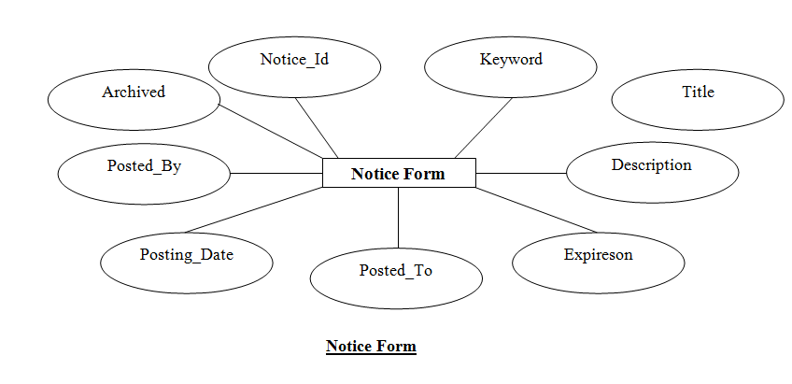

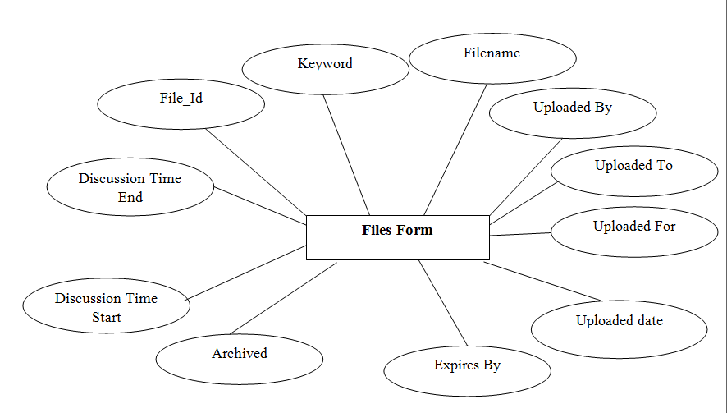

**Files Form**

**E-R Diagram of Brain Cafe**

**Notice**

**Faculty**

Add

**Management**

Allotted

**Subject**

**Student**

**Course**

Marks

Marks

**Evaluation**

**Exam**

**Report**

Write

Apply

Appoint By

**Designation**

Have

Stud.

Rep.

# System Design

**Basic Modules :-** Whole System is divided into four module-

A. Learner Module

B. Trainer Module

C. Course Module

D. Administrator Module

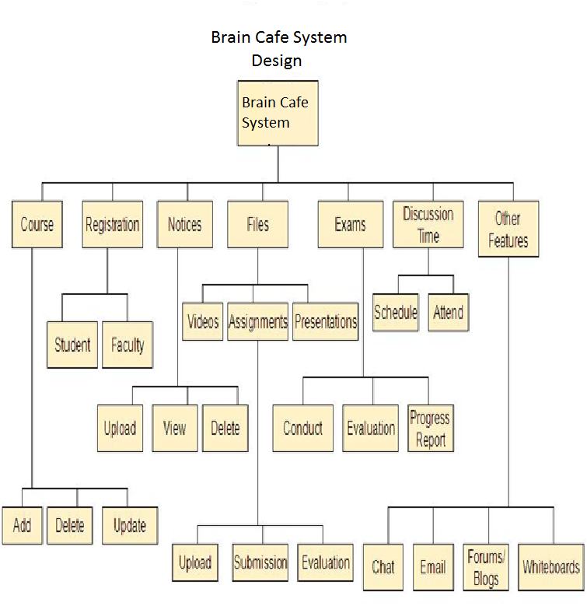

**Use case Diagram:**

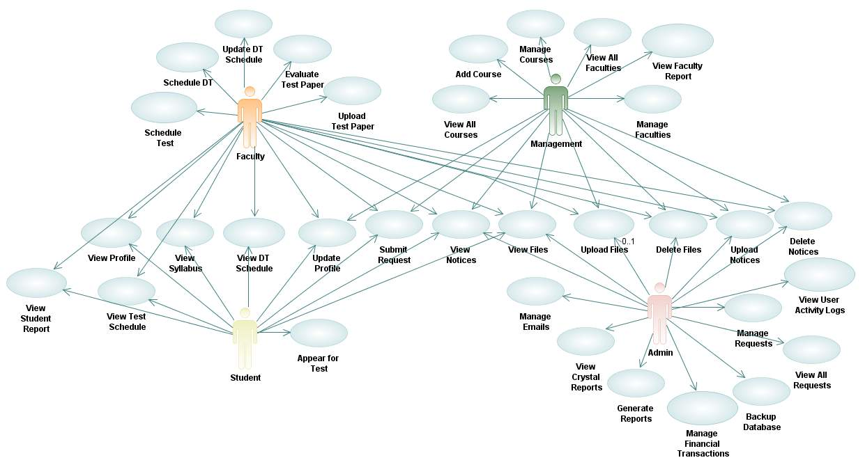

**Architecture Diagram:**

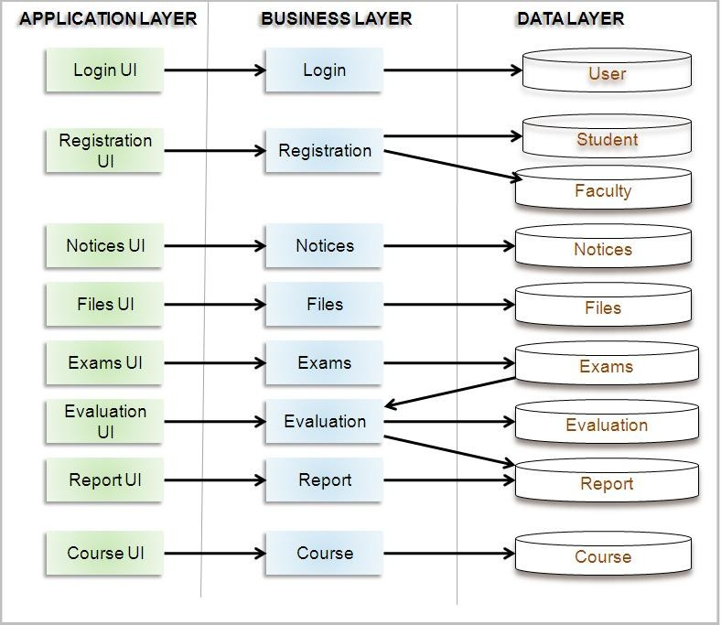

**Sequence Diagram:**

**Student Registration:**

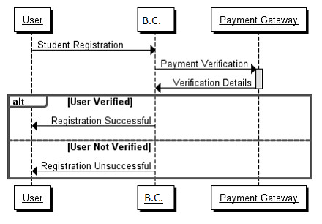

**Faculty Registration**

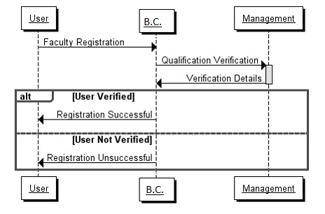

**Notice**

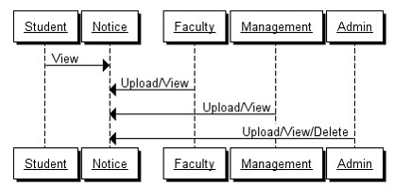

**Files (Assignments)**

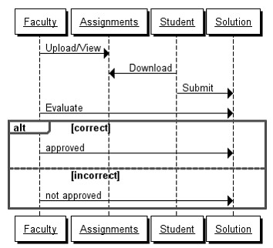

**Files (Lecture)**

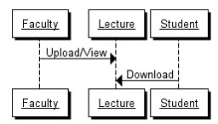

**Files (General)**

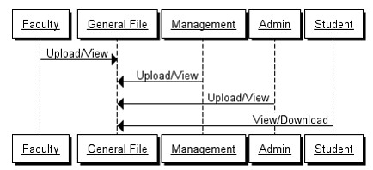

**Examination**

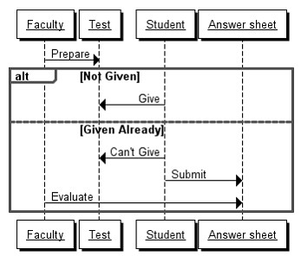

**Adding Courses**

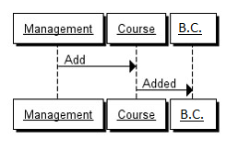

**Data Description**

**1. Table Name: - Course**

**Description: - Course Form**

**Used By: - Admin**

**Structure:-**

|  |  |  |
| --- | --- | --- |
| Field Name | Data Type | Description |
| Course_Id | Int | Primary Key |
| Cname | Varchar(20) |  |
| Duration | Int |  |
| Assignmentents | Int |  |

2**. Table Name: -Exam**

**Description: - Exam Form**

**Used By: - User**

**Structure:-**

|  |  |  |
| --- | --- | --- |
| Field Name | Data Type | Description |
| Exam_Id | Int | Primary Key |
| Column1 | Char(5) |  |
| Course_Id | Int | Foreign key |
| Subject_Id | Int | Foreign key |
| Organized By | Varchar(30) |  |
| Test Paper | Varchar(max) |  |
| Evaluated | Int |  |

**3. Table Name: - Student**

**Description: - Registration Form**

**Used By: - User**

**Structure:-**

|  |  |  |
| --- | --- | --- |
| Field Name | Data Type | Description |
| Student_Id | Int | Primary Key |
| User_Id | Varchar(20) | Foreign key |
| Name | Varchar(20) |  |
| DOB | Date |  |
| E-mail Primary | Varchar(20) | Not null |
| E-mail Secondary | Varchar(20) | Null able |
| ContectNo First | Int(10) | Not Null |
| ContactNo Second | Int(10) | Null able |
| Address | Varchar(50) | Not null |
| Father Name | Varchar(30) |  |
| Occupation | Varchar(10) |  |
| Course_Id | Int | Foreign key |
| Start Date | Date |  |
| Completion Date | Date |  |

1. **Table Name: -User**

**Description: - Login Form**

**Used By: - User**

**Structure:-**

|  |  |  |
| --- | --- | --- |
| Field Name | Data Type | Description |
| User_Id | Varchar(20) | Primary Key |
| Password | Varchar(15) |  |
| Level | Int |  |

1. **Table Name: -Notice**

**Description: - Notice Form**

**Used By: - User**

**Structure:-**

|  |  |  |
| --- | --- | --- |
| Field Name | Data Type | Description |
| Notice_Id | Int | Primary Key |
| Key Word | Varchar(max) |  |
| Description | XML |  |
| Posted To | Varchar |  |
| Posted By | Varchar(20) | Foreign key |
| Posting Date | Date |  |
| Expireson | Date |  |
| Title | XML |  |
| Archived | Int |  |

1. **Table Name: - Faculty**

**Description: - Registration Form**

**Used By: - Admin**

**Structure:-**

|  |  |  |
| --- | --- | --- |
| Field Name | Data Type | Description |
| Faculty_id | Varchar (20) | Primary Key |
| User_Id | Varchar(20) | Foreign key |
| Name | Varchar(20) |  |
| DOB | Date |  |
| Email Primary | Varchar(20) | Not Null |
| Email Secondary | Varchar(20) | Null able |
| Contact No | Int(10) |  |
| Address | Varchar(30) |  |
| Qualification | Varchar(max) |  |
| Appointed By | Varchar(20) |  |
| Course_Id | Int | Foreign key |
| Subject_Id | Int | Foreign key |

1. **Table Name: - Designation**

**Description: - Designation Form**

**Used By: - User**

**Structure:-**

|  |  |  |
| --- | --- | --- |
| Field Name | Data Type | Description |
| Id | Int | Primary Key |
| Name | Varchar(20) |  |

1. **Table Name: -Subject**

**Description: - Subject Form**

**Used By: - Admin**

**Structure:-**

|  |  |  |
| --- | --- | --- |
| Field Name | Data Type | Description |
| Subject_Id | Int | Primary key |
| Course_Id | Int | Foreign key |
| SubjectName | Varchar(20) |  |
| Syllabus | Varchar(max) |  |
| Requirement | int |  |

1. **Table Name: - Evolution**

**Description: - Evolution Form**

**Used By: - User**

**Structure:-**

|  |  |  |
| --- | --- | --- |
| Field Name | Data Type | Description |
| Exam_Id | Int | Foreign key |
| Student_Id | Int | Foreign key |
| Submission | Date |  |
| File Name | Varchar(20) |  |
| Evaluated | Int |  |
| Column1 | Char(5) | Foreign key |

1. **Table Name: - Files**

**Description: - Files Form**

**Used By: - User**

**Structure:-**

|  |  |  |
| --- | --- | --- |
| Field Name | Data Type | Description |
| File_Id | Int | Primary Key |
| Key Word | Varchar(20) |  |
| Filename | Varchar(20) |  |
| Uploaded By | Varchar | Foreign key |
| Uploaded To | Varchar | Foreign key |
| Uploaded For | Varchar() |  |
| Uploaded date | Date |  |
| Expires By | XML |  |
| Archived | Int |  |
| Discussion Time start | Time |  |
| Discussion Time End | Time |  |

1. **Table Name: - Report**

**Description: - Report Form**

**Used By: - User**

**Structure:-**

|  |  |  |
| --- | --- | --- |
| Field Name | Data Type | Description |
| Report_Id | Int | Primary key |
| Exam_Id | Int | Foreign key |
| Evaluated By | Varchar(20) | Foreign key |
| Evaluated For | Varchar(20) | Foreign key |
| Report | Varchar(max) |  |
| Date | Date |  |
| Column1 | Char(5) |  |

1. **Table Name: - Management**

**Description: - Registration Form**

**Used By: - User**

**Structure:-**

|  |  |  |
| --- | --- | --- |
| Field Name | Data Type | Description |
| Management_Id | Int | Primary Key |
| User_id | Varchar | Foreign key |
| Name | Varchar |  |
| DOB | Date |  |
| Email | Varchar |  |
| Contact No | Int |  |
| Address | Varchar |  |
| Designation_Id | Varchar | Foreign key |

### Security issues

The system security problem can be divided into four related issues-Security, Integrity, Privacy, confidentiality.

**System security**: refers to the technical innovations and procedures applied to the hardware and operating systems to protect against deliberate or accidental damage from a defined threat. In contrast data security is the protection against data from loss disclosure modification and destruction.

**System integrity:** refers to the proper functioning of hardware and programs, appropriate physical security, and safe against external threats such as eavesdropping and wire-tapping. In contrast data integrity makes sure that data do not differ from their original form and have not been accidentally or intentionally disclosed, altered or destroyed.

**Privacy:** defines the rights of the users or organizations to determine what information they are willing to share with or accept from others and how the organization can be protected against unwelcome, unfair or excessive dissemination of information about it.

**Confidentiality:** is a special status given to sensitive information in a database to minimize possible invasion of privacy. It is an attribute of information that characterizes its need for protection.

**Control Measures:** After system security risks have been evaluated, the next step is to select the measures that are internal and external to the facility. The measures are generally classified under the following:

**Identification** There are three schemes for identifying persons to the computer:

Something you know *-* such as password. A password is the most commonly used means for authenticating the identity of people. Passwords should be hard to guess and easy to remember.

**Access Control:** Various steps are taken to control access to a computer facility. One way is to use an encoded card system with a log-keeping capability. Encryptionis and effective and practical way to safeguard datatransmitted over an unprotected communications channel

**Audit Controls:** It protects a system from external security breaches and internal fraud or embezzlement. The resources invested in audit controls, however, should balance with the sensitivity of the data being manipulated. One problem with audit controls is that it is difficult to prove their worth until the system has been violated or a company officer imprisoned. For this reason, audibility must be supported at all management levels and planned into every system

**System Integrity:** It is a line of defense that concentrates on the functioning of hardware, database and supportive software, physical security and operating procedures. The most costly software loss is program error. It is possible to eliminate such error through proper testing routines. Parallel runs should be implemented whenever possible. Physical security provides safeguards against the destruction of hardware, databases, and documentation- fire, flood, theft, sabotage, and eavesdropping, and loss of power through proper backup.

## CONCLUSIONS

1. **Conclusion**

This project has great scope in future because in today’s world scenario people are moving towards internet for fulfilling their small needs. And we all know that “learning is the process” which never ends. So this application gives users a very good opportunity to share information and knowledge in a systematic way by using this website.

This project has been developed keeping in mind that user may use the system to a long period of time with equal efficiency. In ever changing world this might not be possible. But all these problems have been kept in mind and the system is developed accordingly.

1. **Limitations of this Project**

The limitation of this project is –

1. This project is web based application so without networks its not work properly.
2. In this project there is also some videos tutorial which required more speed so smooth videos play.
3. Video Confrencing between learner and trainer is not possible.

**5.3 Future Enhancement**

1. Students can choose courses, attend lectures, take exams, view their attendance records, progress reports etc as per their convenience.
2. Attend lectures either at the scheduled time or on request view lecture at a later time.
3. Faculties can take lectures, upload assignments, announcements, evaluate answer sheets and also can upload lectures and other discussions in various formats as in videos, power point presentation etc.
4. Upload and Download of various assignments, college notices, student's notices, journals, videos.
5. Real Time collaboration among Users via **Chat Rooms**, shared and interactive **Whiteboards**.
6. **Asynchronous communication** in the form of Emails, discussion boards that enable communication to occur at "convenient-times" that suit student schedules and are not accessed at simultaneous or prearranged times.
7. There can be **Forums**, **Blogs** etc to discuss various queries and to put up suggestions posted both by students and teachers.
8. Administrator can generate reports, log files, backup/recovery of data at any time.
9. Shared documents and media library that can help in active learning of a student.
10. Images library.
11. One-to-Many, Many-to-One and Many-to-Many information sharing.
12. Availability of **Voice Mail Box** to allow faculties to get the descriptive

messages left by the students.

1. Provision of resources to arouse the interest of students in extracurricular

activities like public speaking etc and to grasp the chance to enhance their

personalities.

1. Students can take up various quizzes which can help them to realize their inbuilt talents in various fields.

## REFERENCES

There are some study materials which is used by us to develop our application software, which are as follows:

**Books**

* IGNOU Study Materials.
* Microsoft Sql Server :
* Tata McGraw-Hill Publishing Company Limited, New Delhi
* PL/SQL ( By Ivan N. Bayross),BPB Publications, New Delhi
* Introduction to System Analysis and Design, Third Edition (BY I T Hawryszkiewycz) Prentice-Hall of India Pvt. Ltd New Delhi.

**Internet Sites**

* [*www.programmingtutorials.com*](http://www.programmingtutorials.com)
* [*www.thecodeproject.com*](http://www.thecodeproject.com)
* *http://stackoverflow.com*
* [*www.brothersoft.com*](http://www.brothersoft.com)
* *http://en.wikipedia.org*

**Software Tutorials**

* + - Microsoft Developer Network (MSDN) Library Help Visual Studio .NET 2010 release

PROJECT

REPORT

TITLE OF PROJECT

**“Brain Cafe”**

**BEST PLATFORM FOR SELF LEARNING**

**1.INTRODUCTION**

This website is designed to provide students an opportunity to integrate knowledge and skills acquired throughout the study and to apply them to the improvement of their knowledge. In current system, user gathered books of different writers or publications from different resources, read them, solve the questionnaires, match the answer to check their knowledge in that subject. It is a tedious job in which user wastes its manpower and money. Beside this, solve different questionnaires from various books to test our skills is a time consuming process. The website provides facility to the user to test their knowledge in a subject in a simple manner. In this system user can register itself by paying a small amount to the owner of site. When user registers itself, it can choose its interested course and related subject to test its skills in that subject through just one click. This website provides an easy and fast method to retrieve our knowledge and test our skills. The key goal of the site is to save user’s manpower time and money also. The main objective behind developing the website is to offer the user a simple way to test their knowledge. The project is divided in following different module-

* User Registration
* Sign In
* Content search
* Result
* Examination

**2.OBJECTIVES**

In current system a lot of manpower is wastes in collecting books and read them. Few books are so expensive, that a normal user can’t afford it. Maintenance and caring of books is also an important task which is a tiring process. Report generation in current system is a typical job. Searching for answers to test our skills is also a cumbersome process. Retrieval of info (answer) is very slow, users have to read all topics related to question for finding an appropriate answer. In short, we can say that in current system user misuses its lot of time money and manpower in searching and reading to test their skills.

**Goals:-**

* Reduce the effort in solve questionnaires.
* Complete working is in computerized manner.
* Cost effective, it avoids the extra cost wastes in collecting various books.
* Report generation is easy, data handling is simple. .
* Manpower is reduced because user can test its skills in just one click.
* Provide security of data, unauthorized access is denied.

**3. SYSTEM ANALYSIS**

**3.1 Identification Of Need:-**

The complete understanding of software requirements is essential to the success of a software development effort. The requirements analysis task is a process of discovery, refinement modelling and specification. The software scope initially established by the system engineer and refined during software project planning is refined in detail. Modular of the required data, information and control flow, and operational behaviour are created. Alternative solution are analyzed and allocated to various software elements.

Both developer and customer take an active role in requirements analysis and specification. The customer attempts to reformulate a sometimes-nebulous concept of software function and performance into concrete detail. The developer acts as interrogator consultant and problem solver.

Requirements analysis is a software engineering task that bridges the gap between system level software allocation and software design.

Requirement analysis enables the system engineer to specify software function and performance indicate software’s interface with other system elements and establish constraints that software must meet.

**Software requirements analysis**may be divided into five areas of effort:

**(a)** Problem recognition.

**(b)** Evaluation and synthesis

**(c)** Modelling

**(d)** Specification

**(e)** Review

Initially, the analyst studies the system specification and the software project plan. Problem evaluation and solution synthesis is the next major area of effort for analysis. Upon evaluating current problems and desired information (input and output) the analyst begins to synthesize one or more solutions.

During the evaluation and solution synthesis activity, the analyst creates Visit of the system in an effort to better understand data and control flow, functional processing and behavioural operation, and information content. The model serves as a foundation for software design and as the basis for the creation of a specification for the software.

**3.2Preliminary Investigation:-**

Present system is manual. The working of the organization May be described as:

All details of Customer, account and Registration etc are maintained in registers. All deposits & loans are also maintained in registers. All Bills are manually created, and send at desired place for further use. The daily-to-daily entries are also being manually.

Preliminary investigation took me to the Accounts room of the bank, where I came across the current working process. Although the process of maintaining data is not a recorded one as such there were no documents to be reviewed in order to determine efficacy of the current working process. So I had to emphasize on the observation I made while in the office. In order to complement my onsite observations I undertook a simple interview of office bearers. The results of which are broadly catalogued below.

In concurrence with onsite observation I conducted some interviews. To get a closer look at the present working culture and identify the problem domain I talked to some of office bearers. I presented them with the following set of questions.

**Questionnaire:**

**Some general questions-**

**1**.Who is behind the request for this work?

**2.**Who will use the software?

**3.**Why do you want this software?

**4**.Can you show me the environment in which the software will be used?

**5**.What is your requirement?

**6.**What will be the economic benefit of a successful solution?

**Other question about software-**

**1. What do you feel is the biggest bottleneck in your work?**

**Ans**.The slow working process of the work due to high number of calculations.

**2. What effect does it have on your work?**

**Ans**.Usually it delays our work. As such we have to prepare ourselves 3 to 4 days beforehand to say the least.

**3. Are you always satisfied with your results?**

**Ans.**No because it hardly leads to a conclusive result rather generating further queries. Also the bulk of work sometimes forces us to limit our capabilities and skip through some material and information since they may not be available.

**3.3 Feasibility Study:**

Before getting started on the new system it was important to determine the feasibility involved in the developed system so that the new system development could be develop. Feasibility is the determination of whether or not a project is not worth doing. The project followed in making this determination is called a feasibility study. This type of study determines if a project can and should Be Taken. Once it has been determined that project is feasible, the analyst can go ahead and the prepare the project specification which finalizes project requirements.

Generally, feasibility studies are undertaken within tight time constraints and Normally culminate in a written and feasibility report.

The developed system is started after considering the main three type of feasibilities which are discussed below: -

**1)-Technical feasibility**  
**2)-Operational feasibility**

**3)-Economic feasibility**

# 1) Technical Feasibility:

As we know the technical feasibility is concerned with specifying equipment and software that will successfully satisfy the user requirement. The technical needs of the system may very considerably, but might include:

* The facility to produce outputs in a given time.
* Response time under certain conditions.
* Ability to process a certain volume of transaction at a particular speed.
* Facility to communicate data to distinct location.

In examination technical feasibility, configuration of the system is given more importance than the actual make of hardware. The configuration should give the complete picture about the system’s requirements: How many workstations are required, how these units are interconnected so that they could operate and communicate smoothly.

#### 2) Economic Feasibility:

Economic analysis is the most frequently used technique for evaluating the effectiveness of a proposed system. More commonly known as cost/benefits analysis the procedure is to determine the benefits and savings that are expected from a purposed system and compare with costs.

If benefits outweigh cost, a decision is taken to design and implement the system otherwise further justification or alternative in the proposed system will have to be made if it is to have a chance of being approved. This is an ongoing effort that improves in accuracy at each phase of the system life cycle.

The analysis part also clears the doubt of economic problems could be possible in developing the system. As already mentioned that the company has to just pay the developed software cost and not other investment is needed at the time of implementation of the new system as the preliminary requirement are already exist in the company.

Since the cost difference between the present system and the new proposed computerized system will be large. Considering the fact that new system will require only one time monetary investment whereas the present system keeps on adding to the cost in a daily basis. We can conclude that the breakeven point will be reached

Within a year, making this proposed computerized news management system economically feasible.

**3) Operational Feasibility:**

Proposed projects are beneficial only if they can be turned into information system that will meet the operating requirements of the organization. This test of feasibility asks if the system will work when it developed and installed. Are there major barriers to implementation? Some of the important questions that are useful to test the operational feasibility of a project are given below:

* Is there sufficient support for the project from the implementation? From user? If the present system is well liked and used to the extent that persons will not be able to see reasons for change, there may be resistance.
* Are current business methods acceptable to the user? If they are not, user may welcome a change that will bring about a more operational and useful system.
* Have the user been involved in the planning and development of the project? If they are involved at the earliest stage of project development, the chances of resistance can be possibly reduced.
* Will the proposed system cause harm? Will it produce poorer result in any case or area? Will the performance of staff member fall down after implementation?

Issue that appears to be quite minor at the early stage can grow into major problem after implementation. Therefore, it is always advisable to consider operational aspects carefully. The system is developed in keeping mind that it should be user friendly and easy to operate hence the system is operational feasible.

**3.4 Project Scheduling:**

**(a) Pert Chart:-** A PERT chart is a graph-based chart. It can be used to determine the activities that from the “critical path”, which if delayed will cause the overall project to delay. The PERT chart for the project is:

|  |  |  |  |  |
| --- | --- | --- | --- | --- |
| **Phases** | **Old Project** | | **New Project** | |
| **No. Of Days** | **Extra Days** | **No. Of Days** | **Extra Days** |
| Fact finding | 15 | 5 | 10 | 3 |
| Analysis | 20 | 3 | 15 | 5 |
| Designing | 25 | 5 | 20 | 5 |
| Coding | 20 | 5 | 20 | 5 |
| Testing | 10 | 2 | 10 | 2 |
| Maintenance | 35 | 10 | 32 | 10 |

**(b) Gantt Chart:-**

A standard technique employed in recent times to keep track of a project's progress is the Gantt chart named after the industrial engineer Henry Gantt (1861-1919). They are easy to draw, easy to understand and readily adaptable to other planning approaches (e.g. Pert Charts).

As seen below this type of chart shows the start and end of a number of tasks and shows their timing relationship relative to each other.

The bar for each task stretches from the starting date of the task to the end of the task. The bars can be colour coded to show if the task is running behind schedule or based on resources required for the task.

Each task displayed in the GANTT chart is listed below:

* 1. **Identify needs and benefits**Identification of Need and Project ConstraintsMeet with customersEstablish Product Statement**Milestone**:Product Statement defined
  2. **Preparing Feasibility Study**

**Milestone**: Feasibility Study Completed

* 1. **Preparing Software & Hardware Requirement Study**Define Software ScopeInformation DescriptionFunctional DescriptionBehavioural DescriptionValidation Criteria

Hardware Requirement Study**Milestone**: SHRS Complete

* 1. **Define desired output/control/input (OCI)**Define Keyboard functions

Define modes of interaction

Define document diagnosis

Define import functions

Review OCI with customer

**Milestone**:OCI defined

* 1. **Isolate software elements**

**Milestone**: Software elements defined

* 1. **Research availability of existing software**Research text editing componentsResearch image editing componentsResearch MS Word document migration components**Milestone**:Reusable components identified
  2. **Database preparationMilestone**:Database preparation complete
  3. **CodingMilestone**: Coding completes
  4. **Implementation of System Security MeasuresMilestone**: System Security Measures implemented

**2.0 Testing Software**

**Milestone**: Testing Software Complete

**3.5Software Requirement Specifications (SRS):-**

The software requirements specification is produced at the culmination of the analysis task. The function and performance allocated to software as part of system engineering are refined by establishing a complete information description a detailed functional and behavioural description, a indications of performance requirements and design constraints, appropriate validation criteria and other data pertinent to requirements.

**1.** Introduction

a. Purpose

b. Scope

c. Definition, Acronyms, Abbreviations

d. References

e. Developer’s Responsibilities Overview

**2**. General Description

a. Vehicle Functions Overview

b. User Characteristics

c. General Constraints

d. General Assumptions and Dependencies

**3.** Specific Requirements

a. Inputs and Outputs

b. Functional Requirements

c. External Interface Requirements

d. Performance Constraints

e. Design Constraints

* + 1. Software Constraints
    2. Hardware Constraints

**4.** Validation and Criteria

a. Performance bounds

b. Classes of tests

c. Expected Software response

d. Special Considerations

**5.** Acceptance Criteria

**1. Introduction: -**

This is the requirements document for the project that will be used throughout the work. The system to be developed is for financial work of bank, based on the inputs given. This document follows the IEEE standard for a requirement specification document, with some variations.

**a). Purpose:**

The purpose of this document is to describe the requirements of agency. It also describes the interfaces for the system.

**b). Scope:**

This document is the only one that describes the requirements of the system. It is meant for use by the developers and will be the basis for validating the final delivered system. Any changes made to the requirements in the future have to go through a formal change approval process. The developer is responsible for asking for clarifications, where necessary, and will not make any alterations without the permission of the client.

**c). Definitions, Acronyms, Abbreviations:**

Not applicable.

**d). References:**

Not applicable.

**e). Developer’s Responsibilities Overview:**

The developer is responsible for (i) developing the system, (ii) installing the software on the client’s hardware, (iii) conducting any user training that might be needed for using the system, and (iv) maintaining the system for a period of one year after installation.

**2. General Description: -**

**a). Functions Overview:**

In agency there is a counter for booking and various queries of the customers can be solved with ease on one table. As the software provide all information customers, registration etc provided by the bank.

**b). User Characteristics:**

The main users of this system will be the registration department and accounts department, who are somewhat literate with computers and can use programs efficiently.

**c). General Constraints:**

The system should run on win 95 /98/2000 or above.

**d). General Assumptions and Dependencies:**

Not applicable.

**3. Specific Requirements:-**

**a). Inputs and Outputs:**

The system has all the details regarding the Customer, account & Registration etc are maintained etc. The system has several inputs in form of data entry and several outputs in form of bills, reports etc.

Here also, the customer gets the desired registration and all the details are maintained.

**b). Functional Requirements:**

It presents a description of each function required to solve the problem. A processing narrative is provided for each function, design constraints are stated and justified, performance characteristics are stated, and one or more diagrams are included to graphically represent the overall structure of the software and interplay among software functions and other system elements under this topic, the functional working of the various modules where give the complete picture for the data flow from one location to other.

**c). External Interface Requirements:**

Only one user command is required. The file name must be prompted by the system in status bar.

**d). Performance Constraints:**

The reports and bills should be printed in less than 1 minute.

**e). Design Constraints:**

The system is to run under the WINDOWS operating system.

**4. Validation Criteria:-**

Probably the most important section of a software requirements specification is validation Criteria. The specification of validation criteria acts as an implicit review of all other requirements. The tests must be conducted to validate function, performance and constraints.

In this project I have try the various steps in testing the links and connectivity of the data Directorate of public grievances takes up a grievances where it is satisfied that eh matter has not been dealt with by the concerned SSA in a fair, just or objective manner or has been unduly delayed. It may take up such a care for investigation, call for a report and or file from the concerned SSA and ask them to reconsider the matter and to arrive at a fair decision in a time bound manner.

**5.Acceptance Criteria:-**

Before accepting the system, the developer must demonstrate that the system works on the course data for the last 4 semesters. The developer will have to show through test cases that all conditions are satisfied.

**3.6Software Engineering Paradigm Applied:-**

To develop the system **Proto Type Modal** is applied as the company wanted to see the software development process and appearance of the software so that the idea of functionality of the system can be understood. The software developed in three phases in first phase the dry proto type is developed in which after the analysis the screens are designed and no validations are performed and also no database functionality is incorporated. After the demonstration of dry proto type suggestions from the client are noted and the development process is moved to the second phase i.e. wet prototype the actual designed is incorporated, validations are performed and the software is submitted to the user for acceptance and testing and then after final submission of the software is produced with user manual. To under stand the better functionality of the Prototype modal the applied modal is described here given below:

###### **Prototype Type Model:-**

In general Customer defines a set of objectives for software, but does not identify detailed input, processing, or output requirements. In other cases, the developer may be unsure of the efficiency of an algorithm, the adaptability an operating system or the form the human machine interaction should have.

In such situations, a prototyping paradigm offers the best approach. The prototyping paradigm starts with requirements gathering. Developer and customer define the overall objectives for the software, identify requirements and outline areas where definition is necessary. A “quick design“ than focuses on aspects of the software that are visible to the customer /user. The quick design leads to the construction of a prototype. The prototype is evaluated by the customer/user and is used of refine requirement for the software to be developed. Iteration occurs, as the prototype is developed to satisfy the needs of the customer and enabling the developer to better understanding what needs to be done.

The prototype serves as a mechanism for identifying software requirements if a working prototype is built, the developer uses existing program fragments or applies tools to make working program quickly.

**3.7 Data Models:-**

**3.7.1.ER-Diagram:-**



* + 1. **Data Flow Diagram (DFD)**:-

A **DFD** provides no information about the timing or ordering of processes, or about whether processes will operate in sequence or in parallel. It is therefore quite different from a flowchart, which shows the flow of control through an algorithm, allowing a reader to determine what operations will be performed, in what order, and under what circumstances, but not what kinds of data will be input to and output from the system, nor where the data will come from and go to, nowhere the data will be stored (all of which are shown on a**DFD**).

**Zero Level DFD:-**

Enquires about marks detail

Logs in

Student

Examiner

Checks question paper

**ZERO LEVEL DFD**

DATA BASE

Provides answer to question

Enquires about centre

Provide centre detail

Enquires about course detail

Registered

Provides course detail

Provides question

Provide marks detail

Student detail report

Course detail report

Logs in

Verifies username and password

Provide solved question paper

update

**First Level DFD:-**

Student

Username &

Password

User details

Student

database

Course

database

Course details

Centre details

Exam paper

details

Answer

Administrator

Creates

Reports

Database

Centre

database

Marks detail

Reports

Marks info

Result

**First level DFD**

Marks

details

Checked

Question paper

details

Examiner

database

User details

Examiner

Username &

Password

**Second Level DFD:-**

Student

Username &

Password

User details

Student

database

Course

database

Course details

subject details

Selected

Course details

Centre details

Administrator

Creates

Reports

Database

Centre

database

Marks detail

Reports

Marks info

Result

**Second level DFD**

Marks

details

Checking

details

Examiner

database

User details

Examiner

Username &

Password

Student report

Student details

Upload

database

Uploaded

File

Centre

database

Question

details

Answer

**4.SYSTEM DESIGN**

**4.1Modularisation Details:-** This whole system is divided in various modules-:

* User Registration
* Sign In
* Content search
* Result
* Examination

**User Registration-:**This module is used for user registration. In this module, users fill the required information for registration. If user wants to be the permanent user they have to be paid the registration fee which is defined previously.

**Sign In-:**This module helps the user for login. When user registers itself they fill user name and their unique password. This module asks the user name and password and after recognizing the correct password it allow the user for login.

**Content Search-:**It is used for course and paper search when user login the site, it search for the course of its interest and after that it search for the subject related to the course for knowledge test.

**Result-:**This module shows the result of given question paper. When user submits the question paper, it shows the result, which contains the marks obtained by the user. It also contains a sheet which shows the correct and wrong answer.

**Examination-:**It is used for user examination. After login, when user selects the course and related subject of their interest it shows a question paper of that subject. Users tick the most appropriate answer which are given in the form of option and after completing the paper, it submits the paper on clicking submit option.

**4.2Data Integrity And Constraints:-**

Validation refers to a set of activities that ensure that software that has been built is traceable to customer requirements. Validation can be defined in many ways, but a simple definition is that validation succeeds when software functions in a manner that can be reasonably expected by the customer.

Some validation checks in the project are –

1. If the user name and password are incorrect, the box appears the message “**Invalid Username and Password! Try Again…** ”.
2. If user does not give any value in password field or username field it will show error message “**Please enter your password*”***.
3. Login form is case sensitive if user enters their name or password in wrong format then it will display the message.
4. If user enter primary key attribute that exist already in database then application displayed a message “**make sure to id already exist in record, enter a unique Id**”.
5. When user use Edit Command Button, if he/she not enter primary key attribute values then application displayed a message corresponding to each entry form.
6. All primary key attribute corresponding to each entry form

Textbox requires specific entry.

**4.3Procedural Design:-**

A database is a backbone of any computer based information system .**SQL-SERVER** issued as backend for this project .SQL-server can handle any type of data including text, image, sound, video and time series as well as traditional structured data .It is fully compatible with relational database.

This project is designed to manage large bodies of information. It also provides adequate measures for the database safety.It includes security features that control how a database is accessed and used. Other features include consistency and protection of data through locking mechanism.

Another important feature is the flexibility of the database structure at logical as well as at physical level. Any change can be incorporated without making large changes at user application level .To keep detailed information database uses following tables-

**Data Description**

**1. Table Name: - Course**

**Description: - Course Form**

**Used By: - Admin**

**Structure:-**

|  |  |  |
| --- | --- | --- |
| Field Name | Data Type | Description |
| Course_Id | Int | Primary Key |
| Cname | Varchar(20) |  |
| Duration | Int |  |
| Assignmentents | Int |  |

2**. Table Name: -Exam**

**Description: - Exam Form**

**Used By: - User**

**Structure:-**

|  |  |  |
| --- | --- | --- |
| Field Name | Data Type | Description |
| Exam_Id | Int | Primary Key |
| Column1 | Char(5) |  |
| Course_Id | Int | Foreign key |
| Subject_Id | Int | Foreign key |
| Organized By | Varchar(30) |  |
| Test Paper | Varchar(max) |  |
| Evaluated | Int |  |

**3. Table Name: - Student**

**Description: - Registration Form**

**Used By: - User**

**Structure:-**

|  |  |  |
| --- | --- | --- |
| Field Name | Data Type | Description |
| Student_Id | Int | Primary Key |
| User_Id | Varchar(20) | Foreign key |
| Name | Varchar(20) |  |
| DOB | Date |  |
| E-mail Primary | Varchar(20) | Not null |
| E-mail Secondary | Varchar(20) | Null able |
| ContectNo First | Int(10) | Not Null |
| ContactNo Second | Int(10) | Null able |
| Address | Varchar(50) | Not null |
| Father Name | Varchar(30) |  |
| Occupation | Varchar(10) |  |
| Course_Id | Int | Foreign key |
| Start Date | Date |  |
| Completion Date | Date |  |

1. **Table Name: -User**

**Description: - Login Form**

**Used By: - User**

**Structure:-**

|  |  |  |
| --- | --- | --- |
| Field Name | Data Type | Description |
| User_Id | Varchar(20) | Primary Key |
| Password | Varchar(15) |  |
| Level | Int |  |

1. **Table Name: -Notice**

**Description: - Notice Form**

**Used By: - User**

**Structure:-**

|  |  |  |
| --- | --- | --- |
| Field Name | Data Type | Description |
| Notice_Id | Int | Primary Key |
| Key Word | Varchar(max) |  |
| Description | XML |  |
| Posted To | Varchar |  |
| Posted By | Varchar(20) | Foreign key |
| Posting Date | Date |  |
| Expireson | Date |  |
| Title | XML |  |
| Archived | Int |  |

1. **Table Name: - Faculty**

**Description: - Registration Form**

**Used By: - Admin**

**Structure:-**

|  |  |  |
| --- | --- | --- |
| Field Name | Data Type | Description |
| Faculty_id | Varchar (20) | Primary Key |
| User_Id | Varchar(20) | Foreign key |
| Name | Varchar(20) |  |
| DOB | Date |  |
| Email Primary | Varchar(20) | Not Null |
| Email Secondary | Varchar(20) | Null able |
| Contact No | Int(10) |  |
| Address | Varchar(30) |  |
| Qualification | Varchar(max) |  |
| Appointed By | Varchar(20) |  |
| Course_Id | Int | Foreign key |
| Subject_Id | Int | Foreign key |

1. **Table Name: - Designation**

**Description: - Designation Form**

**Used By: - User**

**Structure:-**

|  |  |  |
| --- | --- | --- |
| Field Name | Data Type | Description |
| Id | Int | Primary Key |
| Name | Varchar(20) |  |

1. **Table Name: -Subject**

**Description: - Subject Form**

**Used By: - Admin**

**Structure:-**

|  |  |  |
| --- | --- | --- |
| Field Name | Data Type | Description |
| Subject_Id | Int | Primary key |
| Course_Id | Int | Foreign key |
| SubjectName | Varchar(20) |  |
| Syllabus | Varchar(max) |  |
| Requirement | int |  |

1. **Table Name: - Evolution**

**Description: - Evolution Form**

**Used By: - User**

**Structure:-**

|  |  |  |
| --- | --- | --- |
| Field Name | Data Type | Description |
| Exam_Id | Int | Foreign key |
| Student_Id | Int | Foreign key |
| Submission | Date |  |
| File Name | Varchar(20) |  |
| Evaluated | Int |  |
| Column1 | Char(5) | Foreign key |

1. **Table Name: - Files**

**Description: - Files Form**

**Used By: - User**

**Structure:-**

|  |  |  |
| --- | --- | --- |
| Field Name | Data Type | Description |
| File_Id | Int | Primary Key |
| Key Word | Varchar(20) |  |
| Filename | Varchar(20) |  |
| Uploaded By | Varchar | Foreign key |
| Uploaded To | Varchar | Foreign key |
| Uploaded For | Varchar() |  |
| Uploaded date | Date |  |
| Expires By | XML |  |
| Archived | Int |  |
| Discussion Time start | Time |  |
| Discussion Time End | Time |  |

1. **Table Name: - Report**

**Description: - Report Form**

**Used By: - User**

**Structure:-**

|  |  |  |
| --- | --- | --- |
| Field Name | Data Type | Description |
| Report_Id | Int | Primary key |
| Exam_Id | Int | Foreign key |
| Evaluated By | Varchar(20) | Foreign key |
| Evaluated For | Varchar(20) | Foreign key |
| Report | Varchar(max) |  |
| Date | Date |  |
| Column1 | Char(5) |  |

1. **Table Name: - Management**

**Description: - Registration Form**

**Used By: - User**

**Structure:-**

|  |  |  |
| --- | --- | --- |
| Field Name | Data Type | Description |
| Management_Id | Int | Primary Key |
| User_id | Varchar | Foreign key |
| Name | Varchar |  |
| DOB | Date |  |
| Email | Varchar |  |
| Contact No | Int |  |
| Address | Varchar |  |
| Designation_Id | Varchar | Foreign key |

FORMS

**4.4User Interface Design:-**

**HOME PAGE:-**

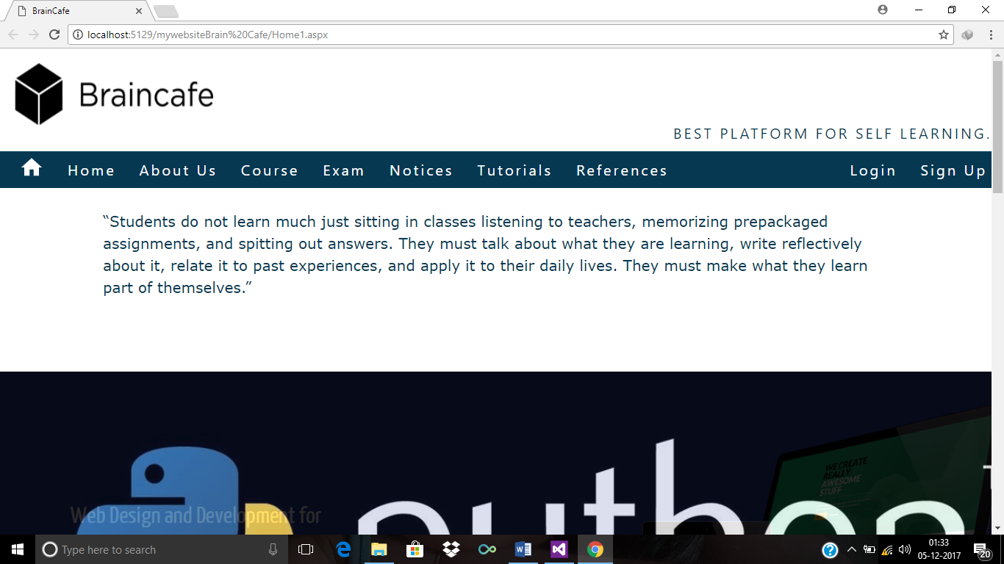

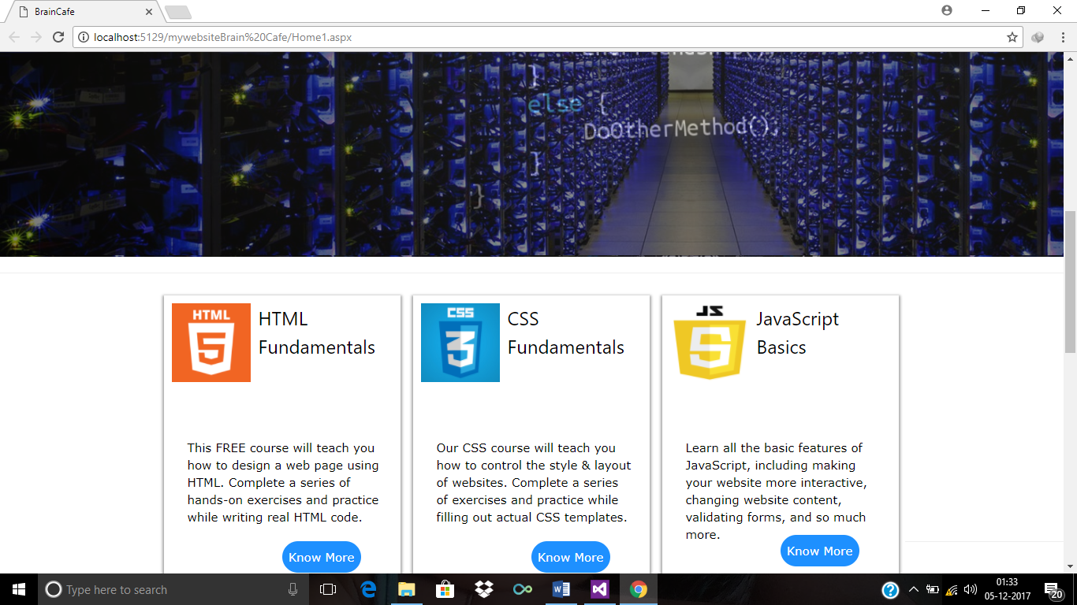

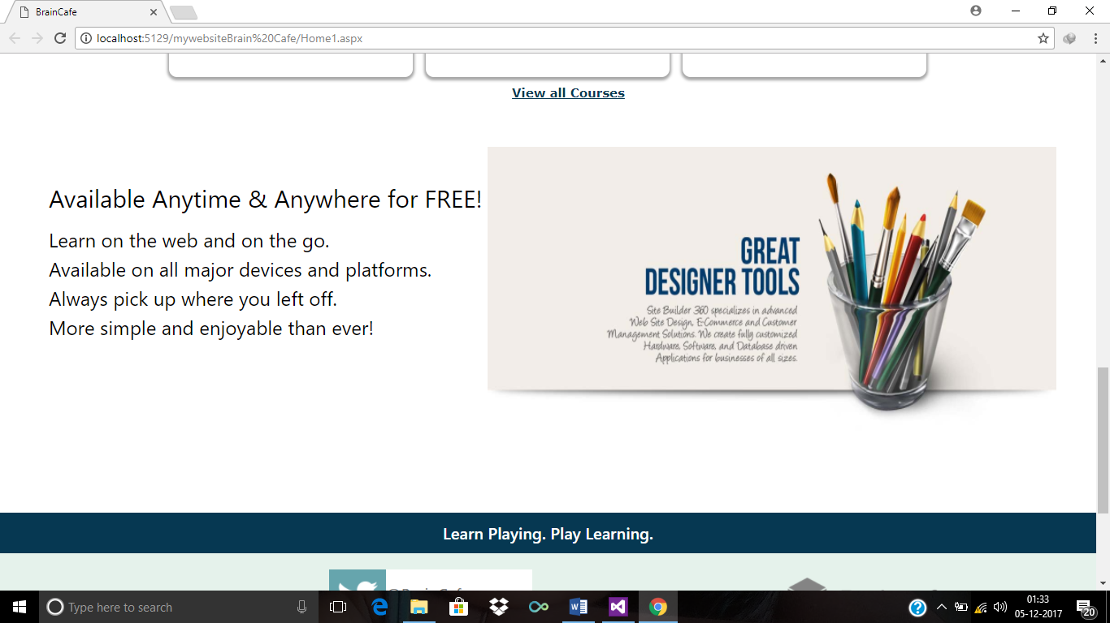

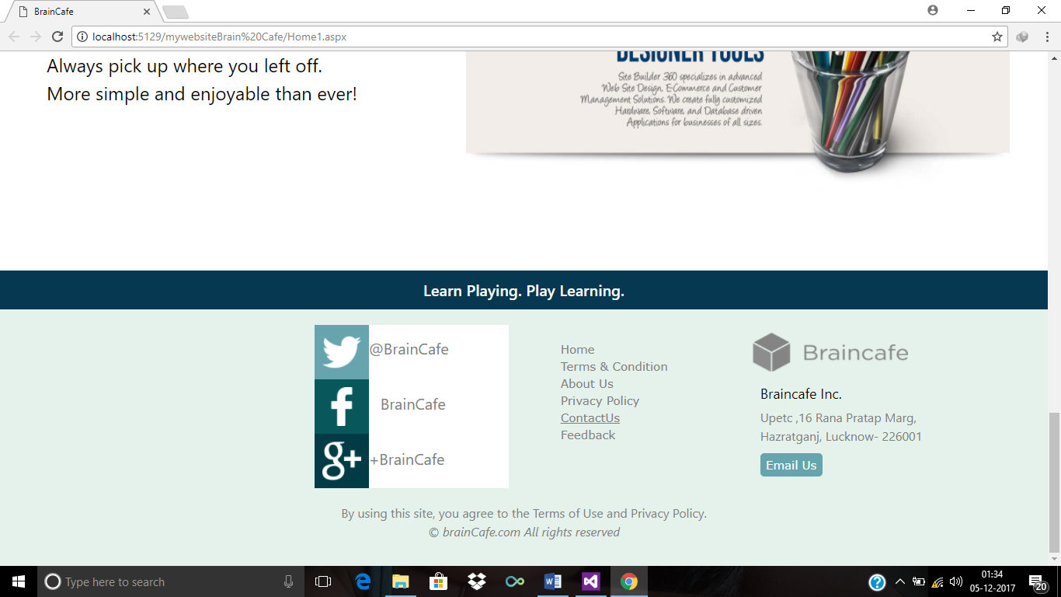

**ABOUT-US:-**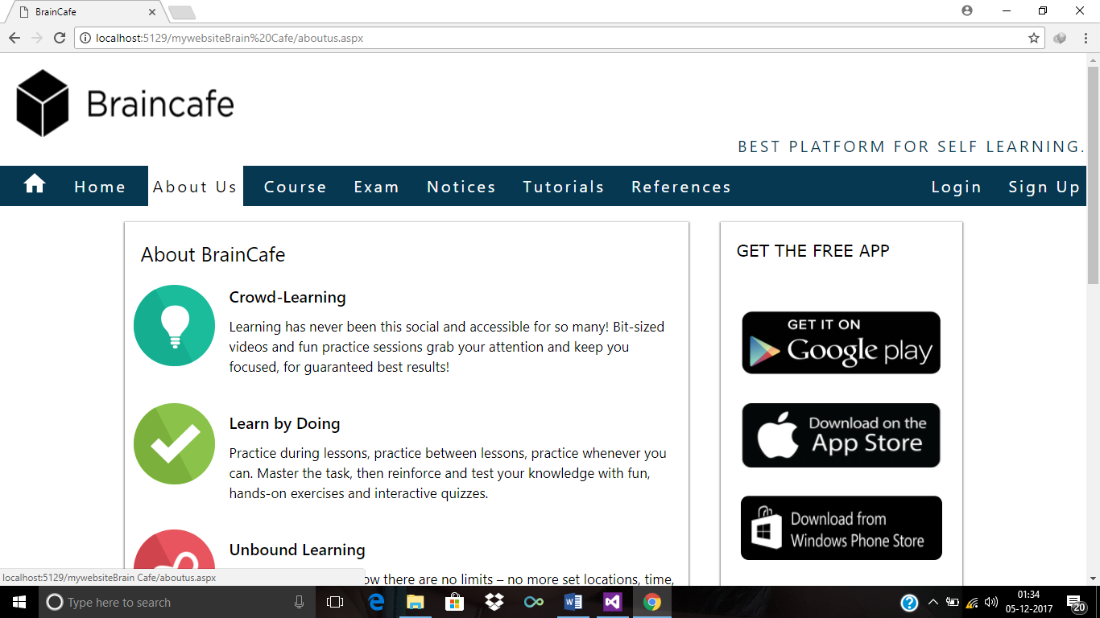

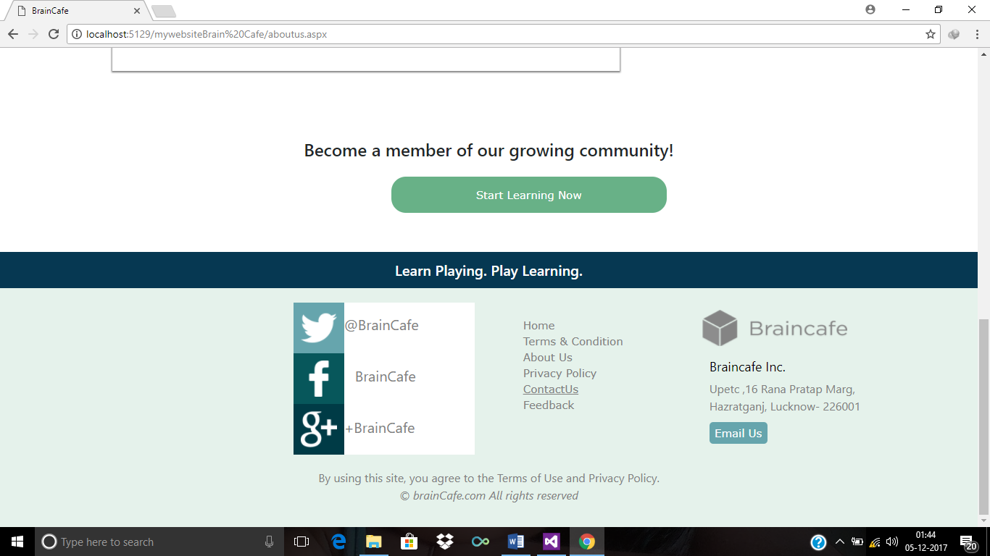

**COURSES:-**

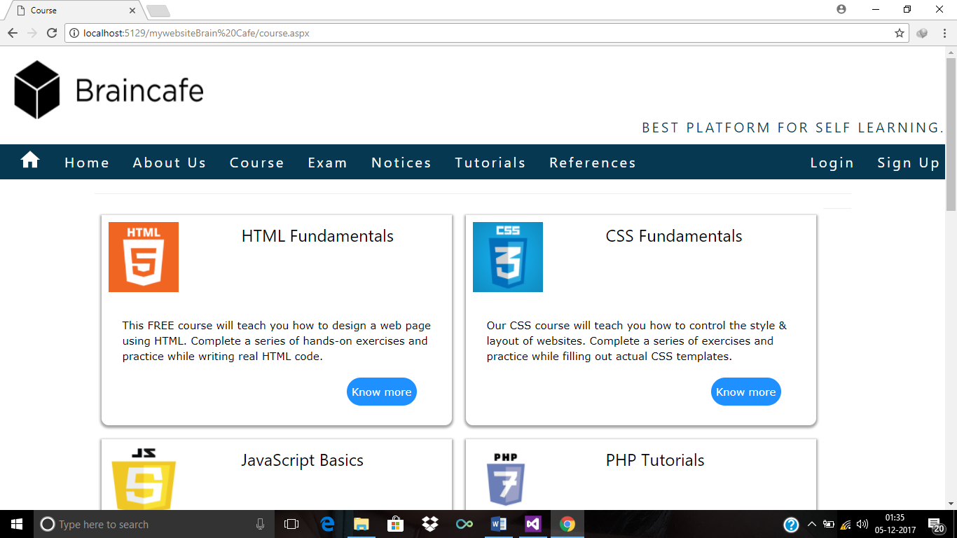

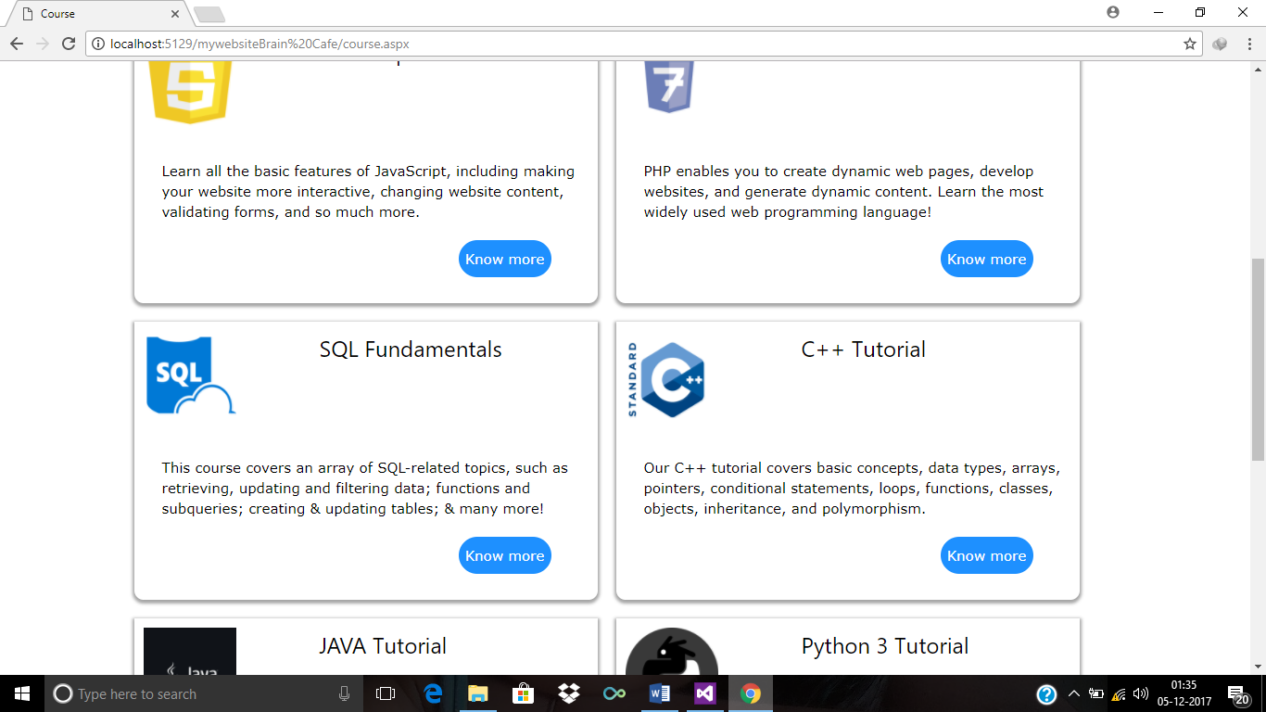

**CONTACT-US**

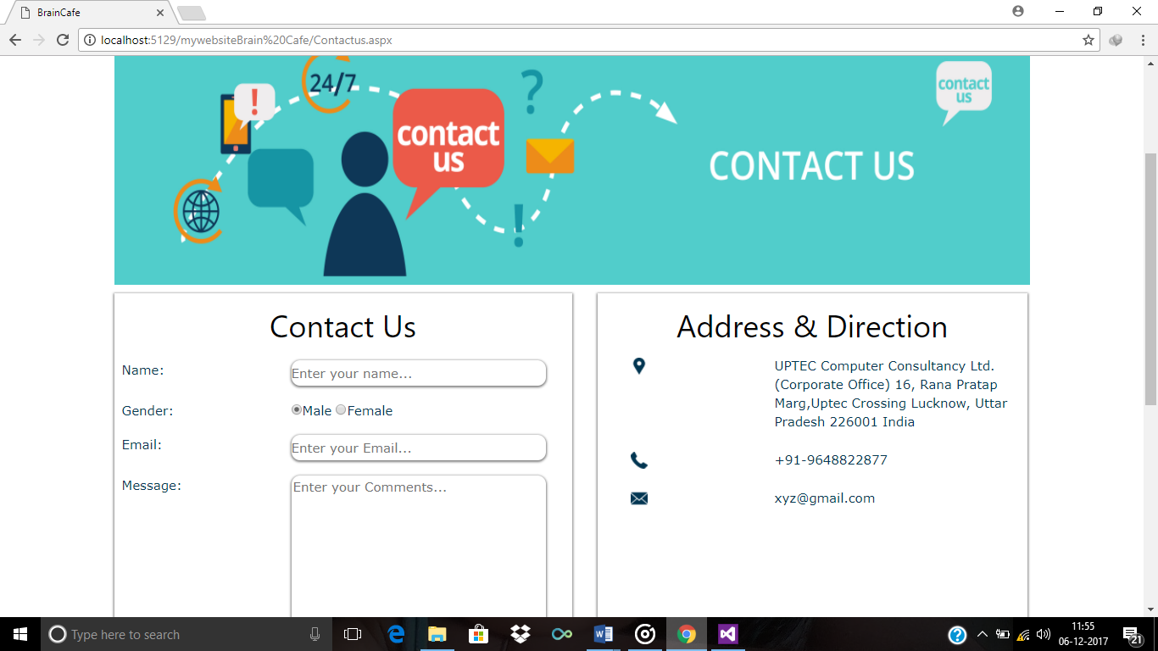

**SUBJECT STUDY MATERIAL:-**

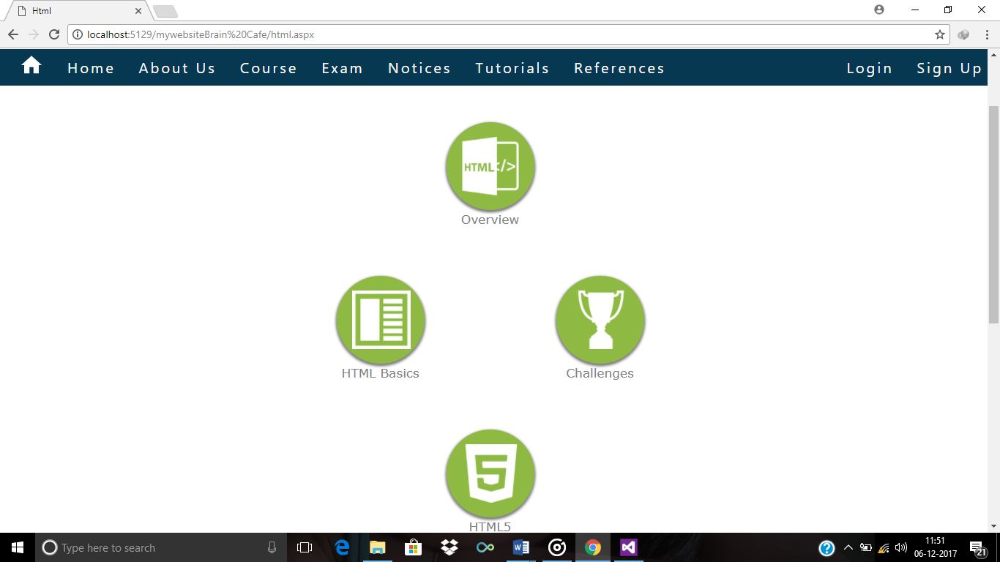

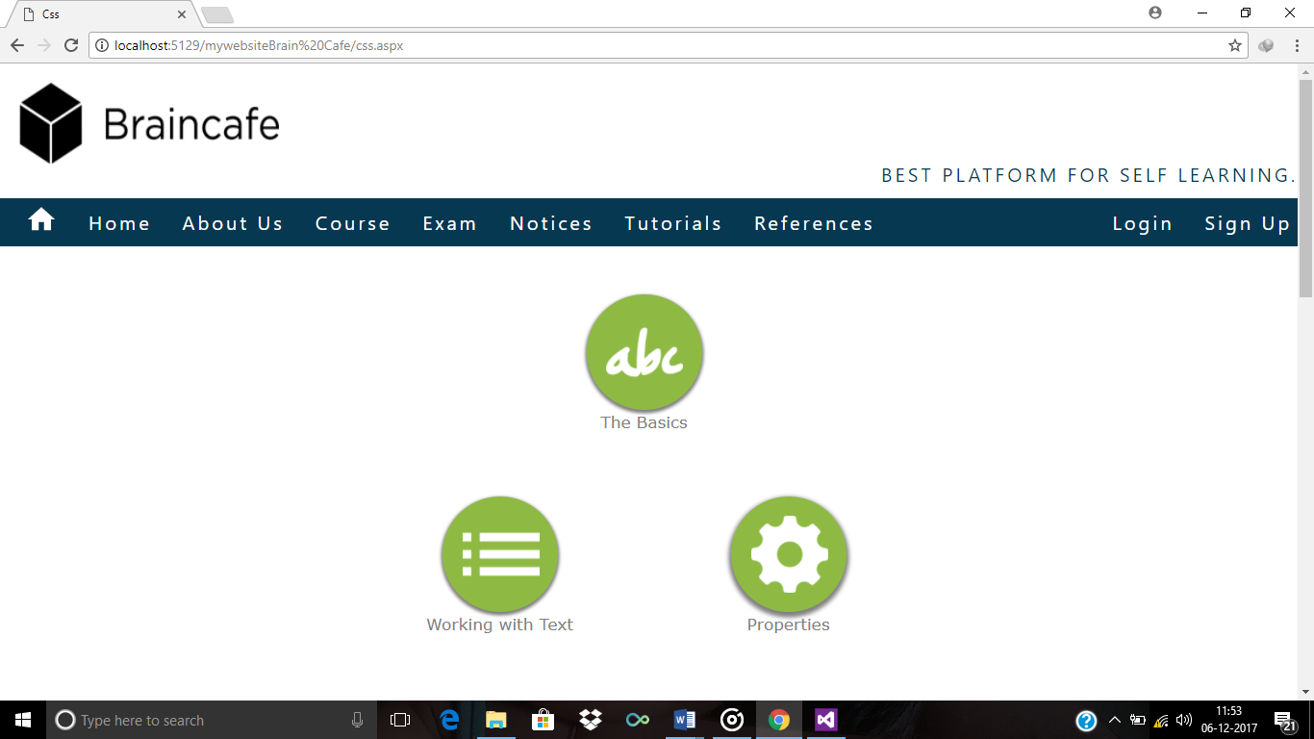

**TUTORIALS:-**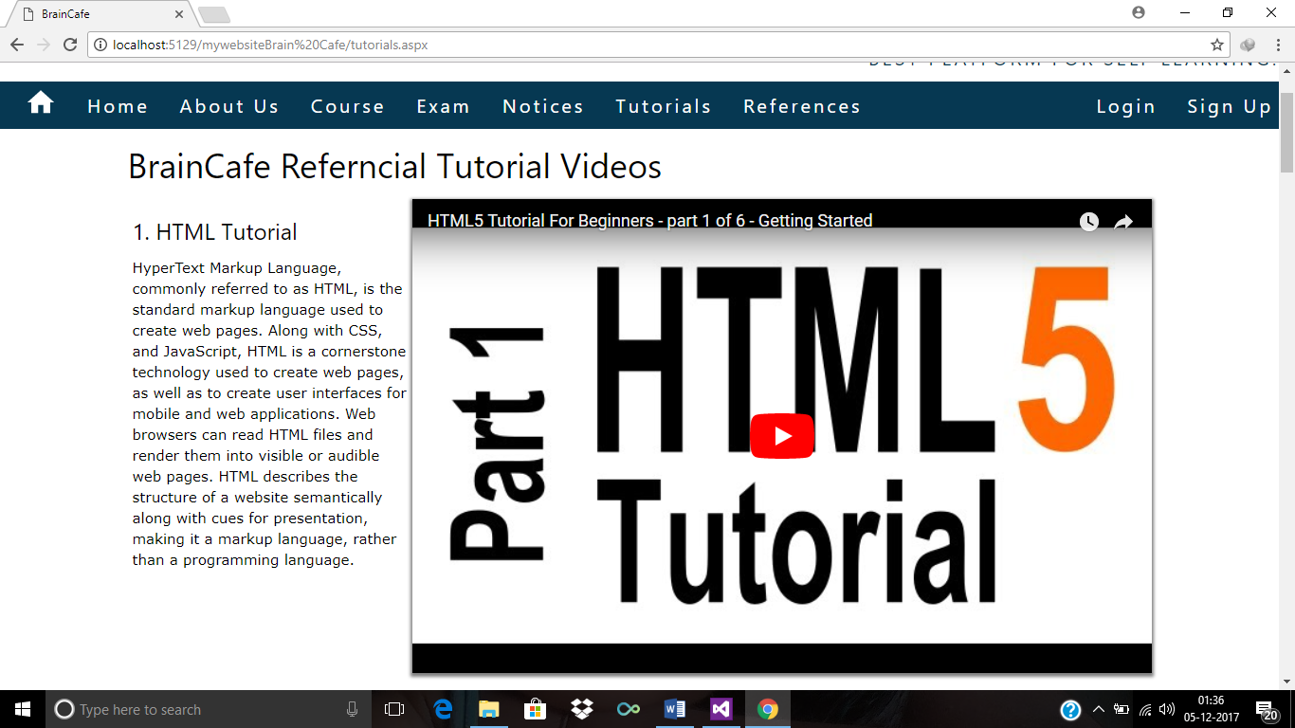

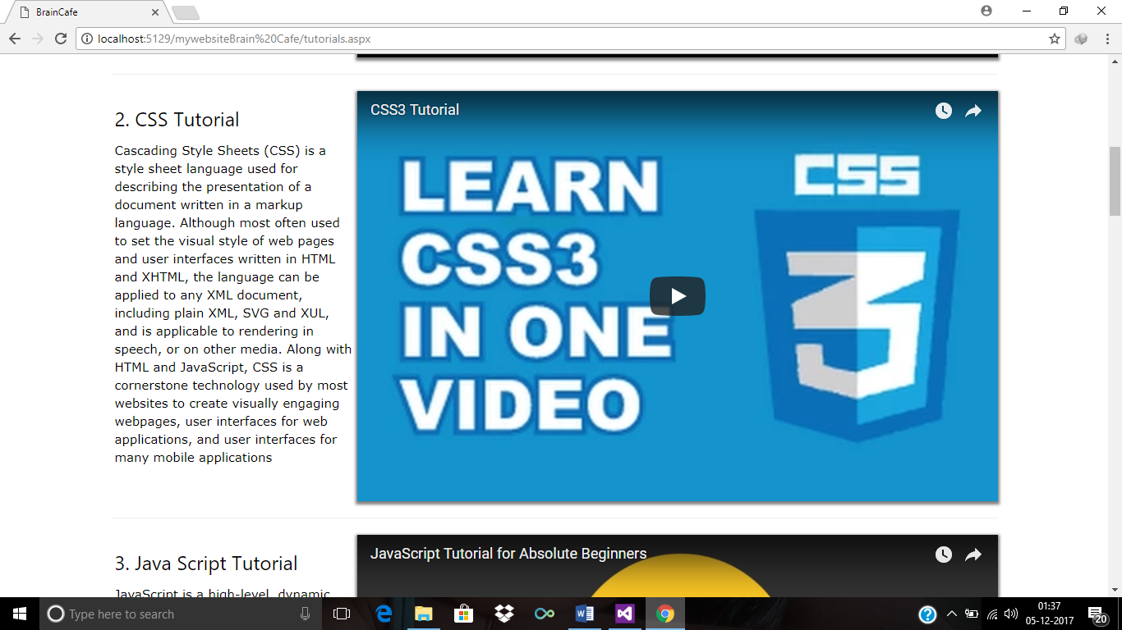

**REFERENCES:-**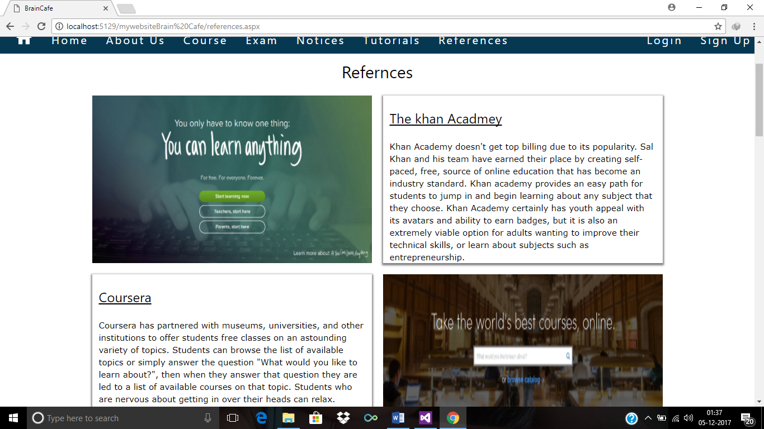

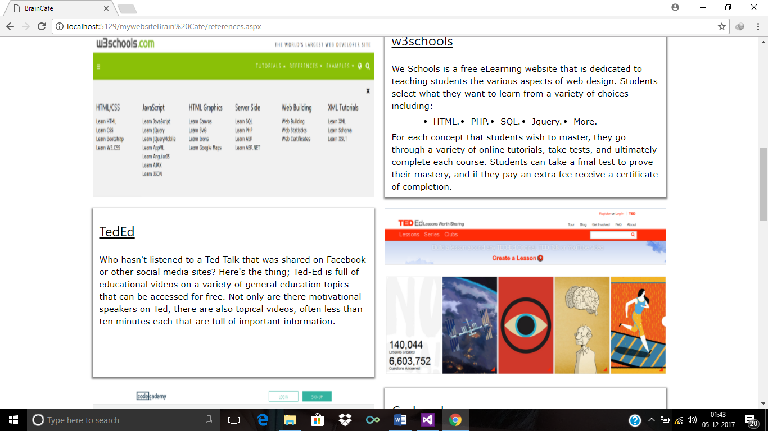

**LOGIN PAGE:-**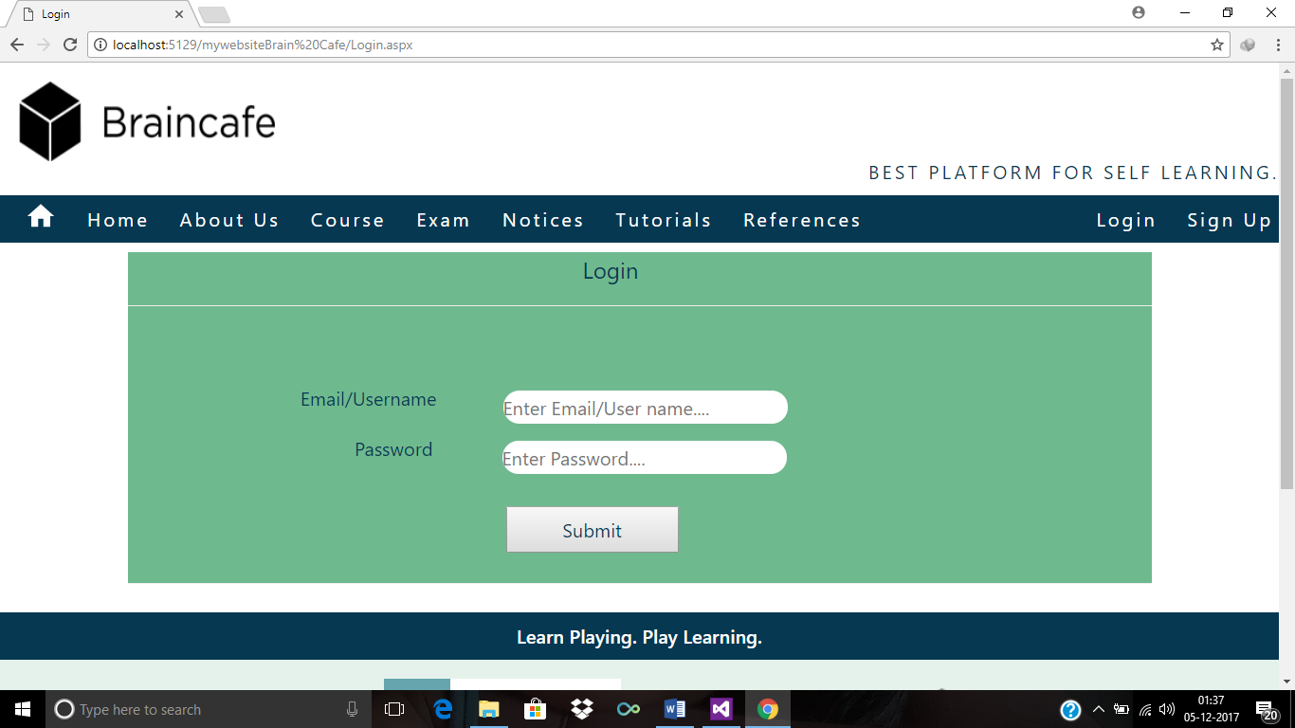

**LOGIN WELCOME PAGE:-**

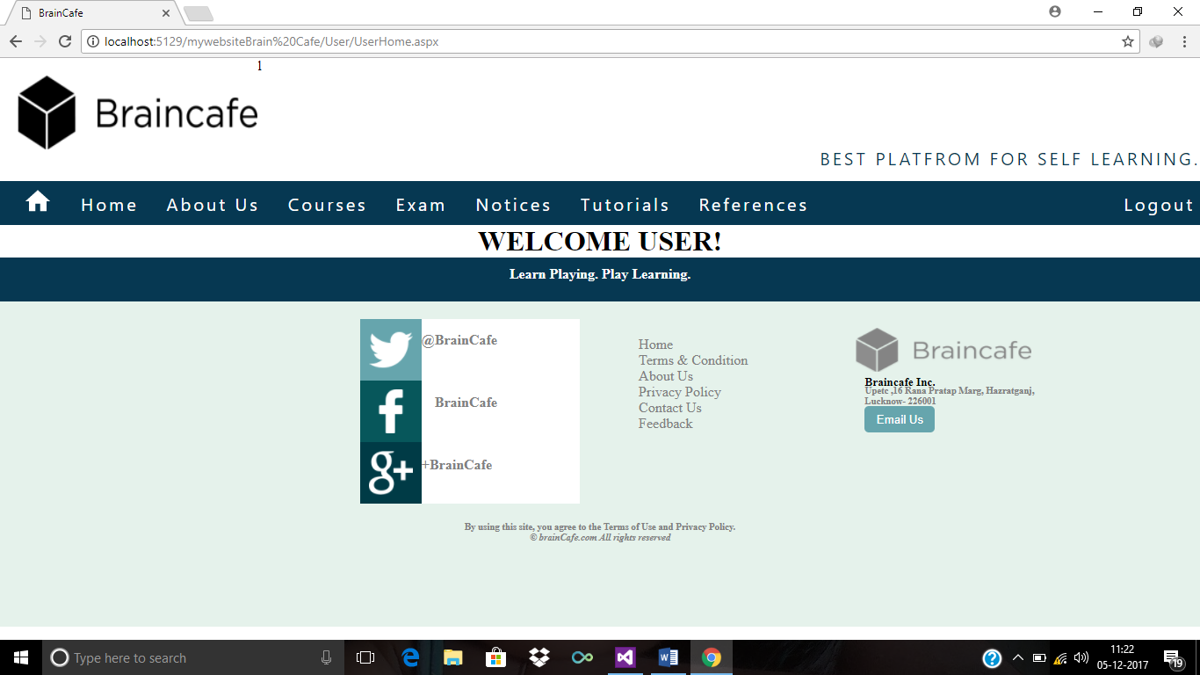

**REGISTRATION PAGE:-**

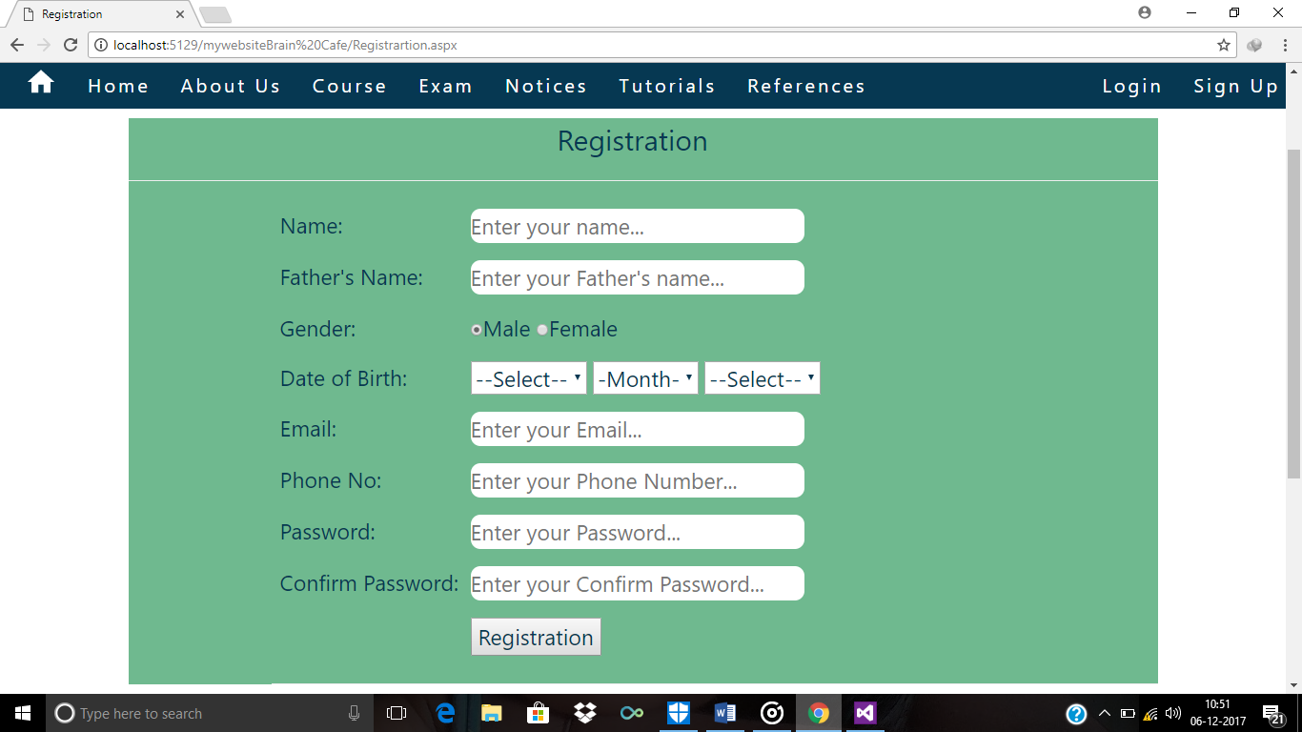

**PRIVACY POLICY:-**

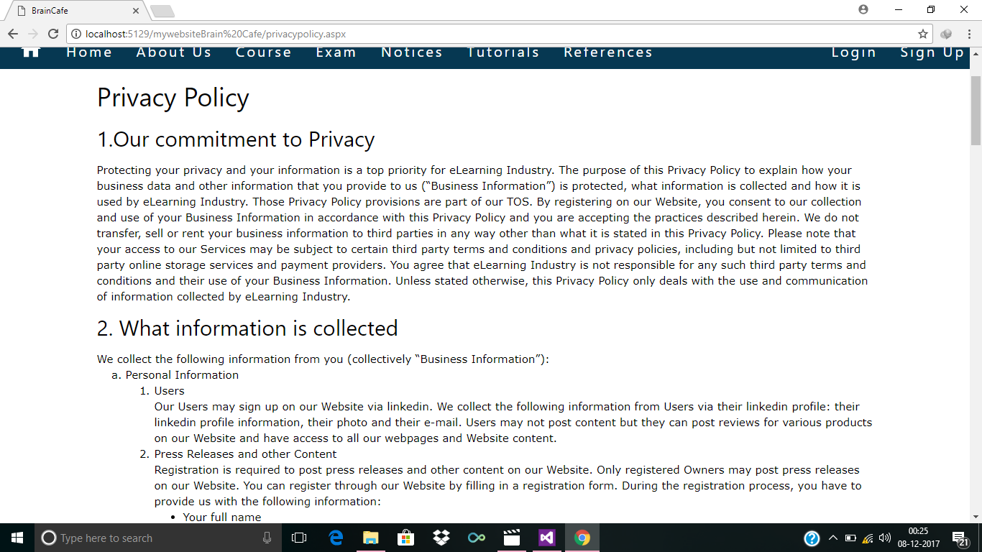

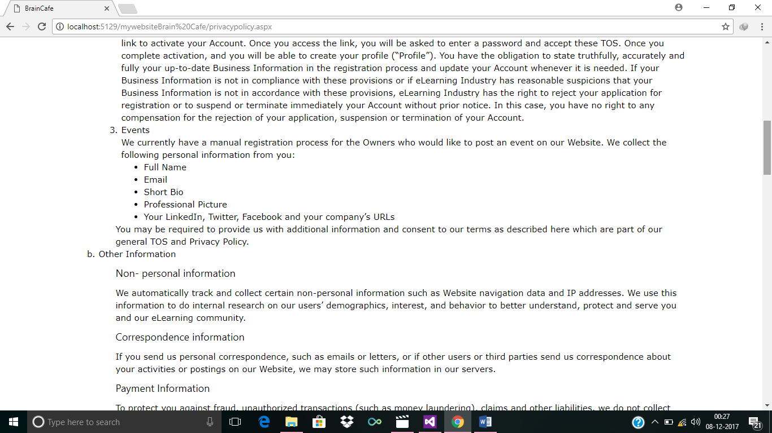

**FEEDBACK:-**

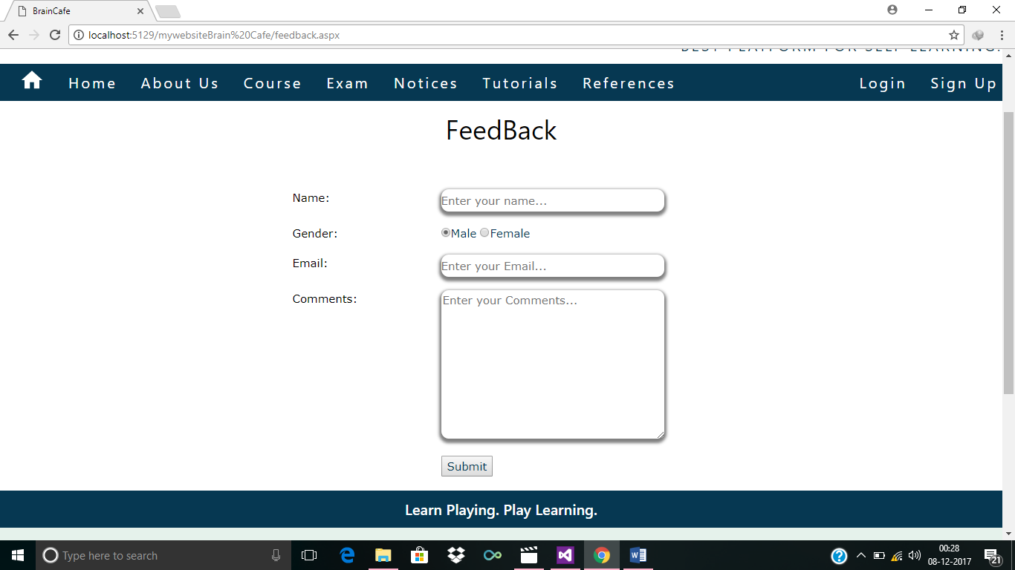

**ADMIN PANEL:-**

**MESSAGE:-**

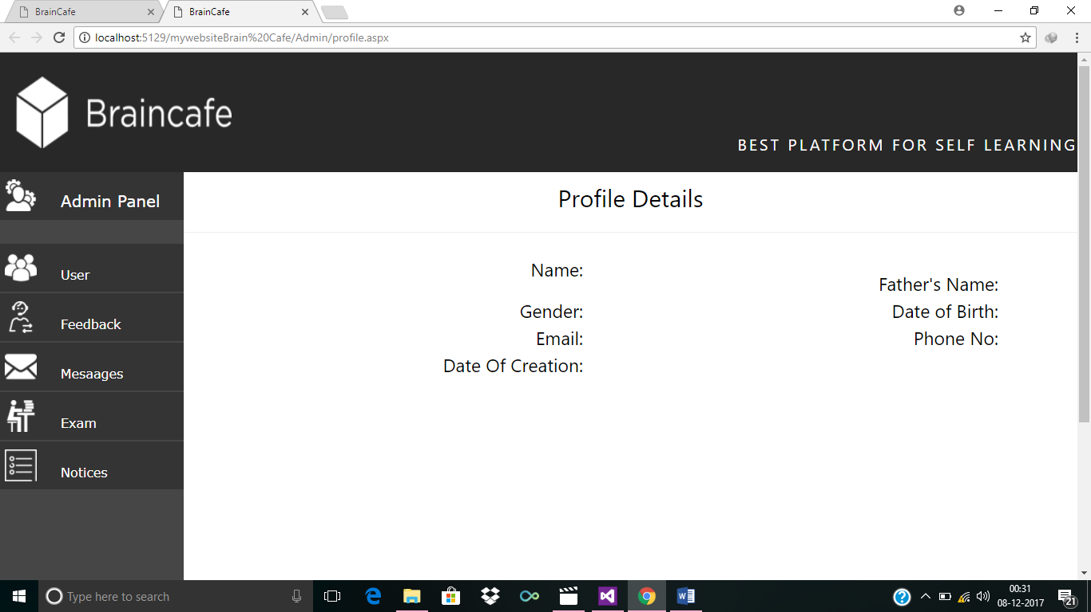

**USER:-**

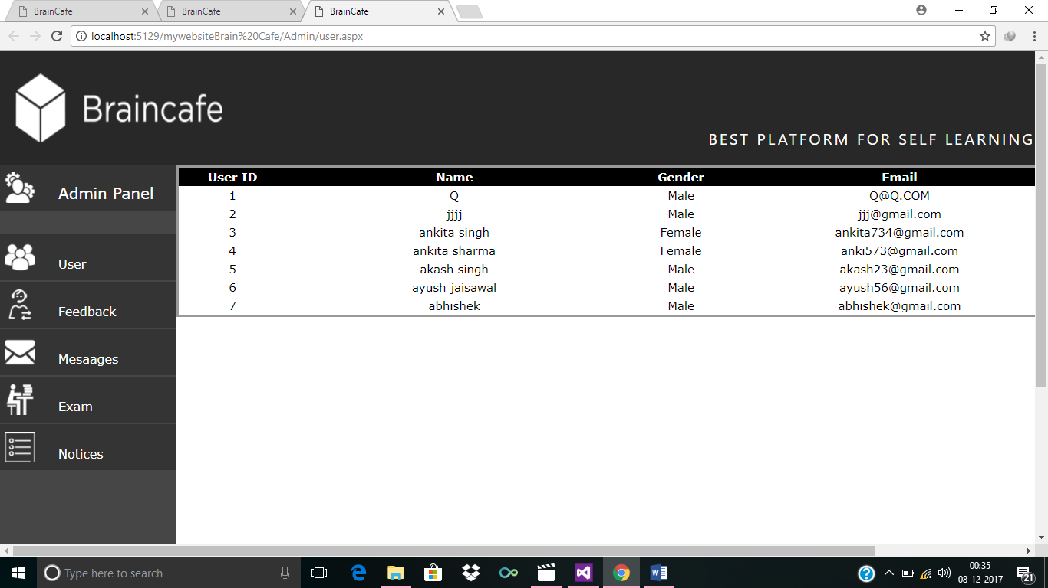

CODING

**5.Coding:-**

**USER MASTER PAGE:-**

<%@ Master Language="C#" AutoEventWireup="true" CodeFile="UserMasterPage.master.cs" Inherits="User_UserMasterPage" %>

<!DOCTYPE html>

<html xmlns="http://www.w3.org/1999/xhtml">

<head id="Head1" runat="server">

<title>BrainCafe</title>

<meta charset="utf-8"/>

<meta name="description" content="Free Web tutorials" />

<meta name="keywords" content="HTML,CSS,JavaScript,E-Learning,Web Tutorials,Learn Playing, Play Learning,Free Learning, Learn Web Design,Learn HTML,Learn CSS"/>

<meta name="author" content="Porush Marwaha"/>

<meta name="viewport" content="width=device-width, initial-scale=1"/>

<link rel="../stylesheet" href="w3css.css"/>

<link href="../StyleSheet.css" rel="stylesheet" />

</head>

<body>

<form id="form1" runat="server">

<div id="background">

<div class="header">

<div class="header_up">

<img src="../logo/1.png" class="logo" />

<p class="logo_text">BEST PLATFORM FOR SELF LEARNING.</p>

</div>

</div>

<div class="header_down">

<button class="headbutton" ><a class="deco" href="home.aspx"><svg fill="white" height="34" viewBox="0 0 24 24" width="34" xmlns="http://www.w3.org/2000/svg" ><path d="M10 20v-6h4v6h5v-8h3L12 3 2 12h3v8z"/><path d="M0 0h24v24H0z" fill="none"/></svg></a></button>

<button class="headbutton" ><a class="deco" href="home.aspx">Home</a></button>

<button class="headbutton" ><a class="deco" href="aboutus.aspx">About Us</a></button>

<button class="headbutton" ><a class="deco" href="course.aspx">Course</></button>

<button class="headbutton" ><a class="deco" href="../Admin/exam.aspx">Exam</></button>

<button class="headbutton" ><a class="deco" href="../Admin/notices.aspx">Notices</></button>

<button class="headbutton" ><a class="deco" href="../tutorials.aspx">Tutorials</></button>

<button class="headbutton" ><a class="deco" href="references.aspx">References</a></button>

<button class="headbutton log" ><a class="deco" href="Registrartion.aspx">Sign Up</a></button>

<button class="headbutton log" ><a class="deco" href="Login.aspx">Login</a></button>

</div>

<div id="content">

<asp:ContentPlaceHolder ID="ContentPlaceHolder1" runat="server">

</asp:ContentPlaceHolder>

</div>

<div class="aboutus-content2-div" style="clear:both;"><h4 class="aboutus-content2-div-h4">Learn Playing. Play Learning.</h4></div>

<div class="aboutus-content3-div">

<div class="aboutus-content3-outer-div1 ">

<div class="aboutus-content3-inner-div ">

<div class="aboutus-content3-inner-div1 hover2 " style="background-color:#66a5ad"><img src="../images/social/social-media.png" style="height:50px; width:50px; margin:10px;" /></div>

<div class="aboutus-content3-inner-div2"><h4 style="margin-top:15px;"> @BrainCafe</h4></div>

</div>

<div class="aboutus-content-inner-div ">

<div class="aboutus-content3-inner-div1 hover2 " style="background-color:#07575b" ><img src="../images/social/social.png" style="height:50px; width:50px; margin:10px;" /></div>

<div class="aboutus-content3-inner-div2"><h4 style="margin-left:15px; margin-top:16px;"> BrainCafe</h4></div>

</div>

<div class="aboutus-content-inner-div ">

<div class="aboutus-content3-inner-div1 hover2 " style="background-color:#003b46" ><img src="../images/social/social-network (1).png" style="height:50px; width:50px; margin:10px;" /></div>

<div class="aboutus-content3-inner-div2"><h4 style="margin-top:17px;" >+BrainCafe</h4></div>

</div>

</div>

<div class="aboutus-content3-outer-div2">

<ul style="color:grey; list-style:none; padding-top:20px;">

<li>Home </li>

<li><a class="deco" a href="../termsNconditions.aspx">Terms & Condition</a></li>

<li> About Us</li>

<li> <a class="deco" a href="../privacypolicy.aspx">Privacy Policy</a></li>

<li><a class="deco" a href="../Contactus.aspx">Contactus</a></li>

<li><a class="deco" a href="../feedback.aspx">feedback</a></li>

</ul>

</div>

<div class="aboutus-content3-outer-div3">

<img src="../logo/10.png" style="height:50px; width:80%; margin:10px; margin-bottom:0px;" />

<h5 style="margin-left:20px; color:black; margin-bottom:-5px; ">Braincafe Inc.</h5>

<h6 style="margin-left:20px; color:grey;">Upetc ,16 Rana Pratap Marg, Hazratganj, Lucknow- 226001</h6>

<button style="height:30px; width:80px; color:white; background-color:#66a5ad; margin-left:20px; border-radius:5px; border-width:0px;">Email Us</button>

</div>

<div style="height:50px; width:100%; clear:both ; margin-top:230px; margin-bottom:10px;">

<h6 style="text-align:center; color:gray;"> By using this site, you agree to the Terms of Use and Privacy Policy.<br/>

<i >© brainCafe.com All rights reserved</i></h6><br />

</div>

</div>

</div>

</form>

</body>

</html>

**HOME PAGE:-**

<%@ Page Title="" Language="C#" MasterPageFile="~/MasterPage.master" AutoEventWireup="true" CodeFile="Home1.aspx.cs" Inherits="Home1" %>

<asp:Content ID="Content1" ContentPlaceHolderID="ContentPlaceHolder1" Runat="Server">

<div class="home-bg">

<div class="home-header">

<p >

“Students do not learn much just sitting in classes listening to teachers, memorizing prepackaged assignments, and spitting out answers. They must talk about what they are learning, write reflectively about it, relate it to past experiences, and apply it to their daily lives. They must make what they learn part of themselves.”

<br />

<span ></span>

</p>

</div>

</div>

</asp:Content>

<asp:Content ID="Content2" ContentPlaceHolderID="ContentPlaceHolder3" Runat="Server">

<div class="home-mid">

</div>

</asp:Content>

<asp:Content ID="Content3" ContentPlaceHolderID="ContentPlaceHolder2" Runat="Server">

<hr />

<div class="home-cont">

<div class="course-outer-div" style="margin:8px; height:400px; width:300px;">

<img src="images/courseimage/1.png" class="course-inner-div-img" />

<h3 class="course-inner-div-h3" style="margin-left:100px;">HTML Fundamentals</h3>

<p class="course-inner-div-p">This FREE course will teach you how to design a web page using HTML. Complete a series of hands-on exercises and practice while writing real HTML code.</p>

<asp:button ID="htmlbtn" runat="server" Class="course-inner-div-btn" Text="Know More" />

</div>

<div class="course-outer-div" style="margin:8px;height:400px; width:300px;">

<img src="images/courseimage/2.png" class="course-inner-div-img" />

<h3 class="course-inner-div-h3" style="margin-left:100px;">CSS Fundamentals</h3>

<p class="course-inner-div-p" >Our CSS course will teach you how to control the style &amp; layout of websites. Complete a series of exercises and practice while filling out actual CSS templates.</p>

<asp:button ID="cssbtn" runat="server" Class="course-inner-div-btn" Text="Know More" />

</div>

<div class="course-outer-div" style="margin:8px;height:400px; width:300px;">

<img src="images/courseimage/3.png" class="course-inner-div-img" />

<h3 class="course-inner-div-h3" style="margin-left:100px;">JavaScript <br />Basics </h3>

<p class="course-inner-div-p">Learn all the basic features of JavaScript, including making your website more interactive, changing website content, validating forms, and so much more.</p>

<asp:button ID="jsbtn" runat="server" Class="course-inner-div-btn" style="margin-top:-30px;" Text="Know More" />

</div>

<div style="float:left; width:1000px; height:40px; text-align:center; color:#063852; ">

<a href="course.aspx">

<b> View all Courses</b>

</a>

</div>

</div>

<hr />

<br />

<br />

<div class="home-footer" >

<h2 class="home-footer-font" >Available Anytime & Anywhere for FREE!</h2>

<h3 class="home-footer-font" >Learn on the web and on the go. <br />

Available on all major devices and platforms.<br>

Always pick up where you left off. <br />

More simple and enjoyable than ever! </h3>

<img src="images/photos/1.jpg" style="height:350px; width:700px; margin-top:-250px; margin-left:600px;" />

</div>

</asp:Content>

**ABOUT-US:-**

<%@ Page Title="" Language="C#" MasterPageFile="~/MasterPage.master" AutoEventWireup="true" CodeFile="aboutus.aspx.cs" Inherits="aboutus" %>

<asp:Content ID="Content1" ContentPlaceHolderID="ContentPlaceHolder1" Runat="Server">

<div class="aboutus-bg" style="">

<div class="aboutus-div1" >

<p class="aboutus-div1-p1">About BrainCafe</p>

<img src="images/aboutus/features_1.png" class="aboutus-div1-img" />

<h4 class="aboutus-div1-h4">Crowd-Learning</h4>

<p class="aboutus-div1-p2">Learning has never been this social and accessible for so many! Bit-sized videos and fun practice sessions grab your attention and keep you focused, for guaranteed best results!</p>

<br />

<img src="images/aboutus/features_2.png" class="aboutus-div1-img" />

<h4 class="aboutus-div1-h4">Learn by Doing</h4>

<p class="aboutus-div1-p2">Practice during lessons, practice between lessons, practice whenever you can. Master the task, then reinforce and test your knowledge with fun, hands-on exercises and interactive quizzes.</p>

<br />

<img src="images/aboutus/features_3.png" class="aboutus-div1-img" />

<h4 class="aboutus-div1-h4">Unbound Learning</h4>

<p class="aboutus-div1-p2">Don’t limit yourself! Now there are no limits – no more set locations, time, or pace! You decide where, when, and how quickly you’ll learn, and you can do it anytime, anywhere, on any device.</p>

<br />

<img src="images/aboutus/features_4.png" class="aboutus-div1-img" />

<h4 class="aboutus-div1-h4">Learn while Playing</h4>

<p class="aboutus-div1-p2">Learning should be fun. Develop your profile, unlock each level, earn skill points and achievements, and challenge yourself by competing with other learners throughout the world.</p>

</div>

<div class="aboutus-div2" >

<p class="aboutus-div2-p1">GET THE FREE APP</p>

<img src="images/social/Get_it_on_Google_play.svg.png" class="aboutus-div2-img hover2" />

<img src="images/social/itunes-app-store-logo.png" class="aboutus-div2-img hover2" />

<img src="images/social/ico_download_windowsphonestore-0001.png" class="aboutus-div2-img hover2" />

<div class="aboutus-div2-div1 hover2">

<img src="images/social/square.png" class="aboutus-div2-img2" />

<p class="aboutus-div2-p2" >Learn on the</p>

<h3 class="aboutus-div2-h3" >WEB</h3>

</div>

</div>

</div>

</asp:Content>

<asp:Content ID="Content2" ContentPlaceHolderID="ContentPlaceHolder3" Runat="Server">

<div style="height:150px; width:100%; background-color: ">

<h3 style="font-weight:500; text-align:center; color:#222728;"> Become a member of our growing community!</h3>

<button class="hover4" style="height:50px; width:380px; color:white; background-color:#68b187; border-radius:20px; border-width:0px; margin-left:40%; margin-top:10px;">Start Learning Now</button>

</div>

</asp:Content>

<asp:Content ID="Content3" ContentPlaceHolderID="ContentPlaceHolder2" Runat="Server">

</asp:Content>

**C++:-**

<%@ Page Title="C++" Language="C#" MasterPageFile="~/MasterPage.master" AutoEventWireup="true" CodeFile="C plus plus.aspx.cs" Inherits="C_plus_plus" %>

<asp:Content ID="Content1" ContentPlaceHolderID="ContentPlaceHolder1" Runat="Server">

<div class="html-bg">

<div class="outer-html-div outer-html-div-margin1">

<div class="inner-html-div1 hover2">

<img src="images/icons/cpp/1.png" class="html-div-img1"/>

</div>

Basic Concepts

</div>

<div class="outer-html-div outer-html-div-margin2">

<div class="inner-html-div2 hover2">

<img src="images/icons/cpp/2.png" class="html-div-img2"/><br/>

</div>

Conditionals & Loops

</div>

<div class="outer-html-div outer-html-div-margin3">

<div class="inner-html-div3 hover2">

<img src="images/icons/cpp/3.png" class="html-div-img3"/>

</div>

Data Types,Arrays,Pointers

</div>

<div class="outer-html-div outer-html-div-margin2">

<div class="inner-html-div2 hover2">

<img src="images/icons/cpp/4.png" class="html-div-img2"/><br/>

</div>

Functions

</div>

<div class="outer-html-div outer-html-div-margin3">

<div class="inner-html-div3 hover2">

<img src="images/icons/cpp/5.png" class="html-div-img3"/>

</div>

Classes and Objects

</div>

<div class="outer-html-div outer-html-div-margin1">

<div class="inner-html-div1 hover2">

<img src="images/icons/cpp/6.png" class="html-div-img1"/>

</div>

Challenges

</div>

<div class="outer-html-div outer-html-div-margin2">

<div class="inner-html-div2 hover2">

<img src="images/icons/cpp/7.png" class="html-div-img2"/><br/>

</div>

More On Classes

</div>

<div class="outer-html-div outer-html-div-margin3">

<div class="inner-html-div3 hover2">

<img src="images/icons/cpp/8.png" class="html-div-img3"/>

</div>

Inheritance & Polymarphism

</div>

<div class="outer-html-div outer-html-div-margin4">

<div class="inner-html-div4 hover2">

<img src="images/icons/cpp/9.png" class="html-div-img4"/><br />

</div>

Templates, Exceptions,and Files

</div>

<div class="outer-html-div outer-html-div-margin4">

<div class="inner-html-div4 hover2">

<img src="images/icons/cpp/10.png" class="html-div-img4"/><br />

</div>

Challenges

</div>

<div class="inner-html-div5">

<img src="images/icons/certificate/diploma.png" class="html-div-img5 "/> Certificate

</div>

<hr/>

</div>

</asp:Content>

**CONTACT-US:-**

<%@ Page Title="" Language="C#" MasterPageFile="~/MasterPage.master" AutoEventWireup="true" CodeFile="Contactus.aspx.cs" Inherits="Contactus" %>

<asp:Content ID="Content1" ContentPlaceHolderID="ContentPlaceHolder1" Runat="Server">

<img src="images/social/contactus.jpg" height="300px" width="100%" style="margin-left:0%;"/>

<div class="contactus-bg" >

<div class="contactus-left-bg" style="color:#063852" >

<div class="contactus-header"><h1>Contact Us</h1></div>

<div class="rows1" style="margin-top:10px;">

<div class="cols1">Name:</div>

<div class="cols2" "><asp:TextBox style="height:30px; width:300px; box-shadow:0px 1px 3px 1px grey;" class="textbox1 hover2" ID="feed_txtname" runat="server" placeholder="Enter your name..."></asp:TextBox></div>

</div>

<div class="rows1">

<div class="cols1">Gender:</div>

<div class="cols2"><asp:RadioButton class="rdb-button" ID="feed_rdbmale" runat="server" GroupName="gender" Checked="true" Text="Male" ></asp:RadioButton>

<asp:RadioButton class="rdb-button" ID="feed_rdbfemale" runat="server" GroupName="gender" Text="Female"/></div>

</div>

<div class="rows1">

<div class="cols1">Email:</div>

<div class="cols2"><asp:TextBox style="height:30px; width:300px; box-shadow:0px 1px 3px 1px grey;" class="textbox1 hover2" ID="feed_txtemail" runat="server" TextMode="Email" placeholder="Enter your Email..."></asp:TextBox></div>

</div>

<div class="rows1">

<div class="cols1">Message:</div>

<div class="cols2"><asp:TextBox style="height:200px; width:300px; box-shadow:0px 1px 3px 1px grey;" class="textbox1 hover2" ID="feed_comments" runat="server" TextMode="MultiLine" Rows="6" Columns="10" placeholder="Enter your Comments..."></asp:TextBox></div>

</div>

<div class="rows1">

<div class="cols1">

<asp:Label ID="lblmsg" runat="server"></asp:Label>

</div>

<div class="cols2"><asp:Button Class="reg-button hover2" runat="server" Id="feed_btnsave" Text="Submit" OnClick="feed_btnsave_Click1"/></div>

</div>

</div>

**COURSES:-**

<%@ Page Title="Course" Language="C#" MasterPageFile="~/MasterPage.master" AutoEventWireup="true" CodeFile="course.aspx.cs" Inherits="course" %>

<asp:Content ID="Content1" ContentPlaceHolderID="ContentPlaceHolder1" Runat="Server">

<div class="course-bg">

<hr />

<div class="course-outer-div">

<img src="images/courseimage/1.png" class="course-inner-div-img" />

<h3 class="course-inner-div-h3">HTML Fundamentals</h3>

<p class="course-inner-div-p">This FREE course will teach you how to design a web page using HTML. Complete a series of hands-on exercises and practice while writing real HTML code.</p>

<asp:Button ID="btnhtml" runat="server" class="course-inner-div-btn" Text="Know more" OnClick="btnhtml_Click" />

</div>

<div class="course-outer-div">

<img src="images/courseimage/2.png" class="course-inner-div-img" />

<h3 class="course-inner-div-h3">CSS Fundamentals</h3>

<p class="course-inner-div-p" >Our CSS course will teach you how to control the style &amp; layout of websites. Complete a series of exercises and practice while filling out actual CSS templates.</p>

<asp:Button ID="btncss" runat="server" class="course-inner-div-btn" Text="Know more" OnClick="btncss_Click" />

</div>

<div class="course-outer-div">

<img src="images/courseimage/3.png" class="course-inner-div-img" />

<h3 class="course-inner-div-h3">JavaScript Basics </h3>

<p class="course-inner-div-p">Learn all the basic features of JavaScript, including making your website more interactive, changing website content, validating forms, and so much more.</p>

<asp:Button ID="btnjavascript" runat="server" class="course-inner-div-btn" Text="Know more" OnClick="btnjavascript_Click" />

</div>

<div class="course-outer-div">

<img src="images/courseimage/4.png" class="course-inner-div-img" />

<h3 class="course-inner-div-h3">PHP Tutorials</h3>

<p class="course-inner-div-p">PHP enables you to create dynamic web pages, develop websites, and generate dynamic content. Learn the most widely used web programming language!</p>

<asp:Button ID="btnphp" runat="server" class="course-inner-div-btn" Text="Know more" OnClick="btnphp_Click" />

</div>

<div class="course-outer-div">

<img src="images/courseimage/5.png" class="course-inner-div-img" />

<h3 class="course-inner-div-h3">SQL Fundamentals</h3>

<p class="course-inner-div-p">This course covers an array of SQL-related topics, such as retrieving, updating and filtering data; functions and subqueries; creating &amp; updating tables; &amp; many more!</p>

<asp:Button ID="btnsql" runat="server" class="course-inner-div-btn" Text="Know more" OnClick="btnsql_Click" />

</div>

<div class="course-outer-div">

<img src="images/courseimage/6.png" class="course-inner-div-img" />

<h3 class="course-inner-div-h3">C++ Tutorial</h3>

<p class="course-inner-div-p">Our C++ tutorial covers basic concepts, data types, arrays, pointers, conditional statements, loops, functions, classes, objects, inheritance, and polymorphism.</p>

<asp:Button ID="btncpp" runat="server" class="course-inner-div-btn" Text="Know more" OnClick="btncpp_Click"/>

</div>

<div style="margin-bottom:30px;" class="course-outer-div">

<img src="images/courseimage/7.png" class="course-inner-div-img" />

<h3 class="course-inner-div-h3">JAVA Tutorial</h3>

<p class="course-inner-div-p">With our interactive Java course, you’ll learn object-oriented Java programming and have the ability to write clear and valid code in almost no time at all.</p>

<asp:Button ID="btnjava" runat="server" class="course-inner-div-btn" Text="Know more" OnClick="btnjava_Click" />

</div>

<div style="margin-bottom:30px;" class="course-outer-div">

<img src="images/courseimage/8.png" class="course-inner-div-img" />

<h3 class="course-inner-div-h3">Python 3 Tutorial</h3>

<p class="course-inner-div-p">Learn Python, one of today&#39;s most in-demand programming languages on-the-go! Practice writing Python code, collect points, &amp; show off your skills.</p>

<asp:Button ID="btnpython" runat="server" class="course-inner-div-btn" Text="Know more" OnClick="btnpython_Click" />

</div>

<hr />

</div>

</asp:Content>

**CSS:-**

<%@ Page Title="Css" Language="C#" MasterPageFile="~/MasterPage.master" AutoEventWireup="true" CodeFile="css.aspx.cs" Inherits="css" %>

<asp:Content ID="Content1" ContentPlaceHolderID="ContentPlaceHolder1" Runat="Server">

<div class="html-bg">

<div class="outer-html-div outer-html-div-margin1">

<div class="inner-html-div1 hover2">

<img src="images/icons/css/1.png" class="html-div-img1"/>

</div>

The Basics

</div>

<div class="outer-html-div outer-html-div-margin2">

<div class="inner-html-div2 hover2">

<img src="images/icons/css/2.png" class="html-div-img2"/><br/>

</div>

Working with Text

</div>

<div class="outer-html-div outer-html-div-margin3">

<div class="inner-html-div3 hover2">

<img src="images/icons/css/3.png" class="html-div-img3"/>

</div>

Properties

</div>

<div class="outer-html-div outer-html-div-margin1">

<div class="inner-html-div1 hover2">

<img src="images/icons/css/4.png" class="html-div-img1"/>

</div>

Positioning and Layout

</div>

<div class="outer-html-div outer-html-div-margin1">

<div class="inner-html-div1 hover2">

<img src="images/icons/css/5.png" class="html-div-img1"/>

</div>

CSS3 Basics

</div>

<div class="outer-html-div outer-html-div-margin2">

<div class="inner-html-div2 hover2">

<img src="images/icons/css/6.png" class="html-div-img2"/><br/>

</div>

Gradients & Backgrounds

</div>

<div class="outer-html-div outer-html-div-margin3">

<div class="inner-html-div3 hover2">

<img src="images/icons/css/7.png" class="html-div-img3"/>

</div>

Transitions & Transforms

</div>

<div class="inner-html-div5">

<img src="images/icons/certificate/diploma.png" class="html-div-img5"/> Certificate

</div>

<hr/>

</div>

</asp:Content>

**FEEDBACK:-**

<%@ Page Title="" Language="C#" MasterPageFile="~/MasterPage.master" AutoEventWireup="true" CodeFile="feedback.aspx.cs" Inherits="feedback" %>

<asp:Content ID="Content1" ContentPlaceHolderID="ContentPlaceHolder1" Runat="Server">

<div class="feedback-header" style="height:50px; width:100%; color:black; text-align:center"><h1>FeedBack</h1></div>

<div class="feedback-bg" style="margin-left:250px; margin-top:50px; ">

<div class="rows1" >

<div class="cols1">Name:</div>

<div class="cols2" "><asp:TextBox style="height:30px; width:300px; box-shadow:0px 3px 5px 3px grey;" class="textbox1 hover2" ID="feed_txtname" runat="server" placeholder="Enter your name..."></asp:TextBox></div>

</div>

<div class="rows1">

<div class="cols1">Gender:</div>

<div class="cols2"><asp:RadioButton class="rdb-button" ID="feed_rdbmale" runat="server" GroupName="gender" Checked="true" Text="Male" ></asp:RadioButton>

<asp:RadioButton class="rdb-button" ID="feed_rdbfemale" runat="server" GroupName="gender" Text="Female"/></div>

</div>

<div class="rows1">

<div class="cols1">Email:</div>

<div class="cols2"><asp:TextBox style="height:30px; width:300px; box-shadow:0px 3px 5px 3px grey;" class="textbox1 hover2" ID="feed_txtemail" runat="server" TextMode="Email" placeholder="Enter your Email..."></asp:TextBox></div>

</div>

<div class="rows1">

<div class="cols1">Comments:</div>

<div class="cols2"><asp:TextBox style="height:200px; width:300px; box-shadow:0px 3px 5px 3px grey;" class="textbox1 hover2" ID="feed_comments" runat="server" TextMode="MultiLine" Rows="6" Columns="10" placeholder="Enter your Comments..."></asp:TextBox></div>

</div>

<div class="rows1">

<div class="cols1"></div>

<div class="cols2"><asp:Button Class="reg-button hover2" runat="server" Id="feed_btnsave" Text="Submit"/></div>

</div>

</div>

</asp:Content>

<asp:Content ID="Content2" ContentPlaceHolderID="ContentPlaceHolder3" Runat="Server">

</asp:Content>

<asp:Content ID="Content3" ContentPlaceHolderID="ContentPlaceHolder2" Runat="Server">

</asp:Content>

**HTML-OVERVIEW:-**

<%@ Page Title="" Language="C#" MasterPageFile="~/MasterPage.master" AutoEventWireup="true" CodeFile="html-overview.aspx.cs" Inherits="html_overview" %>

<asp:Content ID="Content1" ContentPlaceHolderID="ContentPlaceHolder1" Runat="Server">

<div class="html-module1-bg ">

<div class="html-module-outer-div hover2 bottom">

<div class="html-module-inner1-div">

<p class="html-module-inner-p"> 1/4 </p><br />

<h5 class="html-module-inner-h5"> What is HTML? </h5>

</div>

<div class="html-module-inner2-div">

<p class="html-module-inner-p2">2 Topics</p>

</div>

</div>

<div class="html-module-outer-div hover2 bottom">

<div class="html-module-inner1-div">

<p class="html-module-inner-p"> 2/4 </p><br />

<h5 class="html-module-inner-h5"> Basic HTML Document Structure </h5>

</div>

<div class="html-module-inner2-div">

<p class="html-module-inner-p2">3 Topics</p>

</div>

</div>

<div class="html-module-outer-div hover2 bottom">

<div class="html-module-inner1-div">

<p class="html-module-inner-p">3/4</p><br />

<h5 class="html-module-inner-h5"> Creating Your first HTML Page </h5> </div>

<div class="html-module-inner2-div">

<p class="html-module-inner-p2">3 Topics</p>

</div>

</div>

<div class="html-module-outer-div hover2 bottom">

<div class="html-module-inner1-div">

<p class="html-module-inner-p">4/4</p><br />

<h5 class="html-module-inner-h5"> Module 1 Quiz </h5>

</div>

<div class="html-module-inner2-div">

<p class="html-module-inner-p2">4 Questions</p>

</div>

</div>

</div>

</asp:Content>

**HTML:-**

<%@ Page Title="Html" Language="C#" MasterPageFile="~/MasterPage.master" AutoEventWireup="true" CodeFile="html.aspx.cs" Inherits="_Default" %>

<asp:Content ID="Content1" ContentPlaceHolderID="ContentPlaceHolder1" Runat="Server">

<div class="html-bg">

<div class="outer-html-div outer-html-div-margin1">

<a href="html-overview.aspx">

<div class="inner-html-div1 hover2 ">

<img src="images/icons/html/1.png" class="html-div-img1"/>

</div></a>

Overview

</div>

<div class="outer-html-div outer-html-div-margin2">

<a href="html_basics.aspx">

<div class="inner-html-div2 hover2">

<img src="images/icons/html/2.png" class="html-div-img2"/><br/>

</div></a> HTML Basics

</div>

<div class="outer-html-div outer-html-div-margin3">

<a href="html_challenges.aspx">

<div class="inner-html-div3 hover2">

<img src="images/icons/html/3.png" class="html-div-img3"/>

</div></a>

Challenges

</div>

<div class="outer-html-div outer-html-div-margin4">

<a href="html_html5.aspx">

<div class="inner-html-div4 hover2">

<img src="images/icons/html/4.png" class="html-div-img4"/><br />

</div> </a>

HTML5

</div>

<div class="inner-html-div5">

<img src="images/icons/certificate/diploma.png" class="html-div-img5"/> Certificate

</div>

<hr/>

</div>

</asp:Content>

**HTML BASICS:-**

<%@ Page Title="" Language="C#" MasterPageFile="~/MasterPage.master" AutoEventWireup="true" CodeFile="html_basics.aspx.cs" Inherits="html_basics" %>

<asp:Content ID="Content1" ContentPlaceHolderID="ContentPlaceHolder1" Runat="Server">

<div class="html-module1-bg">

<div class="html-module-outer-div hover2">

<div class="html-module-inner1-div">

<p class="html-module-inner-p"> 1/14 </p><br />

<h5 class="html-module-inner-h5"> Paragraphs </h5>

</div>

<div class="html-module-inner2-div">

<p class="html-module-inner-p2">3 Topics</p>

</div>

</div>

<div class="html-module-outer-div hover2">

<div class="html-module-inner1-div">

<p class="html-module-inner-p"> 2/14 </p><br />

<h5 class="html-module-inner-h5">Text Formatting </h5>

</div>

<div class="html-module-inner2-div">

<p class="html-module-inner-p2">2 Topics</p>

</div>

</div>

<div class="html-module-outer-div hover2">

<div class="html-module-inner1-div">

<p class="html-module-inner-p">3/14</p><br />

<h5 class="html-module-inner-h5"> Headings, Lines, Comments </h5>

</div>

<div class="html-module-inner2-div">

<p class="html-module-inner-p2">3 Topics</p>

</div>

</div>

<div class="html-module-outer-div hover2">

<div class="html-module-inner1-div">

<p class="html-module-inner-p">4/14</p><br />

<h5 class="html-module-inner-h5"> Elements </h5>

</div>

<div class="html-module-inner2-div">

<p class="html-module-inner-p2">2 Topics</p>

</div>

</div>

<div class="html-module-outer-div hover2">

<div class="html-module-inner1-div">

<p class="html-module-inner-p"> 5/14 </p><br />

<h5 class="html-module-inner-h5"> Attributes </h5>

</div>

<div class="html-module-inner2-div">

<p class="html-module-inner-p2">4 Topics</p>

</div>

</div>

<div class="html-module-outer-div hover2">

<div class="html-module-inner1-div">

<p class="html-module-inner-p"> 6/14 </p><br />

<h5 class="html-module-inner-h5"> Images </h5>

</div>

<div class="html-module-inner2-div">

<p class="html-module-inner-p2">4 Topics</p>

</div>

</div>

<div class="html-module-outer-div hover2">

<div class="html-module-inner1-div">

<p class="html-module-inner-p">7/14</p><br />

<h5 class="html-module-inner-h5"> Links </h5>

</div>

<div class="html-module-inner2-div">

<p class="html-module-inner-p2">3 Topics</p>

</div>

</div>

<div class="html-module-outer-div hover2">

<div class="html-module-inner1-div">

<p class="html-module-inner-p">8/14</p><br />

<h5 class="html-module-inner-h5"> Lists </h5>

</div>

<div class="html-module-inner2-div">

<p class="html-module-inner-p2">2 Topics</p>

</div>

</div>

<div class="html-module-outer-div hover2">

<div class="html-module-inner1-div">

<p class="html-module-inner-p"> 9/14 </p><br />

<h5 class="html-module-inner-h5"> Tables </h5>

</div>

<div class="html-module-inner2-div">

<p class="html-module-inner-p2">4 Topics</p>

</div>

</div>

<div class="html-module-outer-div hover2">

<div class="html-module-inner1-div">

<p class="html-module-inner-p"> 10/14 </p><br />

<h5 class="html-module-inner-h5"> Inline and Block Elements </h5>

</div>

<div class="html-module-inner2-div">

<p class="html-module-inner-p2">2 Topics</p>

</div>

</div>

<div class="html-module-outer-div hover2">

<div class="html-module-inner1-div">

<p class="html-module-inner-p">11/14</p><br />

<h5 class="html-module-inner-h5"> Forms </h5>

</div>

<div class="html-module-inner2-div">

<p class="html-module-inner-p2">4 Topics</p>

</div>

</div>

<div class="html-module-outer-div hover2">

<div class="html-module-inner1-div">

<p class="html-module-inner-p">12/14</p><br />

<h5 class="html-module-inner-h5"> HTML Colors </h5>

</div>

<div class="html-module-inner2-div">

<p class="html-module-inner-p2">4 Topics</p>

</div>

</div>

<div class="html-module-outer-div hover2">

<div class="html-module-inner1-div">

<p class="html-module-inner-p">13/14</p><br />

<h5 class="html-module-inner-h5"> Frames </h5>

</div>

<div class="html-module-inner2-div">

<p class="html-module-inner-p2">2 Topics</p>

</div>

</div>

<div class="html-module-outer-div hover2">

<div class="html-module-inner1-div">

<p class="html-module-inner-p">14/14</p><br />

<h5 class="html-module-inner-h5"> Module 2 Quiz </h5>

</div>

<div class="html-module-inner2-div">

<p class="html-module-inner-p2">8 Questions</p>

</div>

</div>

</div>

</asp:Content>

**HTML CHALLENGES:-**

<%@ Page Title="" Language="C#" MasterPageFile="~/MasterPage.master" AutoEventWireup="true" CodeFile="html_challenges.aspx.cs" Inherits="html_challenges" %>

<asp:Content ID="Content1" ContentPlaceHolderID="ContentPlaceHolder1" Runat="Server">

<div class="html-module-outer-div hover2 bottom">

<div class="html-module-inner1-div">

<p class="html-module-inner-p">1/1</p><br />

<h5 class="html-module-inner-h5"> Challenge 1 </h5>

</div>

<div class="html-module-inner2-div">

<p class="html-module-inner-p2">9 Questions</p>

</div>

</div>

</asp:Content>

**HTML-HTML5:-**

<%@ Page Title="" Language="C#" MasterPageFile="~/MasterPage.master" AutoEventWireup="true" CodeFile="html_html5.aspx.cs" Inherits="html_html5" %>

<asp:Content ID="Content1" ContentPlaceHolderID="ContentPlaceHolder1" Runat="Server">

<div class="html-module1-bg">

<div class="html-module-outer-div hover2">

<div class="html-module-inner1-div">

<p class="html-module-inner-p"> 1/19 </p><br />

<h5 class="html-module-inner-h5"> Introduction to HTML5 </h5>

</div>

<div class="html-module-inner2-div">

<p class="html-module-inner-p2">2 Topics</p>

</div>

</div>

<div class="html-module-outer-div hover2">

<div class="html-module-inner1-div">

<p class="html-module-inner-p"> 2/19 </p><br />

<h5 class="html-module-inner-h5">Content Models </h5>

</div>

<div class="html-module-inner2-div">

<p class="html-module-inner-p2">3 Topics</p>

</div>

</div>

<div class="html-module-outer-div hover2">

<div class="html-module-inner1-div">

<p class="html-module-inner-p">3/19</p><br />

<h5 class="html-module-inner-h5"> HTML5 Page Structure </h5>

</div>

<div class="html-module-inner2-div">

<p class="html-module-inner-p2">1 Topics</p>

</div>

</div>

<div class="html-module-outer-div hover2">

<div class="html-module-inner1-div">

<p class="html-module-inner-p">4/19</p><br />

<h5 class="html-module-inner-h5"> header,nav & footer </h5>

</div>

<div class="html-module-inner2-div">

<p class="html-module-inner-p2">3 Topics</p>

</div>

</div>

<div class="html-module-outer-div hover2">

<div class="html-module-inner1-div">

<p class="html-module-inner-p"> 5/19 </p><br />

<h5 class="html-module-inner-h5"> article, section & aside </h5>

</div>

<div class="html-module-inner2-div">

<p class="html-module-inner-p2">3 Topics</p>

</div>

</div>

<div class="html-module-outer-div hover2">

<div class="html-module-inner1-div">

<p class="html-module-inner-p"> 6/19 </p><br />

<h5 class="html-module-inner-h5"> The audio Element </h5>

</div>

<div class="html-module-inner2-div">

<p class="html-module-inner-p2">3 Topics</p>

</div>

</div>

<div class="html-module-outer-div hover2">

<div class="html-module-inner1-div">

<p class="html-module-inner-p">7/19</p><br />

<h5 class="html-module-inner-h5"> The Video Element </h5>

</div>

<div class="html-module-inner2-div">

<p class="html-module-inner-p2">2 Topics</p>

</div>

</div>

<div class="html-module-outer-div hover2">

<div class="html-module-inner1-div">

<p class="html-module-inner-p">8/19</p><br />

<h5 class="html-module-inner-h5"> The progress Element </h5>

</div>

<div class="html-module-inner2-div">

<p class="html-module-inner-p2">1 Topics</p>

</div>

</div>

<div class="html-module-outer-div hover2">

<div class="html-module-inner1-div">

<p class="html-module-inner-p"> 9/19 </p><br />

<h5 class="html-module-inner-h5"> Web Storage API </h5>

</div>

<div class="html-module-inner2-div">

<p class="html-module-inner-p2">3 Topics</p>

</div>

</div>

<div class="html-module-outer-div hover2">

<div class="html-module-inner1-div">

<p class="html-module-inner-p"> 10/19 </p><br />

<h5 class="html-module-inner-h5"> Geolocation API </h5>

</div>

<div class="html-module-inner2-div">

<p class="html-module-inner-p2">3 Topics</p>

</div>

</div>

<div class="html-module-outer-div hover2">

<div class="html-module-inner1-div">

<p class="html-module-inner-p">11/19</p><br />

<h5 class="html-module-inner-h5"> Drag&Drop API </h5>

</div>

<div class="html-module-inner2-div">

<p class="html-module-inner-p2">1 Topics</p>

</div>

</div>

<div class="html-module-outer-div hover2">

<div class="html-module-inner1-div">

<p class="html-module-inner-p">12/19</p><br />

<h5 class="html-module-inner-h5"> SVG </h5>

</div>

<div class="html-module-inner2-div">

<p class="html-module-inner-p2">5 Topics</p>

</div>

</div>

<div class="html-module-outer-div hover2">

<div class="html-module-inner1-div">

<p class="html-module-inner-p">13/19</p><br />

<h5 class="html-module-inner-h5"> SVG Animations & Paths </h5>

</div>

<div class="html-module-inner2-div">

<p class="html-module-inner-p2">2 Topics</p>

</div>

</div>

<div class="html-module-outer-div hover2">

<div class="html-module-inner1-div">

<p class="html-module-inner-p">14/19</p><br />

<h5 class="html-module-inner-h5"> Canvas </h5>

</div>

<div class="html-module-inner2-div">

<p class="html-module-inner-p2">3 Topics</p>

</div>

</div>

<div class="html-module-outer-div hover2">

<div class="html-module-inner1-div">

<p class="html-module-inner-p">15/19</p><br />

<h5 class="html-module-inner-h5"> SVG vs. Canvas </h5>

</div>

<div class="html-module-inner2-div">

<p class="html-module-inner-p2">1 Topics</p>

</div>

</div>

<div class="html-module-outer-div hover2">

<div class="html-module-inner1-div">

<p class="html-module-inner-p">16/19</p><br />

<h5 class="html-module-inner-h5"> Canvas Transformations </h5>

</div>

<div class="html-module-inner2-div">

<p class="html-module-inner-p2">3 Topics</p>

</div>

</div>

<div class="html-module-outer-div hover2">

<div class="html-module-inner1-div">

<p class="html-module-inner-p">17/19</p><br />

<h5 class="html-module-inner-h5"> HTML5 Forms, Part 1 </h5>

</div>

<div class="html-module-inner2-div">

<p class="html-module-inner-p2">3 Topics</p>

</div>

</div>

<div class="html-module-outer-div hover2">

<div class="html-module-inner1-div">

<p class="html-module-inner-p">18/19</p><br />

<h5 class="html-module-inner-h5"> HTML5 Forms, Part 2 </h5>

</div>

<div class="html-module-inner2-div">

<p class="html-module-inner-p2">3 Topics</p>

</div>

</div>

<div class="html-module-outer-div hover2">

<div class="html-module-inner1-div">

<p class="html-module-inner-p">19/19</p><br />

<h5 class="html-module-inner-h5"> Module Quiz </h5>

</div>

<div class="html-module-inner2-div">

<p class="html-module-inner-p2">6 Questions</p>

</div>

</div>

</div>

</asp:Content>

**JAVA:-**

<%@ Page Title="Java" Language="C#" MasterPageFile="~/MasterPage.master" AutoEventWireup="true" CodeFile="Java.aspx.cs" Inherits="Java" %>

<asp:Content ID="Content1" ContentPlaceHolderID="ContentPlaceHolder1" Runat="Server">

<div class="html-bg">

<div class="outer-html-div outer-html-div-margin1">

<div class="inner-html-div1 hover2">

<img src="images/icons/java/1.png" class="html-div-img1"/>

</div>

Basic Concepts

</div>

<div class="outer-html-div outer-html-div-margin2">

<div class="inner-html-div2 hover2">

<img src="images/icons/java/2.png" class="html-div-img2"/><br/>

</div>

Conditionals & Loops

</div>

<div class="outer-html-div outer-html-div-margin3">

<div class="inner-html-div3 hover2">

<img src="images/icons/java/3.png" class="html-div-img3"/>

</div>

Arrays

</div>

<div class="outer-html-div outer-html-div-margin2">

<div class="inner-html-div2 hover2">

<img src="images/icons/java/4.png" class="html-div-img2"/><br/>

</div>

Classes & Objects

</div>

<div class="outer-html-div outer-html-div-margin3">

<div class="inner-html-div3 hover2">

<img src="images/icons/java/5.png" class="html-div-img3"/>

</div>

More On Classes

</div>

<div class="outer-html-div outer-html-div-margin4">

<div class="inner-html-div4 hover2">

<img src="images/icons/java/6.png" class="html-div-img4"/><br />

</div>

Exceptions, List, Threads & Files

</div>

<div class="inner-html-div5 ">

<img src="images/icons/certificate/diploma.png" class="html-div-img5"/> Certificate

</div>

<hr/>

</div>

</asp:Content>

**JAVASCRIPT:-**

<%@ Page Title="Java Script" Language="C#" MasterPageFile="~/MasterPage.master" AutoEventWireup="true" CodeFile="javascript.aspx.cs" Inherits="javascript" %>

<asp:Content ID="Content1" ContentPlaceHolderID="ContentPlaceHolder1" Runat="Server">

<div class="html-bg">

<div class="outer-html-div outer-html-div-margin1">

<div class="inner-html-div1 hover2">

<img src="images/icons/javascript/1.png" class="html-div-img1"/>

</div>

Overview

</div>

<div class="outer-html-div outer-html-div-margin1">

<div class="inner-html-div1 hover2">

<img src="images/icons/javascript/2.png" class="html-div-img1"/>

</div>

Basic Concepts

</div>

<div class="outer-html-div outer-html-div-margin2">

<div class="inner-html-div2 hover2">

<img src="images/icons/javascript/3.png" class="html-div-img2"/><br/>

</div>

Coditionals & Loops

</div>

<div class="outer-html-div outer-html-div-margin3">

<div class="inner-html-div3 hover2">

<img src="images/icons/javascript/4.png" class="html-div-img3"/>

</div>

Functions

</div>

<div class="outer-html-div outer-html-div-margin2">

<div class="inner-html-div2 hover2">

<img src="images/icons/javascript/5.png" class="html-div-img2"/><br/>

</div>

Object

</div>

<div class="outer-html-div outer-html-div-margin3">

<div class="inner-html-div3 hover2">

<img src="images/icons/javascript/6.png" class="html-div-img3"/>

</div>

Core Objects

</div>

<div class="outer-html-div outer-html-div-margin4">

<div class="inner-html-div4 hover2">

<img src="images/icons/javascript/7.png" class="html-div-img4"/><br />

</div>

Advance JavaScript

</div>

<div class="inner-html-div5">

<img src="images/icons/certificate/diploma.png" class="html-div-img5"/> Certificate

</div> <hr/>

</div>

</asp:Content>

**LOGIN:-**

<%@ Page Title="Login" Language="C#" MasterPageFile="~/MasterPage.master" AutoEventWireup="true" CodeFile="Login.aspx.cs" Inherits="Login" %>

<asp:Content ID="Content1" ContentPlaceHolderID="ContentPlaceHolder1" Runat="Server">

<link href="StyleSheet.css" rel="stylesheet" />

<div class="login-bg">

<h3 style="margin-left:480px;">Login</h3>

<hr />

<div class="rows">

<div class="col2" style="width: 641px; height: 115px; margin-left: 115px; ">

<div class="col1" style="width: 211px; height: 28px; margin-left: 0px; margin-top: 62px">Email/Username</div>

<asp:TextBox ID="txtemail" class="hover3" runat="server" Height="35px" style="margin-left: 70px; margin-top: 69px; Width:300px; font-family:'Segoe UI',Arial,sans-serif; font-size:20px; color:#063852; border-radius:20px; border:0px solid #633852; " placeholder="Enter Email/User name....">

</asp:TextBox>

</div>

</div>

<div class="rows">

<div class="col2">

<div class="col1" style="width: 112px; height: 33px; margin-left: 0px; margin-top: 0px">Password</div>

<asp:TextBox ID="txtpassword" class="hover3" TextMode="password" runat="server" Height="35px" style="margin-left: 73px; margin-top: 7px; Width:300px; font-family:'Segoe UI',Arial,sans-serif; font-size:20px; color:#063852; border-radius:20px; border:0px solid #633852;" placeholder="Enter Password...."/>

<asp:Label ID="lblmsg" runat="server"></asp:Label>

</div>

</div>

<div class="rows">

<div class="col2" style="height: 95px; width: 444px; margin-left: 216px">

<asp:Button ID="btnsub" runat="server" Text="Submit" Height="49px" style="margin-left: 183px; margin-top: 34px;text-align:right; font-family:'Segoe UI',Arial,sans-serif; font-size:20px; text-align:center; color:#063852; " Width="182px" OnClick="btnsub_Click1"/>

</div>

</div>

<hr />

</div>

</asp:Content>

**PHP:-**

<%@ Page Title="Php" Language="C#" MasterPageFile="~/MasterPage.master" AutoEventWireup="true" CodeFile="php.aspx.cs" Inherits="php" %>

<asp:Content ID="Content1" ContentPlaceHolderID="ContentPlaceHolder1" Runat="Server">

<div class="html-bg">

<div class="outer-html-div outer-html-div-margin1">

<div class="inner-html-div1 hover2">

<img src="images/icons/php/1.png" class="html-div-img1"/>

</div>

Basic Syntax

</div>

<div class="outer-html-div outer-html-div-margin2">

<div class="inner-html-div2 hover2">

<img src="images/icons/php/2.png" class="html-div-img2"/><br/>

</div>

Variables

</div>

<div class="outer-html-div outer-html-div-margin3">

<div class="inner-html-div3 hover2">

<img src="images/icons/php/3.png" class="html-div-img3"/>

</div>

Operators

</div>

<div class="outer-html-div outer-html-div-margin2">

<div class="inner-html-div2 hover2">

<img src="images/icons/php/4.png" class="html-div-img2"/><br/>

</div>

Arrays

</div>

<div class="outer-html-div outer-html-div-margin3">

<div class="inner-html-div3 hover2">

<img src="images/icons/php/5.png" class="html-div-img3"/>

</div>

Control Structures

</div>

<div class="outer-html-div outer-html-div-margin4">

<div class="inner-html-div4 hover2">

<img src="images/icons/php/6.png" class="html-div-img4"/><br />

</div>

Functions

</div>

<div class="outer-html-div outer-html-div-margin2">

<div class="inner-html-div2 hover2">

<img src="images/icons/php/7.png" class="html-div-img2"/><br/>

</div>

Predefined Variables

</div>

<div class="outer-html-div outer-html-div-margin3">

<div class="inner-html-div3 hover2">

<img src="images/icons/php/8.png" class="html-div-img3"/>

</div>

Working with Files

</div>

<div class="inner-html-div5">

<img src="images/icons/certificate/diploma.png" class="html-div-img5"/> Certificate

</div>

<hr/>

</div>

</div>

</asp:Content>

**PRIVACY POLICY:-**

<%@ Page Title="" Language="C#" MasterPageFile="~/MasterPage.master" AutoEventWireup="true" CodeFile="privacypolicy.aspx.cs" Inherits="privacypolicy" %>

<asp:Content ID="Content1" ContentPlaceHolderID="ContentPlaceHolder1" Runat="Server">

<div class="privacy-bg">

<div>

<h1>Privacy Policy</h1>

<h2>1.Our commitment to Privacy</h2>

<p>

Protecting your privacy and your information is a top priority for eLearning Industry. The purpose of this Privacy Policy to explain how your business data and other information that you provide to us (“Business Information”) is protected, what information is collected and how it is used by eLearning Industry. Those Privacy Policy provisions are part of our TOS.

By registering on our Website, you consent to our collection and use of your Business Information in accordance with this Privacy Policy and you are accepting the practices described herein. We do not transfer, sell or rent your business information to third parties in any way other than what it is stated in this Privacy Policy.

Please note that your access to our Services may be subject to certain third party terms and conditions and privacy policies, including but not limited to third party online storage services and payment providers. You agree that eLearning Industry is not responsible for any such third party terms and conditions and their use of your Business Information. Unless stated otherwise, this Privacy Policy only deals with the use and communication of information collected by eLearning Industry.

</p>

<h2>2. What information is collected</h2>

<p>

We collect the following information from you (collectively “Business Information”):

<ol type="a">

<li> Personal Information </li>

<ol type="1">

<li>Users</li>

Our Users may sign up on our Website via linkedin. We collect the following information from Users via their linkedin profile: their linkedin profile information, their photo and their e-mail. Users may not post content but they can post reviews for various products on our Website and have access to all our webpages and Website content.

<li> Press Releases and other Content</li>

Registration is required to post press releases and other content on our Website. Only registered Owners may post press releases on our Website. You can register through our Website by filling in a registration form. During the registration process, you have to provide us with the following information:

<ul type="disc" >

<li>Your full name</li>

<li>Your company’s </li>

<li>Your company’s country</li>

<li>Your professional e-mail</li>

</ul>

Once we receive your registration application, we will create an account (“Account”) for you at the Website and we will e-mail you a link to activate your Account. Once you access the link, you will be asked to enter a password and accept these TOS. Once you complete activation, and you will be able to create your profile (“Profile”).

You have the obligation to state truthfully, accurately and fully your up-to-date Business Information in the registration process and update your Account whenever it is needed. If your Business Information is not in compliance with these provisions or if eLearning Industry has reasonable suspicions that your Business Information is not in accordance with these provisions, eLearning Industry has the right to reject your application for registration or to suspend or terminate immediately your Account without prior notice. In this case, you have no right to any compensation for the rejection of your application, suspension or termination of your Account.

<li> Events</li>

</ol>

<p style="margin-left:40px;">We currently have a manual registration process for the Owners who would like to post an event on our Website. We collect the following personal information from you:</p>

<ul type="disc" style="margin-left:40px;">

<li>Full Name</li>

<li>Email</li>

<li>Short Bio</li>

<li>Professional Picture</li>

<li>Your LinkedIn, Twitter, Facebook and your company’s URLs</li>

</ul>

<p style="margin-left:30px;">You may be required to provide us with additional information and consent to our terms as described here which are part of our general TOS and Privacy Policy.</p>

<li> Other Information</li>

<h5 style="margin-left:30px;">Non- personal information</h5>

<p style="margin-left:30px;"> We automatically track and collect certain non-personal information such as Website navigation data and IP addresses. We use this information to do internal research on our users’ demographics, interest, and behavior to better understand, protect and serve you and our eLearning community.</p>

<h5 style="margin-left:30px;">Correspondence information</h5>

<p style="margin-left:30px;"> If you send us personal correspondence, such as emails or letters, or if other users or third parties send us correspondence about your activities or postings on our Website, we may store such information in our servers.</p>

<h5 style="margin-left:30px;">Payment Information</h5>

<p style="margin-left:30px;"> To protect you against fraud, unauthorized transactions (such as money laundering), claims and other liabilities, we do not collect credit card information. We only collect an identification number and order details which enable us to match each Owner to the payments he makes.

We allow our third party payment vendor to collect information for the purpose of collecting fees from Owners on the Website. We do not have access to the payment information that you provide to our third party payment vendor and this information is subject to the privacy policy of the third party payment vendor. For more information regarding what payment information our third party payment vendor collects and how it uses this information, please their privacy policy.

You consent to our access to and collection of such information described as above under clause 2.</p>

</ol>

</p>

<h2>3. How the information is used</h2>

<p>

We treat all Business Information according to Delaware, US law.

We use your Business Information as follows:

<ul><li> We use your Business Information in order to resolve disputes; troubleshoot problems; help promote safe matching; collect fees owed; measure consumer interest in Services; inform you about offers, products, services, and updates; customize your experience; detect and protect us against error, fraud and other criminal activity; enforce our TOS; and as otherwise described to you at the time of collection. We may compare and review your Business Information for errors, omissions and for accuracy.</li>

<li> We use your e-mail to send you system e-mails about the functionality of our Website that you cannot opt out from and you will have to receive if you want to use our Website. If you want to stop receiving our system e-mails, you will have to de-activate your Account here.</li>

<li>We use your e-mail associated with your Account in order to send you newsletters and promotions in conjunction with your use of our Services. If you do not wish to receive newsletters you may unsubscribe by clicking the unsubscription link in the newsletter e-mail.</li>

<li> We may use your Business Information in order to provide benchmark analysis and aggregate statistics. This particular Business Information will be anonymized, will not contain personal identification and will not be transferred or sold to third parties in any way or format that identifies you.</li>

<li>We use Website navigation data to operate and improve the Website. We may also use Website navigation data alone or in combination with your Business Information to provide aggregated information about eLearning Industry.</li>

<li>We collect the Internet Protocol (“IP”) addresses to track and aggregate your non-personal information when you use our Website. We use IP addresses to monitor the regions from which you navigate our Website and sign-up to use our Services. Your IP-address is also registered for statistical purposes and to better our advertising and layout of the Website.</li>

<li>We do not transfer, sell or rent your Business Information to third parties for their marketing purposes other than what is stated in this Privacy Policy. We request only the information that we need to operate our Services and improve our Website’s user experience. We do not use your Business Information to create any advertising creative.</li>

<h5>Use of Business Information by third parties</h5>

<li> We partner with third-party advertising networks to either display advertising on our Website or to manage our advertising on other Websites. These ad network partners do not collect and do not have access to any Business Information. They may, however, anonymously track your internet usage.</li>

<li> We make reasonable efforts to make sure that our Users and Owners, who use our Services, will use the information available to them solely for eLearning-related purposes. However, we cannot control their use of that information outside this scope and we are not responsible for such unauthorized uses.</li>

<li>eLearning Industry reserves its right to share your Business Information with a third party in case of sale merger, control changes, reorganization or liquidation of the Company. All actions will naturally be completed in compliance with applicable laws of personal data and privacy.</li>

</ul>

All the information, described in this clause 3, will be disclosed in accordance with applicable laws and regulations. We do not use your Business Information in any other context other than the one described in our TOS and Privacy Policy.

</p>

<h2>4. How your information is protected

</h2>

<p>

You agree that eLearning Industry and its associated companies may use that Business Information for marketing purposes.

<ul>

<li> All our employees, independent contractors and agents have executed non-disclosure agreements, which provide explicit confidentiality protections. Any employee, independent contractor or agent who violates such privacy and/or security policies is subject to possible termination and civil and/or criminal prosecution.</li>

<li> We do not make any of your Business Information available to third parties for their marketing purposes. eLearning Industry’s software runs on individual servers and no data given or collected is shared with other social media platforms.</li>

</ul>

If however, we share your Business Information with third parties, we will notify you. Please note that no transmission over the internet can guarantee confidentiality and non-disclosure, and as such, you transmit at your own risk.

<ul>

<li> We do not tolerate Spam. To report eLearning Industry-related spam, please contact us at webmaster@elearningindustry.com. You may not use our communication tools to send spam or otherwise send content that would violate our TOS. We may check for spam, viruses, phishing attacks and other malicious activity or illegal or prohibited content of the Website, but we will not permanently store messages sent through these tools.</li>

<li> eLearning Industry does its utmost to secure communications and data storage in order to protect confidentiality of your Business Information against loss and interception by third parties. However, it is important to know that there is no zero-risk against loss or interception by others of your Business Information. You are responsible for maintaining the security and confidentiality of your Account’s username and password.</li>

</ul>

</p>

<h2>5. How the information is stored</h2>

<p>We save your Business Information in our database in order to improve our Website’s and user experience and in accordance with our TOS. If you wish that your Business Information be permanently deleted from our database when you stop using our Services, please notify us at webmaster@elearningindustry.com.</p>

<p>eLearning Industry LLC is a United States (US) company. If you are located outside the US and choose to provide information to us, eLearning Industry transfers your Information to our servers in the US. The US may not have the same data protection laws as the country in which you initially provided the Information. When we transfer your Information to the US, we will protect it as described in this Privacy Policy. By visiting our Website or providing eLearning Industry with your Information, you fully understand and unambiguously consent to this transfer, processing and storage of your Information in the US.</p>

<h2>6. Cookies Policy</h2>

<p>eLearning Industry is using cookies to improve your experience of our Website. When you visit our Website, eLearning Industry servers send a cookie to your computer in order to determine your location and use the appropriate language for our Services. You can delete these cookies at any time. Standing alone, cookies do not personally identify an individual. Cookies merely recognize the web browser. Unless an individual chooses to identify himself/herself to eLearning Industry, such as through opening an Account or entering login information, individuals remain anonymous to eLearning Industry.</p>

<h2>7. Legal requests</h2>

<p>We cooperate with law enforcement authorities, as well as with other third parties, to enforce laws, intellectual property rights and to prevent fraud. In response to a verified request by law enforcement or other government officials relating to a criminal investigation or alleged illegal activity, we can, and you authorize us to, disclose your name, e-mail address and Website use history, with or without a subpoena. Without limiting the above, we will not disclose your Business Information to any law enforcement or other governmental officials without a subpoena or court order, except when we believe in good faith that the disclosure of information is necessary to protect our rights, enforce our policies, respond to claims that your use of our Services violates eLearning Industry’s policies or rights or others, or protect anyone’s rights, property or safety.</p>

<h2>8. Consent</h2>

<p>By using our Website, you consent to the collection and use of your Business Information as described in this Privacy Policy and our TOS.</p>

<h2>9. Links to Other Sites</h2>

<p>eLearning Industry’s Website may contain links to other Websites that are not owned or controlled by eLearning Industry. Please be aware that we are not responsible for the privacy practices of such other Websites. We encourage you to be aware when you leave our Website and to read the privacy policies of each and every Website that collects personal information. This privacy policy applies only to information collected by this Website.</p>

<h2>10. Changes</h2>

<p>eLearning Industry’s Website may contain links to other Websites that are not owned or controlled by eLearning Industry. Please be aware that we are not responsible for the privacy practices of such other Websites. We encourage you to be aware when you leave our Website and to read the privacy policies of each and every Website that collects personal information. This privacy policy applies only to information collected by this Website.</p>

</div>

</div>

</asp:Content>

<asp:Content ID="Content2" ContentPlaceHolderID="ContentPlaceHolder3" Runat="Server">

</asp:Content>

<asp:Content ID="Content3" ContentPlaceHolderID="ContentPlaceHolder2" Runat="Server">

</asp:Content>

**PYTHON:-**

<%@ Page Title="Python" Language="C#" MasterPageFile="~/MasterPage.master" AutoEventWireup="true" CodeFile="python.aspx.cs" Inherits="python" %>

<asp:Content ID="Content1" ContentPlaceHolderID="ContentPlaceHolder1" Runat="Server">

<div class="html-bg">

<div class="outer-html-div outer-html-div-margin1">

<div class="inner-html-div1 hover2">

<img src="images/icons/python/1.png" class="html-div-img1"/>

</div>

Basic Concepts

</div>

<div class="outer-html-div outer-html-div-margin2">

<div class="inner-html-div2 hover2">

<img src="images/icons/python/2.png" class="html-div-img2"/><br/>

</div>

Control Structures

</div>

<div class="outer-html-div outer-html-div-margin3">

<div class="inner-html-div3 hover2">

<img src="images/icons/python/3.png" class="html-div-img3"/>

</div>

Functions & Modules

</div>

<div class="outer-html-div outer-html-div-margin1">

<div class="inner-html-div1 hover2">

<img src="images/icons/python/4.png" class="html-div-img1"/>

</div>

Exceptions & Files

</div>

<div class="outer-html-div outer-html-div-margin2">

<div class="inner-html-div2 hover2">

<img src="images/icons/python/5.png" class="html-div-img2"/><br/>

</div>

More Types

</div>

<div class="outer-html-div outer-html-div-margin3">

<div class="inner-html-div3 hover2">

<img src="images/icons/python/6.png" class="html-div-img3"/>

</div>

Functional Programmming

</div>

<div class="outer-html-div outer-html-div-margin4">

<div class="inner-html-div4 hover2">

<img src="images/icons/python/7.png" class="html-div-img4"/><br />

</div>

Object-Oriented-Programming

</div>

<div class="outer-html-div outer-html-div-margin2">

<div class="inner-html-div2 hover2">

<img src="images/icons/python/8.png" class="html-div-img2"/><br/>

</div>

Regular Expressions

</div>

<div class="outer-html-div outer-html-div-margin3">

<div class="inner-html-div3 hover2">

<img src="images/icons/python/9.png" class="html-div-img3"/>

</div>

Pythonicess & Packaging

</div>

<div class="inner-html-div5">

<img src="images/icons/certificate/diploma.png" class="html-div-img5"/> Certificate

</div>

<hr/>

</div>

</asp:Content>

**REFERENCES:-**

<%@ Page Title="" Language="C#" MasterPageFile="~/MasterPage.master" AutoEventWireup="true" CodeFile="references.aspx.cs" Inherits="references" %>

<asp:Content ID="Content1" ContentPlaceHolderID="ContentPlaceHolder1" Runat="Server">

<div class="refer-bg">

<h2 style="text-align:center;">Refernces</h2>

<div class="refer-outer-div" >

<img class="refer-inner-img" src="images/e- learning images/1_-_khan_academy-800x376.png" />

<div class="refer-inner-div" >

<h3 class="refer-inner-div-h3"><a href="https://www.khanacademy.org/">The khan Acadmey</a></h3>

<p class="refer-inner-div-p">

Khan Academy doesn't get top billing due to its popularity. Sal Khan and his team have earned their place by creating self-paced, free, source of online education that has become an industry standard. Khan academy provides an easy path for students to jump in and begin learning about any subject that they choose.

Khan Academy certainly has youth appeal with its avatars and ability to earn badges, but it is also an extremely viable option for adults wanting to improve their technical skills, or learn about subjects such as entrepreneurship.

</p>

</div>

</div>

<hr/>

<div class="refer-outer-div" >

<div class="refer-inner-div" style="margin-left:30px;">

<h3 class="refer-inner-div-h3"><a href="https://www.coursera.org/">Coursera</a></h3>

<p class="refer-inner-div-p">

Coursera has partnered with museums, universities, and other institutions to offer students free classes on an astounding variety of topics. Students can browse the list of available topics or simply answer the question "What would you like to learn about?", then when they answer that question they are led to a list of available courses on that topic. Students who are nervous about getting in over their heads can relax.

</p>

</div>

<img class="refer-inner-img" src="images/e- learning images/2.1_coursera-800x237.png" style="margin-left:10px;"/>

</div>

<hr/>

<div class="refer-outer-div" >

<img class="refer-inner-img" src="images/e- learning images/3_w3schools-800x274.png" />

<div class="refer-inner-div" >

<h3 class="refer-inner-div-h3" style="margin-top:-10px;"><a href="http://www.w3schools.com/">w3schools</a></h3>

<p class="refer-inner-div-p">

We Schools is a free eLearning website that is dedicated to teaching students the various aspects of web design. Students select what they want to learn from a variety of choices including:

</p>

<ul style="display: flex; margin-left:20px; ">

<li style=" margin-left:20px;">HTML.</li>

<li style=" margin-left:20px;">PHP.</li>

<li style=" margin-left:20px;">SQL.</li>

<li style=" margin-left:20px;">Jquery.</li>

<li style=" margin-left:20px;" >More.</li>

</ul>

<p class="refer-inner-div-p">

For each concept that students wish to master, they go through a variety of online tutorials, take tests, and ultimately complete each course. Students can take a final test to prove their mastery, and if they pay an extra fee receive a certificate of completion.

</p>

</div>

</div>

<hr/>

<div class="refer-outer-div" >

<div class="refer-inner-div" style="margin-left:30px;">

<h3 class="refer-inner-div-h3"><a href="http://ed.ted.com/">TedEd</a></h3>

<p class="refer-inner-div-p">

Who hasn't listened to a Ted Talk that was shared on Facebook or other social media sites? Here's the thing; Ted-Ed is full of educational videos on a variety of general education topics that can be accessed for free. Not only are there motivational speakers on Ted, there are also topical videos, often less than ten minutes each that are full of important information.

</p>

</div>

<img class="refer-inner-img" src="images/e- learning images/4_ted_ed-800x430.png" style="margin-left:10px;"/>

</div>

<hr/>

<div class="refer-outer-div" >

<img class="refer-inner-img" src="images/e- learning images/5_codecademy-800x356.png" />

<div class="refer-inner-div" >

<h3 class="refer-inner-div-h3"><a href="https://www.codecademy.com/">Codecademy</a></h3>

<p class="refer-inner-div-p">

One of the most exciting developments in the tech world is the number of people who are learning to write code. Codecademy allows students to select their goal/learning objective and then recommends the proper course for that student.

Codecademy works because it makes coding accessible to any interested student, provides practical recommendations for students who want to learn how to code but don't understand how these new skill might apply to their current job

</p>

</div>

</div>

<hr/>

<div class="refer-outer-div" >

<div class="refer-inner-div" style="margin-left:30px;">

<h3 class="refer-inner-div-h3"><a href="http://www.openculture.com/">openculture</a></h3>

<p class="refer-inner-div-p">

Open Culture is a website where free online educational opportunities are curated. Learners can sign up to take classes on a variety of subjects that are offered by a variety of colleges and universities. This website is designed to give students of any age access to online learning and even internet based certification programs.

</p>

</div>

<img class="refer-inner-img" src="images/e- learning images/7_open_culture-800x144.png" style="margin-left:10px;"/>

</div>

<hr/>

<div class="refer-outer-div" >

<img class="refer-inner-img" src="images/e- learning images/8_open_Yale_courses-800x325.png" />

<div class="refer-inner-div" >

<h3 class="refer-inner-div-h3"><a href="http://oyc.yale.edu/">Open Yale Courses</a></h3>

<p class="refer-inner-div-p">

There's an obvious attraction to taking free online classes from Yale. After all, who wouldn't want to learn something from an Ivy League instructor?

Open Yale works because it gives almost any curious person the chance to take courses led by Yale instructors.

</p>

</div>

</div>

<hr/>

<div class="refer-outer-div" style="" >

<div class="refer-inner-div" style="margin-left:30px;">

<h3 class="refer-inner-div-h3"><a href="http://academicearth.org/">Academic Earth</a></h3>

<p class="refer-inner-div-p">

Academic Earth probably brings the most unique concept of education that there is. This is the idea that education should be accessible worldwide. This level of access is convenient for many students, but potentially lifesaving for students in underprivileged areas.

</p>

</div>

<img class="refer-inner-img" src="images/e- learning images/9_academic_earth-800x343.png" style="margin-left:10px;"/>

</div>

</div>

</asp:Content>

<asp:Content ID="Content2" ContentPlaceHolderID="ContentPlaceHolder3" Runat="Server">

</asp:Content>

<asp:Content ID="Content3" ContentPlaceHolderID="ContentPlaceHolder2" Runat="Server">

</asp:Content>

**REGISTRATION:-**

<%@ Page Title="Registration" Language="C#" MasterPageFile="~/MasterPage.master" AutoEventWireup="true" CodeFile="Registrartion.aspx.cs" Inherits="Signup" %>

<asp:Content ID="Content1" ContentPlaceHolderID="ContentPlaceHolder1" Runat="Server">

<div class="reg-background">

<h2 style="margin-left:450px;">Registration</h2>

<hr />

<div class="reg-mainbg">

<div class="rows1" >

<div class="cols1">Name:</div>

<div class="cols2"><asp:TextBox class="textbox1 hover3" ID="txtname" runat="server" placeholder="Enter your name..."></asp:TextBox></div>

</div>

<div class="rows1">

<div class="cols1">Father's Name:</div>

<div class="cols2"><asp:TextBox class="textbox1 hover3" ID="txtfname" runat="server" placeholder="Enter your Father's name..."></asp:TextBox></div>

</div>

<div class="rows1">

<div class="cols1">Gender:</div>

<div class="cols2"><asp:RadioButton class="rdb-button" ID="rdbmale" runat="server" GroupName="gender" Checked="true" Text="Male" ></asp:RadioButton>

<asp:RadioButton class="rdb-button" ID="rdbfemale" runat="server" GroupName="gender" Text="Female"/></div>

</div>

<div class="rows1">

<div class="cols1">Date of Birth:</div>

<div class="cols2">

<asp:DropDownList ID="ddlyear" runat="server" AutoPostBack="True" ></asp:DropDownList>

<asp:DropDownList ID="txtmonth" runat="server" AutoPostBack="True">

<asp:ListItem Value="00">-Month-</asp:ListItem>

<asp:ListItem Value="01">Jan</asp:ListItem>

<asp:ListItem Value="02">Feb</asp:ListItem>

<asp:ListItem Value="03">March</asp:ListItem>

<asp:ListItem Value="04">april</asp:ListItem>

<asp:ListItem Value="05">May</asp:ListItem>

<asp:ListItem Value="06">June</asp:ListItem>

<asp:ListItem Value="07">July</asp:ListItem>

<asp:ListItem Value="08">August</asp:ListItem>

<asp:ListItem Value="09">Sept</asp:ListItem>

<asp:ListItem Value="10">Oct</asp:ListItem>

<asp:ListItem Value="11">Nov</asp:ListItem>

<asp:ListItem Value="12">Dec</asp:ListItem>

</asp:DropDownList>

<asp:DropDownList ID="ddldate" runat="server" AutoPostBack="True" ></asp:DropDownList>

</div>

</div>

<div class="rows1">

<div class="cols1">Email:</div>

<div class="cols2"><asp:TextBox class="textbox1 hover3" ID="txtemail" runat="server" TextMode="Email" placeholder="Enter your Email..."></asp:TextBox></div>

</div>

<div class="rows1">

<div class="cols1">Phone No:</div>

<div class="cols2"><asp:TextBox class="textbox1 hover3" ID="txtphone" runat="server" TextMode="Number" placeholder="Enter your Phone Number..."></asp:TextBox></div>

</div>

<div class="rows1">

<div class="cols1">Password:</div>

<div class="cols2"><asp:TextBox class="textbox1 hover3" ID="TextBox1" runat="server" TextMode="Password" placeholder="Enter your Password..."></asp:TextBox></div>

</div>

<div class="rows1">

<div class="cols1">Confirm Password:</div>

<div class="cols2"><asp:TextBox class="textbox1 hover3" ID="TextBox2" runat="server" TextMode="Password" placeholder="Enter your Confirm Password..."></asp:TextBox></div>

</div>

<div class="rows1">

<div class="cols1"></div>

<div class="cols2"><asp:Button Class="reg-button hover3" runat="server" Id="btnsave" Text="Registration" OnClick="btnsave_Click"/><asp:Label ID="lblmsg" runat="server" Text="Label"></asp:Label></div>

</div>

<hr/>

</div>

</div>

</asp:Content>

**SQL:-**

<%@ Page Title="SQL" Language="C#" MasterPageFile="~/MasterPage.master" AutoEventWireup="true" CodeFile="sql.aspx.cs" Inherits="sql" %>

<asp:Content ID="Content1" ContentPlaceHolderID="ContentPlaceHolder1" Runat="Server">

<div class="html-bg">

<div class="outer-html-div outer-html-div-margin1">

<div class="inner-html-div1 hover2">

<img src="images/icons/sql/1.png" class="html-div-img1"/>

</div>

Basic Concepts

</div>

<div class="outer-html-div outer-html-div-margin2">

<div class="inner-html-div2 hover2">

<img src="images/icons/sql/2.png" class="html-div-img2"/><br/>

</div>

Filtering, Functions,Subqueries

</div>

<div class="outer-html-div outer-html-div-margin3">

<div class="inner-html-div3 hover2">

<img src="images/icons/sql/3.png" class="html-div-img3"/>

</div>

JOIN, Table Operations

</div>

<div class="html-bg">

<div class="outer-html-div outer-html-div-margin1">

<div class="inner-html-div1 hover2">

<img src="images/icons/sql/4.png" class="html-div-img1"/>

</div>

Challenges

</div>

<div class="inner-html-div5">

<img src="images/icons/certificate/diploma.png" class="html-div-img5"/> Certificate

</div>

<hr/>

</div>

</div>

</asp:Content>

**TUTORIALS:-**

<%@ Page Title="" Language="C#" MasterPageFile="~/MasterPage.master" AutoEventWireup="true" CodeFile="tutorials.aspx.cs" Inherits="tutorials" %>

<asp:Content ID="Content1" ContentPlaceHolderID="ContentPlaceHolder1" Runat="Server">

<div class="tuto-bg">

<h1>BrainCafe Referncial Tutorial Videos</h1>

<div class="tuto-outer-div" >

<div class="tuto-inner-div" >

<h3 >1. HTML Tutorial</h3>

<p>HyperText Markup Language, commonly referred to as HTML, is the standard markup language used to create web pages. Along with CSS, and JavaScript, HTML is a cornerstone technology used to create web pages, as well as to create user interfaces for mobile and web applications. Web browsers can read HTML files and render them into visible or audible web pages. HTML describes the structure of a website semantically along with cues for presentation, making it a markup language, rather than a programming language.</p>

</div>

<iframe width="780" height="500" class="tuto-inner-div-iframe" src="http://www.youtube.com/embed/9gTw2EDkaDQ?" frameborder="0" allowfullscreen></iframe>

</div>

<hr />

<div class="tuto-outer-div" >

<div class="tuto-inner-div" >

<h3 >2. CSS Tutorial</h3>

<p>Cascading Style Sheets (CSS) is a style sheet language used for describing the presentation of a document written in a markup language. Although most often used to set the visual style of web pages and user interfaces written in HTML and XHTML, the language can be applied to any XML document, including plain XML, SVG and XUL, and is applicable to rendering in speech, or on other media. Along with HTML and JavaScript, CSS is a cornerstone technology used by most websites to create visually engaging webpages, user interfaces for web applications, and user interfaces for many mobile applications</p>

</div>

<iframe width="780" height="500" class="tuto-inner-div-iframe" src="http://www.youtube.com/embed/CUxH_rWSI1k?" frameborder="0" allowfullscreen></iframe>

</div>

<hr />

<div class="tuto-outer-div" >

<div class="tuto-inner-div" >

<h3 >3. Java Script Tutorial</h3>

<p>JavaScript is a high-level, dynamic, untyped, and interpreted programming language. It has been standardized in the ECMAScript language specification. Alongside HTML and CSS, it is one of the three essential technologies of World Wide Web content production; the majority of websites employ it and it is supported by all modern Web browsers without plug-ins. JavaScript is prototype-based with first-class functions, making it a multi-paradigm language, supporting object-oriented, imperative, and functional programming styles.</p>

</div>

<iframe width="780" height="500" class="tuto-inner-div-iframe" src="http://www.youtube.com/embed/XL9Ri8pO68w?" frameborder="0" allowfullscreen></iframe>

</div>

<hr />

<div class="tuto-outer-div" >

<div class="tuto-inner-div" >

<h3 >4. PHP Tutorial</h3>

<p>PHP is a server-side scripting language designed for web development but also used as a general-purpose programming language. Originally created by Rasmus Lerdorf in 1994, the PHP reference implementation is now produced by The PHP Group. PHP originally stood for Personal Home Page, but it now stands for the recursive backronym PHP: Hypertext Preprocessor.</p>

</div>

<iframe width="780" height="500" class="tuto-inner-div-iframe" src="http://www.youtube.com/embed/kY5P9sZqFas?" frameborder="0" allowfullscreen></iframe>

</div>

<hr />

<div class="tuto-outer-div" >

<div class="tuto-inner-div" >

<h3 >5. SQL Tutorial</h3>

<p>SQL (Structured Query Language) is a special-purpose programming language designed for managing data held in a relational database management system (RDBMS), or for stream processing in a relational data stream management system (RDSMS).

Originally based upon relational algebra and tuple relational calculus, SQL consists of a data definition language, data manipulation language, and a data control language. The scope of SQL includes data insert, query, update and delete, schema creation and modification, and data access control. Although SQL is often described as, and to a great extent is, a declarative language (4GL), it also includes procedural elements.</p>

</div>

<iframe width="780" height="500" class="tuto-inner-div-iframe" src="http://www.youtube.com/embed/7Vtl2WggqOg?" frameborder="0" allowfullscreen></iframe>

</div>

<hr />

<div class="tuto-outer-div" >

<div class="tuto-inner-div" >

<h3 >6. C++ Tutorial</h3>

<p>C++ is a general-purpose programming language. It has imperative, object-oriented and generic programming features, while also providing facilities for low-level memory manipulation.

It was designed with a bias toward system programming and embedded, resource-constrained and large systems, with performance, efficiency and flexibility of use as its design highlights. C++ has also been found useful in many other contexts, with key strengths being software infrastructure and resource-constrained applications, including desktop applications, servers (e.g. e-commerce, web search or SQL servers), and performance-critical applications.</p>

</div>

<iframe width="780" height="500" class="tuto-inner-div-iframe" src="http://www.youtube.com/embed/Rub-JsjMhWY?" frameborder="0" allowfullscreen></iframe>

</div>

<hr />

<div class="tuto-outer-div" >

<div class="tuto-inner-div" >

<h3 >7. JAVA Tutorial</h3>

<p>Java is a general-purpose computer programming language that is concurrent, class-based, object-oriented, and specifically designed to have as few implementation dependencies as possible. It is intended to let application developers "write once, run anywhere" (WORA), meaning that compiled Java code can run on all platforms that support Java without the need for recompilation. Java applications are typically compiled to bytecode that can run on any Java virtual machine (JVM) regardless of computer architecture. As of 2016, Java is one of the most popular programming languages in use, particularly for client-server web applications, with a reported 9 million developers.</p>

</div>

<iframe width="780" height="500" class="tuto-inner-div-iframe" src="http://www.youtube.com/embed/3u1fu6f8Hto?" frameborder="0" allowfullscreen></iframe>

</div>

<hr />

<div class="tuto-outer-div" >

<div class="tuto-inner-div" >

<h3 >8. Python3 Tutorial</h3>

<p>Python was conceived in the late 1980s[1] and its implementation was started in December 1989 by Guido van Rossum at CWI in the Netherlands as a successor to the ABC programming language capable of exception handling and interfacing with the Amoeba operating system. Van Rossum is Python's principal author, and his continuing central role in deciding the direction of Python is reflected in the title given to him by the Python community, Benevolent Dictator for Life (BDFL).</p>

</div>

<iframe width="780" height="500" class="tuto-inner-div-iframe" src="http://www.youtube.com/embed/N4mEzFDjqtA?" frameborder="0" allowfullscreen></iframe>

</div>

<br />

</div>

</asp:Content>

<asp:Content ID="Content2" ContentPlaceHolderID="ContentPlaceHolder3" Runat="Server">

</asp:Content>

<asp:Content ID="Content3" ContentPlaceHolderID="ContentPlaceHolder2" Runat="Server">

</asp:Content>

**STYLESHEET:-**

*{margin:0 0 0 0px;}

/* master main background*/

.background{ background-color:red; height:100%; width:100%;}

/* header section*/

.header{background-color:green; height:140px; width:100%; }

.header_up{background-color:white; height:140px; width:100%; }

.logo{ height:60%; width:20%; float:left; margin-top:20px; margin-left:20px;}

.logo_text{font-family:"Segoe UI",Arial,sans-serif; font-size:20px; float:right; margin-top:100px; letter-spacing:3px; color:#063852; }

/* menu section*/

.header_down{background-color:#063852; height:50px; width:100%; text-decoration:none;}

.headbutton{height:100%; float:left; font-family:"Segoe UI",Arial,sans-serif; letter-spacing :3px; font-size:20px; background-color:#063852; border:thin; color:white; margin-left:20px; text-decoration:none; }

.deco{text-decoration:none;}

.headbutton:hover {background-color:white; color:black; text-decoration:none; } svg:hover { fill:black;}

.log{ float:right;}

/*main section*/

#content{ width:1080px; height:100%; background-color:#fff; margin:0px auto;}

/*footer section*/

.aboutus-content2-div {height:50px; width:100%; background-color:#063852; }

.aboutus-content2-div-h4 {color:white; text-align:center; font-weight:600; padding-top:10px;}

.aboutus-content3-div {height:330px; width:100%; background-color:#e5f2eb; padding-top:20px; padding-bottom:20px;}

.aboutus-content3-outer-div1{height:210px; width:250px; background-color:green; margin-left:30%; float:left; }

.aboutus-content3-inner-div{height:70px; width:100%; background-color:blue; color:#9dafbb}

.aboutus-content3-inner-div1{height:70px; width:70px; float:left;background-color:aqua;}

.aboutus-content3-inner-div2{height:70px; width:180px; float:left; background-color:white; color:gray;}

.aboutus-content3-outer-div2{height:210px; width:250px; float:left; margin-left:2%; }

.aboutus-content3-outer-div3{height:210px; width:250px; float:left; margin-left:2%;}

/* end maseter main background*/

/* login page*/

.login-bg{ background-color:#6fb98f; color:#063852; }

.rows{ }

.col1 {float: left; width: 200px; text-align:right; font-family:"Segoe UI",Arial,sans-serif; font-size:20px; }

.col2 { margin-left:210px; border-radius:30px; }

/* end login page*/

/* hover classes*/

.hover:hover { box-shadow: 0 4px 8px 0 rgba(0,250,154, 0.2), 0 6px 20px 0 rgba( 0,250,154, 0.49); }

.hover:active { box-shadow: 0 4px 8px 0 rgba(0,250,154, 0.2), 0 6px 20px 0 rgba( 0,250,154, 0.49); }

.hover2:hover {box-shadow:grey 0px 3px 6px 3px;}

.hover2:active{box-shadow:#78a2dd 0px 3px 6px 3px ;}

.hover3:hover { box-shadow: 0 4px 8px 0 #063852, 0 6px 20px 0 #063852 }

.hover3:active { box-shadow: 0 4px 8px 0 #063852, 0 6px 20px 0 #063852 }

.hover4:hover { background-color:#20948b; }

.hover4:active {background-color:#20948b; }

.hover5:hover{background-color:#9bc01c; width:103%; color:white; }

.hover5:active{background-color:#9bc01c; width:103%; color:white; }

/* end hover clasess*/

/* Registration Page*/

.reg-background{ background-color:#6fb98f; color:#063852; }

.reg-mainbg{margin-left:150px; font-family:"Segoe UI",Arial,sans-serif; font-size:23px; }

.rows1{padding:9px;}

.cols1{float:left; }

.cols2{margin-left:200px; }

.calender{height:40px; width:350px; background-color:white; color:#063852; font-size:15px; border-color:#6fb98f;}

.textbox1{width:350px; color:#063852; border-radius:10px; border:0px solid #633852;}

.reg-button{color:#063852;}

.rdb-button{color:#063852;}

.cl1 {

width:500px;

text-align:right;

margin-right:20px;

}

/* end Registration page*/

/* Course Page*/

.course-bg{background-color:white;}

.course-outer-div{width:500px; height:300px; background-color:white; box-shadow:rgba(128, 128, 128, 0.7) 0px 2px 4px 2px; border-radius: 0px 0px 10px 10px; float:left; margin:10px; }

.course-inner-div-img{height:100px; width:100px; margin:10px; float:left;}

.course-inner-div-h3{margin-left:200px}

.course-inner-div-p{margin:100px 20px 20px 30px;}

.course-inner-div-btn{height:40px; width:100px; background-color:dodgerblue; Color:white; border-radius:25px; float:right; margin-right:50px; border-width:0px;}

/* end Course page*/

/* html page*/

.html-bg {background-color:white; color:grey; font-size:17px;}

.outer-html-div {background-color:white; height:170px; width:170px;margin: 40px 0px 0px 450px; text-align:center;}

.outer-html-div-margin1{margin: 40px 0px 0px 450px;}

.outer-html-div-margin2{margin: 40px 0px 0px 300px; float:left;}

.outer-html-div-margin3{margin: 40px 0px 0px 600px;}

.outer-html-div-margin4{margin: 40px 0px 0px 450px;}

.inner-html-div1{background-color:#8eba43; height:120px; width:120px; margin: 50px 0px 0px 25px; border-radius:100px; box-shadow:0px 2px 4px 2px grey;}

.inner-html-div2{background-color:#8eba43; height:120px; float:left; margin: 0px 0px 0px 25px; border-radius:100px; width:120px; text-align:center; box-shadow:0px 2px 4px 2px grey;}

.inner-html-div3{background-color:#8eba43; height:120px; margin: 0px 0px 0px 25px; width:120px; border-radius:100px; text-align:center; box-shadow:0px 2px 4px 2px grey;}

.inner-html-div4{background-color:#8eba43; height:120px; margin: 0px 0px 0px 25px; width:120px; border-radius:100px; text-align:center;box-shadow:0px 2px 4px 2px grey;}

.inner-html-div5{background-color:white; height:120px; margin: 20px 0px 0px 470px; width:120px; text-align:center;}

.html-div-img1{ height:80px; width:80px; margin-left:20px; margin-top:20px; float:left}

.html-div-img2{ height:80px; width:80px; margin-left:3px; margin-top:20px;}

.html-div-img3{ height:80px; width:80px; margin-left:3px; margin-top:20px;}

.html-div-img4{ height:80px; width:80px; margin-left:3px; margin-top:20px;}

.html-div-img5{ height:80px; width:80px; margin-left:0px; margin-top:20px;}

/* end html page*/

/* module page */

.html-module-outer-div{ height:250px; width:250px; background-color:white; float:left; margin:10px; margin-top:30px; box-shadow: grey 0px 2px 5px 2px; border-radius:5px; }

.html-module-inner1-div{height:200px; width:250px; background-color:white; color:rgba(128, 128, 128, 1); font-size:20px; }

.html-module-inner-p{float:right; color:rgba(128, 128, 128, 1.0);}

.html-module-inner-h5{margin-left:10px; margin-right:10px;}

.html-module-inner2-div{height:50px; width:250px; background-color:#8eba43; color:white; font-size:17px;}

.html-module-inner-p2{text-align: center;font-size: 18px;}

.bottom{margin-bottom:300px;}

/* end module page */

/*home page*/

.home-bg{width:100%; height:100%; background-color:white;}

.home-cont{height:300px; width:950px; background-color:white; margin:0px auto; }

.home-header{height:220px; width:99%; margin:0px auto; color:#063852; font-size:20px; margin-top:30px; }

.home-mid {height:500px; width:100%; transition-delay: 10s; animation-name:slider; animation-duration:30s; animation-fill-mode:both; transition-delay: 10s;

animation-iteration-count:infinite; animation-timing-function:cubic-bezier(); animation-direction:alternate-reverse; }

@keyframes slider{

0%{background-image: url('images/slider/2.jpg'); }

10%{background-image: url('images/slider/10.jpg');}

20%{background-image: url('images/slider/3.jpg');}

30%{background-image: url('images/slider/4.jpg');}

40%{background-image: url('images/slider/5.jpg');}

50%{background-image: url('images/slider/7.png');}

60%{background-image: url('images/slider/9.jpg');}

70%{background-image: url('images/slider/11.jpg');}

80%{background-image: url('images/slider/12.jpg');}

90%{background-image: url('images/slider/13.jpg');}

100%{background-image: url('images/slider/15.jpg');}

}

.home-footer{ height:400px; width:100%; margin-top:150px; }

.home-footer-font{ margin-left:60px; font-weight:400; }

/* end home page*/

/*about us page*/

.aboutus-bg{background-color:white; height:800px; width:100%;}

.aboutus-div1{height:700px; width:700px; float:left; margin:20px; box-shadow: grey 0px 1px 2px 1px; font-family:'Segoe UI', Tahoma, Geneva, Verdana, sans-serif;}

.aboutus-div1-p1{font-size:25px; margin:20px;}

.aboutus-div1-img{float:left; margin-left:10px;}

.aboutus-div1-h4{margin:10px; margin-left:130px; font-weight:500;}

.aboutus-div1-p2{margin:10px; margin-left:130px; font-size:17px; margin-top:0px;}

.aboutus-div2{height:600px; width:300px; float:left; margin:20px; box-shadow: grey 0px 1px 2px 1px;}

.aboutus-div2-p1{font-size:20px; margin:20px;}

.aboutus-div2-img{float:left; margin-left:25px; margin-top:40px; height:80px; width:250px; border-radius:10px;}

.aboutus-div2-div1{float:left; margin-left:25px; margin-top:40px; height:80px; width:260px; background-color:#063852; border-radius:10px; }

.aboutus-div2-img2{float:left;height:60px; width:60px; margin-left:10px; margin-top:10px;}

.aboutus-div2-p2{color:white; float:left; font-size:16px; margin-top:15px; margin-left:18px;}

.aboutus-div2-h3{margin-left:100px; color:white; margin-top:40px; }

/* end about us page*/

/* Refernces page*/

.refer-bg{background-color:white;}

.refer-outer-div{ height:320px; width:100%; float:left;}

.refer-inner-img{height:300px; width:500px; margin:10px; float:left; margin-left:30px;}

.refer-inner-div{height:300px; width:500px; color:black; float:left; margin:10px; padding:6px; box-shadow:0px 2px 4px 2px grey;}

.refer-inner-div-h3{padding:6px;}

.refer-inner-div-p{padding:6px;}

/* end References page*/

/* tutorial page*/

.tuto-bg{}

.tuto-outer-div {height:500px; width:100%; margin-top:0px;}

.tuto-inner-div {height:500px; width:300px; float:left; padding:5px;}

.tuto-inner-div-iframe{box-shadow:0px 2px 4px 2px grey;}

/* end tutorial page*/

/* contact us page*/

.contactus-header{height:50px; width:100%; color:black; text-align:center;}

.contactus-bg{ margin-bottom:500px; }

.contactus-left-bg{ margin-left:0px; margin-top:10px; box-shadow:0px 1px 3px 1px grey; float:left; width:50%;}

.contactus-right-bg{ margin-left:30px; margin-top:10px; box-shadow:0px 1px 3px 1px grey; float:left; width:47%; }

/* end conatctus page*/

/* admin panel matrial */

.admin-bg{margin:0px auto;}

.admin-header{height:150px; width:100%; background-color:#282828;}

.admin-navigation{height:600px; width:230px; background-color:#464646; margin-left:0px; float:left;}

.admin-nav-btn{height:60px; width:100%; border:0px solid #383838; font-weight:500; color:white; background-color:#343434; font-size:16px; margin-top:0px;}

.admin-nav-btn-icon{height:40px; width:40px; }

#admin-content{ width:200%; height:100%; background-color:#000;float:left;}

/* end admin panel matrial */

**LOGIN WELCOME:-**

<%@ Page Language="C#" AutoEventWireup="true" CodeFile="UserHome.aspx.cs" Inherits="User_UserHome" %>

<!DOCTYPE html>

<html xmlns="http://www.w3.org/1999/xhtml">

<head id="Head1" runat="server">

<title>BrainCafe</title>

<meta charset="utf-8"/>

<meta name="description" content="Free Web tutorials" />

<meta name="keywords" content="HTML,CSS,JavaScript,E-Learning,Web Tutorials,Learn Playing, Play Learning,Free Learning, Learn Web Design,Learn HTML,Learn CSS"/>

<meta name="author" content="Porush Marwaha"/>

<meta name="viewport" content="width=device-width, initial-scale=1"/>

<link rel="../stylesheet" href="w3css.css"/>

<link href="../StyleSheet.css" rel="stylesheet" />

</head>

<body>

<form id="form1" runat="server">

<div id="background">

<div class="header">

<div class="header_up">

l<img src="../logo/1.png" class="logo" />

<p class="logo_text">BEST PLATFROM FOR SELF LEARNING.</p>

</div>

</div>

<div class="header_down">

<button class="headbutton" ><a class="deco" href="home1.aspx"><svg fill="white" height="34" viewBox="0 0 24 24" width="34" xmlns="http://www.w3.org/2000/svg" ><path d="M10 20v-6h4v6h5v-8h3L12 3 2 12h3v8z"/><path d="M0 0h24v24H0z" fill="none"/></svg></a></button>

<button class="headbutton" ><a class="deco" a href="../Home1.aspx"style="color:white">Home</a></button>

<button class="headbutton" ><a class="deco" a href="../aboutus.aspx"style="color:white">About Us</a></button>

<button class="headbutton" ><a class="deco" a href="../course.aspx"style="color:white">Courses</a></button>

<button class="headbutton" ><a class="deco" a href="../Admin/exam.aspx"style="color:white">Exam</a></button>

<button class="headbutton" ><a class="deco" a href="../Admin/notices.aspx"style="color:white">Notices</a></button>

<button class="headbutton" ><a class="deco" a href="../tutorials.aspx"style="color:white">Tutorials</a></button>

<button class="headbutton" ><a class="deco" a href="../references.aspx"style="color:white">References</a></button>

<button class="headbutton log" ><a class="deco" a href="../Home1.aspx"style="color:white">Logout</a></button>

</div>

<div>

<center><h1>WELCOME USER!</h1></center>

</div>

<div id="content">

</div>

<div class="aboutus-content2-div" style="clear:both;"><h4 class="aboutus-content2-div-h4">Learn Playing. Play Learning.</h4></div>

<div class="aboutus-content3-div">

<div class="aboutus-content3-outer-div1 ">

<div class="aboutus-content3-inner-div ">

<div class="aboutus-content3-inner-div1 hover2 " style="background-color:#66a5ad"><img src="../images/social/social-media.png" style="height:50px; width:50px; margin:10px;" /></div>

<div class="aboutus-content3-inner-div2"><h4 style="margin-top:15px;"> @BrainCafe</h4></div>

</div>

<div class="aboutus-content-inner-div ">

<div class="aboutus-content3-inner-div1 hover2 " style="background-color:#07575b" ><img src="../images/social/social.png" style="height:50px; width:50px; margin:10px;" /></div>

<div class="aboutus-content3-inner-div2"><h4 style="margin-left:15px; margin-top:16px;"> BrainCafe</h4></div>

</div>

<div class="aboutus-content-inner-div ">

<div class="aboutus-content3-inner-div1 hover2 " style="background-color:#003b46" ><img src="../images/social/social-network (1).png" style="height:50px; width:50px; margin:10px;" /></div>

<div class="aboutus-content3-inner-div2"><h4 style="margin-top:17px;" >+BrainCafe</h4></div>

</div>

</div>

<div class="aboutus-content3-outer-div2">

<ul style="color:grey; list-style:none; padding-top:20px;">

<li>Home </li>

<li>Terms & Condition</li>

<li> About Us</li>

<li> Privacy Policy</li>

<li>Contact Us</li>

<li>Feedback</li>

</ul>

</div>

<div class="aboutus-content3-outer-div3">

<img src="../logo/10.png" style="height:50px; width:80%; margin:10px; margin-bottom:0px;" />

<h5 style="margin-left:20px; color:black; margin-bottom:-5px; ">Braincafe Inc.</h5>

<h6 style="margin-left:20px; color:grey;">Upetc ,16 Rana Pratap Marg, Hazratganj, Lucknow- 226001</h6>

<button style="height:30px; width:80px; color:white; background-color:#66a5ad; margin-left:20px; border-radius:5px; border-width:0px;">Email Us</button>

</div>

<div style="height:50px; width:100%; clear:both ; margin-top:230px; margin-bottom:10px;">

<h6 style="text-align:center; color:gray;"> By using this site, you agree to the Terms of Use and Privacy Policy.<br/>

<i >© brainCafe.com All rights reserved</i></h6><br />

</div>

</div>

</div>

</form>

</body>

</html>

**ADMIN PANEL:-**

**MESSAGE:-**

<%@ Page Title="" Language="C#" MasterPageFile="~/Admin/AdminMasterPage.master" AutoEventWireup="true" CodeFile="profile.aspx.cs" Inherits="Admin_profile" %>

<asp:Content ID="Content1" ContentPlaceHolderID="admincontentplaceholder" Runat="Server">

<h2 style="text-align:center;">Profile Details</h2>

<hr />

<div class="reg-mainbg">

<div class="rows1" >

<div class="cols1 cl1">Name:</div>

<div class="cols2"><asp:Label class="textbox1 " ID="lblname" runat="server" placeholder="Enter your name..."></asp:Label></div>

</div>

<div class="rows1">

<div class="cols1 cl1">Father's Name:</div>

<div class="cols2"><asp:label class="textbox1 " ID="lblfname" runat="server" placeholder="Enter your Father's name..."></asp:label></div>

</div>

<div class="rows1">

<div class="cols1 cl1">Gender:</div>

<div class="cols2"><asp:Label ID="gender" runat="server"></asp:Label>

</div>

<div class="rows1">

<div class="cols1 cl1">Date of Birth:</div>

<div class="cols2">

<asp:Label ID="lbldob" runat="server"></asp:Label>

</div>

</div>

<div class="rows1">

<div class="cols1 cl1">Email:</div>

<div class="cols2"><asp:Label class="textbox1 " ID="lblemail" runat="server" TextMode="Email" placeholder="Enter your Email..."></asp:Label></div>

</div>

<div class="rows1">

<div class="cols1 cl1">Phone No:</div>

<div class="cols2"><asp:Label class="textbox1 " ID="lblphone" runat="server" TextMode="Number" placeholder="Enter your Phone Number..."></asp:Label></div>

</div>

<div class="rows1">

<div class="cols1 cl1">Date Of Creation:</div>

<div class="cols2"><asp:Label class="textbox1" ID="lbldoc" runat="server" placeholder="Enter your Password..."></asp:Label></div>

</div>

</div></div>

</asp:Content>

**USER:-**

<%@ Page Title="" Language="C#" MasterPageFile="~/Admin/AdminMasterPage.master" AutoEventWireup="true" CodeFile="user.aspx.cs" Inherits="Admin_Default2" %>

<asp:Content ID="Content1" ContentPlaceHolderID="admincontentplaceholder" Runat="Server">

<asp:GridView ID="GridView1" runat="server" AutoGenerateColumns="False" CellPadding="1" ForeColor="Black" style="float:left; position:absolute; margin-left:230px;" BackColor="#CCCCCC" BorderColor="#999999" BorderStyle="Solid" BorderWidth="3px" CellSpacing="2">

<Columns>

<asp:BoundField DataField="id" HeaderText="User ID" >

<ItemStyle HorizontalAlign="Center" Width="40px" />

</asp:BoundField>

<asp:BoundField DataField="name" HeaderText="Name" >

<ItemStyle HorizontalAlign="Center" Width="180px" />

</asp:BoundField>

<asp:BoundField DataField="gender" HeaderText="Gender" >

<ItemStyle HorizontalAlign="Center" Width="60px"/>

</asp:BoundField>

<asp:BoundField DataField="email" HeaderText="Email" >

<ItemStyle HorizontalAlign="Center" Width="120px"/>

</asp:BoundField>

<asp:TemplateField HeaderText="View">

<ItemTemplate>

<asp:LinkButton ID="lnikbtn" runat="server" PostBackUrl='<%#Eval("id","Profile.aspx?pid={0}" )%>' Text="View Profile"></asp:LinkButton>

</ItemTemplate>

<ItemStyle HorizontalAlign="Center" Width="80px" />

</asp:TemplateField>

</Columns>

<FooterStyle BackColor="#CCCCCC" />

<HeaderStyle BackColor="Black" Font-Bold="True" ForeColor="White" />

<PagerStyle BackColor="#CCCCCC" ForeColor="Black" HorizontalAlign="Left" />

<RowStyle BackColor="White" />

<SelectedRowStyle BackColor="#000099" Font-Bold="True" ForeColor="White" />

<SortedAscendingCellStyle BackColor="#F1F1F1" />

<SortedAscendingHeaderStyle BackColor="#808080" />

<SortedDescendingCellStyle BackColor="#CAC9C9" />

<SortedDescendingHeaderStyle BackColor="#383838" />

</asp:GridView>

</asp:Content>

**6. Standardization of the Coding**

**6.1 Code Efficiency:-**

It has been recognized that good coding style can overcome many of the deficiencies of a primitive programming language, while poor styles can defeat the intent of an excellent language. The goal of a good coding style is to provide easily understood, straight–forward and elegant code. The guidelines for coding include:

* Use of a few standard control constants.
* Use of unconditional branching (go to) in a disciplined manner.
* Introduction of user-defined data types to model entities in the problem domain.
* Hiding of data structures behind access functions.
* Providing standard documentation prologues for each subprogram and compilation unit.
* Use of indentation, parenthesis, and blank spaces, blank lines, borders and comments to enhance readability.

###### **Optimization of Code**

Object oriented programming principles have been implemented during coding for this software. Choice of PHP as a language for my project was based on the fact that this language utilizes the principles of OOPS to a greater degree. By creating code objects, code reusability increases to a greater extent. With less code more efficiency can be achieved. Object-oriented means that we organize software as a collection of discrete object that incorporate both data structure and behaviour. In conventional programming, data structure and behaviour are loosely connected.

**6.2Validation Checks:-**

**Validation Checks during Password verification Process:**

There are lots of stages in the proposed software where Validation checks will be used. The first such check will be used during Password verification.

If the Password entered by a user is correct then proceed and log him into the software else ask again for the password.

**Enter the Software**

**If**

**Password**

**correct**

**Enter Password**

**No**

**Yes**

**Validation Checks during Addition of Data:**

The flowchart below shows validation checks being implemented during input of data. If any of the field is empty, the data does not get saved instead it keeps on asking for the values and saves the data when all these fields are provided.

**Validation Checks during Fetching of Data:**

The flowchart below shows validation checks fetching of data. If there is no data in the database corresponding to the criteria then message will be display that **“There is no data please enter the data then fetch”.**

**No**

**Yes**

**Display Data**

**If there is data**

**Fetch Data**

**Enter Data**

**Validation Checks during Number Entry:**

The textbox which is defined for the number should be take only numeric value .To prevent the entry of any other value except number value we use some method of checking number value.

**Display” Enter Numeric value”**

**Accept Data**

**If data is**

**Numeric**

**Enter Data**

**No**

**Yes**

**7.Testing Techniques & Strategies**

Software testing is a critical element of software quality assurance and represents the ultimate review of specification, design and coding testing requires that the developer discard preconceived notions of the “correctness” of software just developed and overcome a conflict of interest that occurs when errors are uncovered.

Testing is a process of executing a program care is one that have a high probability of finding an as yet undiscovered error. A successful test is one that uncovers an as-yet undiscovered error.

Testing is the necessary part of the project the various methods are used for testing the software. The new look to the project is giving by the perfect testing. I prefer the black box testing method. Black - box testing, focuses on the functional requirements of the software. That is black - box testing enables the software engineer to derive sets of input conditions that will fully exercise all functional requirements for a program. Black - box testing is not an alternative to white - box techniques Rather, it is a complementary approach that is likely to uncover a different class of errors than white - box methods.

## Black-box testing attempts in following categories:-

(1) In correct or missing functions.

(2) Interface errors.

(3) Errors in data structures or external data base access.

(4) Performance errors.

(5) Initialization and termination errors.

**Firstly,** test the incorrect or missing function in the project design, testing all modules and their dependent modules such as for new care, detail of old care, forwarding of case reminder of case and disposal of case.

**Secondly,** test the interface of the software. The input and output of the project also depends upon the interface use, so that all links should be display accordingly.

**Thirdly,** testing on the data that are use, it should be properly fitted. The connectivity should be proper.

**Fourthly,** the performance error, testing is also done on the performance error, checking the display time, loading time, clear picture and message.

**Finally,** testing on the idealization and termination error, test the proper loading of the input data easily connection of the data and display of cases.

Unlike white - box testing, which is performed early in the testing process, black- box testing tender to be applied during later stages of testing? Because black - box testing purposely disregards control structure, alteration is focused on the information domain.

By applying black box techniques, we derive a set of test cares that satisfy the following criteria

**(1)** Test cases that reduce, by a count that is greater that one, the number of additional test cares that must be designed to achieve reasonable testing.

**(2)** Test cases that tell us something about the presence or absence of classes of errors rather then errors associated only with specify test at hand.

**Unit Testing**

During the implementation of the system each module of the system was tested separately to uncover errors within its boundaries. User interface was used as a guide in the process.

In the unit testing interfaces, local data structures, boundary conditions, independent paths, error-handling paths are tested. Test cases should be design to uncover errors due to erroneous computations, incorrect comparisons, or improper control flow developed, reviewed and verified for correspondence to component level design, . For this purpose basis path and loop testing is done. After source level code has been unit test case design begins. In unit test application ‘drivers’ are developed which are programs, accept test case data, passes such data to the component to be tested and prints relevant results. ‘Stubs’ are also developed which serve to replace modules, that are subordinate the component to be tested.

**8. System Security Measures:-**

**Need of software security: -**A central and critical aspect of the computer security problem is a software problem. Software defects with security ramifications—including implementation bugs such as buffer overflows and design flaws such as inconsistent error handling—promise to be with us for years.

Software security is a system-wide issue that takes into account both security mechanisms (such as access control) and design for security (such as robust design that makes software attacks difficult).Sometimes these overlap, but often they don’t. Put another way, security is an emergent property of a software system.

* If we develop our own application introduce password to access our application; these passwords should not be visible on the screen when keyed-in;
* **Password security**

**Authentication:**This indicates that a person or object is who he, she or it claims to be. This could be achieved by asking some standard question and getting answer to them .If the answer match with those held on the system, the person or object is authenticated.

**Authorization**:Through this we can ensure that only a given user, terminal or other resource can access data to which permission has been granted to read, write or alter.

Thus a matrix can be created to indicate which users have access to which file records or fields. If user request passes the matrix he is allowed access, otherwise he is denied access to some parts of the database.

**9. Cost Estimation Of The Project:-**

For a given set of requirements it is desirable to know how much it will cost to develop the software to satisfy the given requirements, and how much time development will take. These estimates are needed before development is initiated. The primary reason for cost and schedule estimation is to enable the client or developer to perform a cost benefit analysis and for project monitoring and control. A more practical use of these estimates is in bidding for software projects, where the developers must give cost estimates to a potential client for the development contract.

For a software development project, detailed, and accurate cost and schedule estimates are essential prerequisites for managing the project. Otherwise, even simple question like “is the project late”, “are there cost overruns”, and “when is the project likely to complete” cannot be answered. Cost and schedule estimate are also required to determine the staffing level for a project a deferent phase. It can be safely said that cost and schedule estimates are fundamental to any form of management and are generally always required for aproject.

Cost in a project is due to the requirement for software, hardware, and human resources. Hardware resources are such thing as the computer time, terminal time, and memory required for the project, whereas software resources include the tool and compilers needed during development .The bulk of the cost of software development is due to the human resources needed, and most cost estimation procedure focus on this aspect. Most cost estimates are determined in terms of person-month (PM). By properly including the “overheads” in rupees cost of a person-month, besides including the direct cost of the person month, most costs for a project can be incorporated by using PM as the basic measure. Estimates can be based on subjective opinion of some person or determined through the use of Visit.

The costs associated with the system are expenses, outlays or losses arising from developing and using a system. But the benefits are the advantages received from installing and using this system.

Cost and benefits can be classified as follow:

**Tangible or intangible**

Cost that are known to exist but their financial value cannot be exactly measured are referred to as intangible costs. The estimate is only an approximation. It is difficult to fix exact intangible costs. For example, employee movable problems because of installing new system are an intangible cost. How much moral of an employee has be affected can not be exactly measured in terms of financial value.

**Fixed or variable**

Some costs and benefits remain constant, regardless of how a system is used. Fixed costs are considered as sunk costs. Once encountered, they will not recur. For example, the purchase of an equipment for a computer center is called as fixed cost as it remains constant whether in equipment is being is called as fixed cost as it remains constant whether in equipment is being used extensively or not. Similarly, the insurance, purchase of software etc. Contrast, variable costs are incurred on a regular basis. They are generally proportional to work volume and continue as long as the system is in operation. For example, the cost of forms varies in proportion to the amount of processing or the length of the reports desired.

**Direct or indirect-**

Direct cost are those which are directly associated with a system. They are applied directly to the operator. For example, the purchase of floppy for Rs 500/- is a direct cost because we can associate the floppy box with money spent.

Direct benefits also can be specifically attributable to a given project. For example, a new system that can process 30 percent more transactions per day is a direct benefit.

Indirect costs are not directly associated with a specific activity in the system. They are often referred to as overhead expenses. For example, cost of space to install a system, maintenance of computer centre, heat, light and air-conditioning are all tangible costs, but it is difficult to calculate the proportion of each attributable to a specific activity such as a report.

The estimation of cost of the project is a difficult task but we can estimate the cost of the project by various methods.

I am using the **COCOMO (Constructive Cost Model)**. The model has following hierarchy: -

**Model 1: -** The basic COCOMO model computed software development effort land cost as a function of program size expressed in estimated lines of code.

**Model 2: -** The intermediate COCOMO model computer software

development effort as a function of program size and a set of “cost drivers” that include subjective assessments of vehicle, hardware personnel and project attributes.

**Model 3: -** The advanced COCOMO model incorporates all characteristics of the intermediate version with an assessment of the cost drivers’ impact on each step (analysis, design etc.) of the software engineering process.

The COCOMO model is defined for three classes of software projects are: -

**1) Organic Mode:-** Relatively small, simple projects in which small teams with good application experience work to a set of less than rigid requirements.

**2) Semidetached Mode:-** An intermediate (in size and complexity) software project in which teams with mixed experience levels must meet a mix of rigid and less than rigid requirements.

**3) Embedded Mode:-** A software project that must developed within a set of tight hardware, software and operational constraints.

The basis COCOMO equation takes the form.

E = ab KLOCbb

D = Cb Edb

When E is the effort applied in person months, D is the development time in chronological months, and KLOC is the estimated number of delivered lines of code for the project. (Express in thousands). The coefficients ab and cb and the exponents bb and db where taken as.

This project is an organic project so: -

ab = 4

bb = 1.05

cb = 2.5

db = 0.38

LOC = 1555

KLOC = 3000/1000 = 3.0

E = 2.4 (KLOC)1.05

= 2.4(3.0)1.05

= 7.6

= 7 person-months

New calculate the D is the development time in chronological months

D = 2.5 E 0.35 = 2.5 (8) 0.35 = 5.2 months

= 5 months approximately

The computer project duration we use the effort estimated described above

N = E/D = 7/5

= 1.4 person = 1 person

When N is the recommended number of people for the project.

10.Reports of Project:-

Project Reports is a great project management tool with a comprehensive view of activities, ease of use, and adds a complete set of business tools when we need them. In short it helps we stay on top of tasks and keep information we need accessible anywhere and at anytime.

Projects reports visually represent the project status, length of an activity and time spent on it. You can assess how long a project will take to complete, determine the resources needed, and prioritize the order in which tasks are to be carried out. Project Reports are easy-to-interpret, making them an ideal way of communicating latest project information to managers, team members, clients and stakeholders.

The project reports are always available on-demand, up-to-date, enabling you to make informed decisions based on the very latest information. With this you can work out quickest possible time in which a project can be successfully completed.

There are two types of report:

**ID wise**:-

* Course details
* Paper details
* User registration details
* Examination details
* Result details
* Subject details

**Date wise**:-

* User registration details
* Examination details

11. Future Scope

**Member management: -** It empowers the site owner to customize each and every aspect of the membership like: maintaining complete profile of the member.

**Security enhancement: -** More authentication responsibilities can be added in existing system. .

**User download: -**Facility to downloading of questions with their answers can be provided to the user.

**Answer search: -** It offers user a facility to search answer of questions.

12.Bibliography:-

* Software Engineering, Roger S. Pressman, McGraw-Hill
* An integrated approach to software engineering, Pankaj Jalote, Narosa Publishing House
* System Analysis and Design, Elias M Awad, Galgotia publication
* Mastering in Asp.Net, Evangelos Petroutsos, BPB Publications
* Introduction to SQL Server, Kevin Loney & George Koch, Tata McGraw Hills